Supplementary Material for:
Study of the 3-(3,3-Dimethylbutanoyl)-4-hydroxy-6-neopentyl-2H-pyran-2-one by IR, Raman spectroscopy, and DFT
V.L. Furer^{a*}, A.E. Vandyukov^{c}, E.I. Nomerotskaya^{b}, M.M. Mukhtarova^{b}, V.V. Kovalev^{b},
V.I. Kovalenko^{c*}
ªKazan State Architect and Civil Engineering University, 1 Zelenaya, 420043 Kazan, Russia
^{b}Department of Chemistry, Moscow State University, 1-3 Lenin’s Hills, 119991 Moscow, Russia
^{c}A.E. Arbuzov Institute of Organic and Physical Chemistry, RAS, 8 Arbuzov Str., 420088 Kazan, Russia
E-mail: furer@kgasu.ru;
*For correspondence

Supplementary information S1
X-ray crystal structure data.
checkCIF/PLATON report
You have not supplied any structure factors. As a result the full set of tests cannot be run.
THIS REPORT IS FOR GUIDANCE ONLY. IF USED AS PART OF A REVIEW PROCEDURE
FOR PUBLICATION, IT SHOULD NOT REPLACE THE EXPERTISE OF AN EXPERIENCED
CRYSTALLOGRAPHIC REFEREE.
No syntax errors found. CIF dictionary Interpreting this report
Datablock: sk1381b2
Bond precision: C-C = 0.0037 A Wavelength=1.54186
Cell: a=6.330(1) b=10.618(3) c=24.685(5)
alpha=90 beta=97.216(10) gamma=90
Temperature: 295 K
Calculated Reported
Volume 1646.0(6) 1646.0(6)
Space group P 21/c P 21/c
Hall group -P 2ybc -P 2ybc
Moiety formula C16 H24 O4 C16 H24 O4
Sum formula C16 H24 O4 C16 H24 O4
Mr 280.35 280.35
Dx,g cm-3 1.131 1.131
Z 4 4
Mu (mm-1) 0.649 0.649
F000 608.0 608.0
F000’ 609.88
h,k,lmax 7,12,29 7,12,29
Nref 2892 2799
Tmin,Tmax 0.890,0.913 0.501,0.670
Tmin’ 0.890
Correction method= # Reported T Limits: Tmin=0.501 Tmax=0.670
AbsCorr = MULTI-SCAN
Data completeness= 0.968 Theta(max)= 66.231
R(reflections)= 0.0411( 1136) wR2(reflections)= 0.0894( 2799)
S = 0.708 Npar= 192
The following ALERTS were generated. Each ALERT has the format
test-name_ALERT_alert-type_alert-level.
Click on the hyperlinks for more details of the test.
Alert level C
GOODF01_ALERT_2_C The least squares goodness of fit parameter lies
outside the range 0.80 <> 2.00
Goodness of fit given = 0.708
PLAT026_ALERT_3_C Ratio Observed / Unique Reflections (too) Low .. 41% Check
PLAT029_ALERT_3_C _diffrn_measured_fraction_theta_full value Low . 0.968 Why?
PLAT230_ALERT_2_C Hirshfeld Test Diff for C2 --C3 . 5.5 s.u.
PLAT242_ALERT_2_C Low ’MainMol’ Ueq as Compared to Neighbors of C8 Check
PLAT242_ALERT_2_C Low ’MainMol’ Ueq as Compared to Neighbors of C14 Check
Alert level G
PLAT883_ALERT_1_G No Info/Value for _atom_sites_solution_primary . Please Do !
0 ALERT level A = Most likely a serious problem - resolve or explain
0 ALERT level B = A potentially serious problem, consider carefully
6 ALERT level C = Check. Ensure it is not caused by an omission or oversight
1 ALERT level G = General information/check it is not something unexpected
1 ALERT type 1 CIF construction/syntax error, inconsistent or missing data
4 ALERT type 2 Indicator that the structure model may be wrong or deficient
2 ALERT type 3 Indicator that the structure quality may be low
0 ALERT type 4 Improvement, methodology, query or suggestion
0 ALERT type 5 Informative message, check
It is advisable to attempt to resolve as many as possible of the alerts in all categories. Often the minor alerts point to easily fixed oversights, errors and omissions in your CIF or refinement strategy, so attention to these fine details can be worthwhile. In order to resolve some of the more serious problems it may be necessary to carry out additional measurements or structure refinements. However, the purpose of your study may justify the reported deviations and the more serious of these should normally be commented upon in the discussion or experimental section of a paper or in the "special_details" fields of the CIF. checkCIF was carefully designed to identify outliers and unusual parameters, but every test has its limitations and alerts that are not important in a particular case may appear. Conversely, the absence of alerts does not guarantee there are no aspects of the results needing attention. It is up to the individual to critically assess their own results and, if necessary, seek expert advice.
Publication of your CIF in IUCr journals
A basic structural check has been run on your CIF. These basic checks will be run on all CIFs submitted for publication in IUCr journals (Acta Crystallographica, Journal of Applied Crystallography, Journal of Synchrotron Radiation); however, if you intend to submit to Acta Crystallographica Section C or E or IUCrData, you should make sure that full publication checks are run on the final version of your CIF prior to submission.
Publication of your CIF in other journals
Please refer to the Notes for Authors of the relevant journal for any special instructions relating to
CIF submission.
PLATON version of 17/03/2019; check.def file version of 04/03/2019
Datablock sk1381b2 - ellipsoid plot

Crystal structure of tautomer A

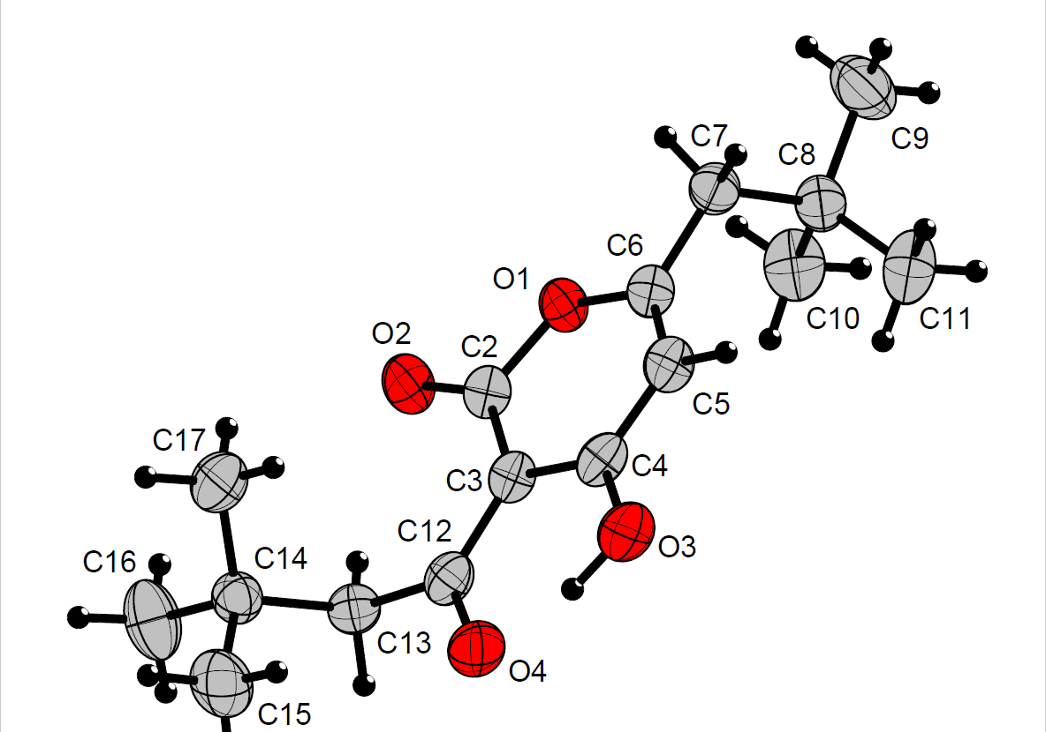

Supplementary information S2
Experimental and calculated bond distances (Ǻ) and bond angles (°) for the A and B tautomeric forms of compound 1.
 |  | A | B |  |  | A | B
 | Exp.ª | Calc. | Calc. |  | Exp.ª | Calc. | Calc.
Bond distances
O(1)–C(5) | 1.400 | 1.425 | 1.411 | C(6)–C(27) | 1.443 | 1.467 | 1.412
O(1)–C(10) | 1.365 | 1.345 | 1.356 | C(7)–C(8) | 1.407 | 1.423 | 1.439
O(2)–C(5) | 1.204 | 1.203 | 1.204 | C(8)–C(10) | 1.333 | 1.355 | 1.350
O(3)–C(7) | 1.313 | 1.313 | 1.261 | C(10)–C(11) | 1.484 | 1.497 | 1.497
O(4)–C(27) | 1.263 | 1.250 | 1.303 | C(27)–C(28) | 1.506 | 1.509 | 1.497
C(5)–C(6) | 1.435 | 1.450 | 1.455 | O(3)–H(44) | 0.953 | 1.019 | 1.430
C(6)–C(7) | 1.408 | 1.413 | 1.458 | O(4)–H(44) | 1.535 | 1.518 | 1.048
Angles
O(1)–C(5)–O(2) | 114.0 | 114.5 | 114.9 | O(4)–C(27)–C(28) | 117.0 | 117.8 | 114.4
O(1)–C (5)–C (6) | 116.6 | 115.9 | 116.0 | C(5)–O(1)–C(10) | 123.1 | 124.1 | 123.8
O(1)–C(10)–C(8) | 120.6 | 121.1 | 121.9 | C(5)–C(6)–C(7) | 118.2 | 118.5 | 119.8
O(1)–C(10)–C(11) | 118.8 | 113.5 | 112.7 | C(6)–C(7)–C(8) | 120.7 | 121.1 | 117.9
O(2)–C(5)–C(6) | 129.4 | 129.7 | 129.1 | C(6)–C(27)–C(28) | 124.2 | 123.5 | 126.8
O(3)–C(7)–C(6) | 121.3 | 122.1 | 121.4 | C(7)–C(8)–C(10) | 120.1 | 119.3 | 120.6
O(3)–C(7)–C(8) | 118.0 | 116.8 | 120.8 | C(8)–C(10)–C(11) | 127.6 | 125.4 | 125.5
O(4)–C(27)–C(6) | 118.7 | 118.6 | 118.8 | C(10)–C(11)–C(14) | 116.1 | 116.8 | 116.9
Dihedral angles
O(1)–C(5)–C(6)–C(7) | 8.4 | 1.3 | 1.7 | O(4)–C(27)–C(6)–C(7) | 0.1 | 0.4 | 0.4
O(1)–C(5)–C(6)–C(27) | 171.8 | 177.7 | 176.8 | C(5)–O(1)–C(10)–C(8) | 2.4 | 0.0 | 0.1
O(1)–C(10)–C(8)–C(7) | 3.3 | 0.9 | 1.2 | C(5)–O(1)–C(10)–C(11) | -176.6 | -179.3 | -179.2
O(1)–C(10)–C(11)–C(14) | -97.1 | -78.2 | -79.0 | C(5)–C(6)–C(7)–C(8) | -3.3 | -0.4 | -0.6
O(2)–C(5)–O(1)–C(10) | 171.5 | 178.8 | 178.5 | C(5)–C(6)–C(27)–C(28) | 2.7 | 0.5 | 0.3
O(2)–C(5)–C(6)–C(7) | -171.3 | -178.6 | -178.3 | C(6)–C(7)–C(8)–C(10) | -2.7 | -0.7 | -0.9
O(2)–C(5)–C(6)–C(27) | 8.5 | 2.4 | 3.1 | C(7)–C(6)–C(27)–C(28) | -177.6 | -178.5 | -178.3
O(3)–C(7)–C(6)–C(5) | 176.9 | 179.7 | 179.6 | C(7)–C(8)–C(10)–C(11) | -177.9 | -179.8 | -179.7
O(3)–C(7)–C(8)–C(10) | 177.1 | 179.2 | 178.9 | C(8)–C(10)–C(11)–C(14) | 84.0 | 102.5 | 101.8
O(4)–C(27)–C(6)–C(5) | 179.7 | 179.4 | 178.9

ª Supplementary information S1

Supplementary information S3
The partial charges of the atoms determined by natural population analysis (NPA) and the local reactivity properties of A and B tautomeric forms of compound 1.

Atom | q_{n} | q_{n-1} | q_{n+1} | f_{k}⁺ | f_{k}⁻ | s_{k}⁺ | s_{k}⁻ | ω_{k}⁺ | ω_{k}⁻
A form
O1 | -0.528 | -0.486 | -0.568 | 0.040 | 0.042 | 0.005 | 0.005 | 0.114 | 0.120
O2 | -0.581 | -0.391 | -0.649 | 0.068 | 0.190 | 0.009 | 0.024 | 0.194 | 0.542
O3 | -0.635 | -0.580 | -0.715 | 0.080 | 0.055 | 0.010 | 0.007 | 0.228 | 0.157
O4 | -0.638 | -0.525 | -0.743 | 0.105 | 0.113 | 0.013 | 0.014 | 0.299 | 0.322
C5 | 0.780 | 0.747 | 0.783 | 0.003 | 0.033 | 0.000 | 0.004 | 0.009 | 0.094
C6 | -0.380 | -0.137 | -0.383 | 0.003 | 0.243 | 0.000 | 0.031 | 0.009 | 0.693
C7 | 0.471 | 0.430 | 0.324 | 0.147 | 0.041 | 0.019 | 0.005 | 0.419 | 0.117
C8 | -0.359 | -0.229 | -0.351 | 0.008 | 0.130 | 0.001 | 0.017 | 0.023 | 0.371
C10 | 0.455 | 0.539 | 0.280 | 0.175 | 0.084 | 0.022 | 0.011 | 0.499 | 0.239
C27 | 0.581 | 0.560 | 0.439 | 0.142 | 0.021 | 0.018 | 0.003 | 0.405 | 0.060
H44 | 0.501 | 0.505 | 0.495 | 0.006 | 0.004 | 0.001 | 0.000 | 0.017 | 0.011
B form
O1 | -0.537 | -0.489 | -0.557 | 0.020 | 0.048 | 0.003 | 0.006 | 0.059 | 0.142
O2 | -0.579 | -0.407 | -0.661 | 0.082 | 0.172 | 0.010 | 0.022 | 0.243 | 0.510
O3 | -0.646 | -0.590 | -0.749 | 0.103 | 0.056 | 0.013 | 0.007 | 0.305 | 0.166
O4 | -0.627 | -0.529 | -0.720 | 0.093 | 0.098 | 0.012 | 0.012 | 0.276 | 0.291
C5 | 0.791 | 0.762 | 0.762 | 0.002 | 0.029 | 0.004 | 0.002 | 0.006 | 0.086
C6 | -0.392 | -0.202 | -0.360 | 0.006 | 0.190 | 0.004 | 0.024 | 0.018 | 0.563
C7 | 0.495 | 0.442 | 0.384 | 0.111 | 0.053 | 0.014 | 0.007 | 0.329 | 0.157
C8 | -0.362 | -0.199 | -0.363 | 0.001 | 0.163 | 0.000 | 0.021 | 0.003 | 0.483
C10 | 0.439 | 0.514 | 0.302 | 0.137 | 0.075 | 0.017 | 0.009 | 0.406 | 0.222
C27 | 0.567 | 0.587 | 0.358 | 0.209 | 0.020 | 0.026 | 0.003 | 0.620 | 0.059
H44 | 0.495 | 0.498 | 0.489 | 0.006 | 0.003 | 0.000 | 0.000 | 0.018 | 0.009

Supplementary information S4
Second order perturbation theory, analysis of the Fock matrix of A and B tautomeric forms of compound 1 using NBO analysis.
Donor (i) – Acceptor (j) interaction | E^{(2)a}  (kcal mol-1) | E(j) –E(i)^{b}  (a.u.) | F(i,j)^{c}  (a.u.)
A
σ₁(O3–H44) → σ*₁(C7–C8) | 5.83 | 1.23 | 0.076
σ₂(C6–C7) → σ*₂(O2–C5) | 34.18 | 0.28 | 0.088
σ₂(C6–C7) → σ*₂(O4–C27) | 31.20 | 0.27 | 0.084
σ₂(C6–C7) → σ*₂(C8–C10) | 7.49 | 0.29 | 0.043
σ₁(C8–H9) → σ*₁(O1–C10) | 7.07 | 0.90 | 0.071
σ₂(C8–C10) → σ*₂(C6–C7) | 24.96 | 0.29 | 0.079
σ₁(C11–H12) → σ*₁(O1–C10) | 5.76 | 0.87 | 0.063
n(LP₁O1) → σ₁*(C8–C10) | 6.27 | 1.16 | 0.076
n(LP₂O1) → σ₂*(O2–C5) | 29.25 | 0.35 | 0.092
n(LP₂O2) → σ₁*(O1–C5) | 40.10 | 0.52 | 0.131
n(LP₂O2) → σ₁*(C5–C6) | 15.56 | 0.73 | 0.098
n(LP₁O3) → σ₁*(C6–C7) | 7.12 | 1.12 | 0.080
n(LP₂O3) → σ₂*(C6–C7) | 52.45 | 0.32 | 0.120
n(LP₁O4) → σ₁*(O3–H44) | 5.17 | 1.01 | 0.066
n (LP₁O4) → σ₁*(C6–C27) | 5.29 | 1.11 | 0.069
n (LP₂O4) → σ₁*(O3–H44) | 42.96 | 0.71 | 0.158
n (LP₂O4) → σ₁*(C6–C27) | 8.75 | 0.81 | 0.077
n (LP₂O4) → σ₁*(C27–C28) | 14.14 | 0.76 | 0.095
B
σ₂(O2–C5) → n (LP₁C6) | 5.77 | 0.25 | 0.054
σ₂(O3–C7) → n (LP₁C6) | 5.59 | 0.24 | 0.051
σ₁(O4–H44) → σ*₁(C27–C28) | 5.84 | 1.13 | 0.073
σ₁(C8–H9) → σ*₁(O1–C10) | 7.84 | 0.88 | 0.074
σ₂(C8–C10) → σ*₂(O3–C7) | 27.83 | 0.28 | 0.082
σ₁(C11–H12) → σ*₁(O1–C10) | 5.70 | 0.85 | 0.063
n (LP₂O1) → σ₂*(O2–C5) | 31.36 | 0.35 | 0.094
n (LP₂O1) → σ₂*(C8–C10) | 34.08 | 0.37 | 0.102
n (LP₂O2) → σ₁*(O1–C5) | 37.96 | 0.55 | 0.130
n (LP₂O2) → σ₁*(C5–C6) | 15.85 | 0.72 | 0.098
n (LP₁O3) → σ₁*(O4–H44) | 6.14 | 0.97 | 0.071
n (LP₁O3) → σ₁*(C6–C7) | 6.14 | 1.10 | 0.074
n (LP₂O3) → σ₁*(O4–H44) | 63.18 | 0.69 | 0.189
n (LP₂O3) → σ₁*(C6–C7) | 7.56 | 0.83 | 0.073
n (LP₂O3) → σ₁*(C7–C8) | 13.19 | 0.85 | 0.098
n (LP₁O4) → σ₁*(C6–C27) | 6.69 | 1.12 | 0.077
ªStabilization (delocalization) energy (interactions with stabilization energy greater than 5.0 kcal mol⁻¹ are listed).
^{b}Energy difference between i(donor) and j(acceptor) NBO orbitals.
^{e}Fock matrix element i and j NBO orbitals.
LP – Lone pair.

