**Effect of Acyl Chain Variation and Cholesterol on Structural and Dynamic Properties of Lipid Bilayer Probed by Simulation**

Dhruva Bhat, Dr. A. V. R. Murthy

DEPARTMENT OF APPLIED PHYSICS, DEFENCE INSTITUTE OF ADVANCED TECHNOLOGY

PUNE, INDIA

Dhruva Bhat (email: [db110499@gmail.com](mailto:db110499@gmail.com) )

Dr. A. V. R. Murthy (email: [avrmurthy@diat.ac.in](mailto:avrmurthy@diat.ac.in) )

**Table S1:** Calculation of Bilayer Thickness, Area per Lipid and Order Parameter for Lipids with different concentrations of Cholesterol.

|  |  |  |  |  |  |
| --- | --- | --- | --- | --- | --- |
|  | **Lipid** | **Cholesterol Concentration** | **Direct** | ***FATSLiM*** | ***GridMAT-MD*** |
| **Bilayer Thickness (nm)** | **DLPC** | **50** | 4.013 | 3.888±0.019 | 3.905 |
| **40** | 3.838 | 3.865±0.020 | 3.841 |
| **30** | 3.691 | 3.702±0.020 | 3.721 |
| **20** | 3.61 | 3.626±0.021 | 3.625 |
| **10** | 3.541 | 3.535±0.02 | 3.533 |
| **00** | 3.445 | 3.441±0.013 | 3.45 |
| **Area per Lipid (nm2)** | **50** | 0.399 | 0.399±0.002 | 0.398 |
| **40** | 0.424 | 0.423±0.003 | 0.424 |
| **30** | 0.454 | 0.451±0.003 | 0.452 |
| **20** | 0.501 | 0.511±0.02 | 0.505 |
| **10** | 0.544 | 0.546±0.003 | 0.551 |
| **00** | 0.591 | 0.601±0.002 | 0.602 |
| **Order parameter** | **50** | 0.746 | - | - |
| **40** | 0.720 | - | - |
| **30** | 0.681 | - | - |
| **20** | 0.594 | - | - |
| **10** | 0.533 | - | - |
| **00** | 0.479 | - | - |
| **Bilayer Thickness (nm)** | **POPC** | **50** | 4.131 | 4.098±0.019 | 4.133 |
| **40** | 3.265 | 3.251±0.020 | 3.271 |
| **30** | 3.897 | 3.911±0.017 | 3.878 |
| **20** | 4.071 | 4.053±0.021 | 4.070 |
| **10** | 4.281 | 4.269±0.021 | 4.266 |
| **00** | 4.020 | 4.032±0.019 | 4.018 |
| **Area per Lipid (nm2)** | **50** | 0.425 | 0.424±0.002 | 0.426 |
| **40** | 0.463 | 0.463±0.003 | 0.465 |
| **30** | 0.503 | 0.502±0.003 | 0.500 |
| **20** | 0.546 | 0.546±0.002 | 0.546 |
| **10** | 0.559 | 0.560±0.002 | 0.557 |
| **00** | 0.642 | 0.644±0.003 | 0.641 |
| **Order parameter** | **50** | 0.585 | - | - |
| **40** | 0.523 | - | - |
| **30** | 0.490 | - | - |
| **20** | 0.463 | - | - |
| **10** | 0.425 | - | - |
| **00** | 0.375 | - | - |
| **Bilayer Thickness (nm)** | **DGPC** | **50** | 4.606 | 4.611±0.017 | 4.595 |
| **40** | 4.667 | 4.658±0.020 | 4.672 |
| **30** | 4.587 | 4.592±0.019 | 4.602 |
| **20** | 4.503 | 4.489±0.021 | 4.510 |
| **10** | 4.459 | 4.455±0.018 | 4.461 |
| **00** | 4.370 | 4.371±0.020 | 4.372 |
| **Area per Lipid (nm2)** | **50** | 0.428 | 0.426±0.002 | 0.431 |
| **40** | 0.477 | 0.479±0.003 | 0.479 |
| **30** | 0.522 | 0.520±0.002 | 0.521 |
| **20** | 0.569 | 0.569±0.002 | 0.565 |
| **10** | 0.618 | 0.617±0.003 | 0.621 |
| **00** | 0.666 | 0.665±0.002 | 0.667 |
| **Order parameter** | **50** | 0.445 | - | - |
| **40** | 0.418 | - | - |
| **30** | 0.398 | - | - |
| **20** | 0.365 | - | - |
| **10** | 0.341 | - | - |
| **00** | 0.331 | - | - |
| **Bilayer Thickness (nm)** | **DIPC** | **50** | 3.732 | 3.754±0.022 | 3.751 |
| **40** | 3.795 | 3.789±0.019 | 3.798 |
| **30** | 3.726 | 3.698±0.020 | 3.725 |
| **20** | 3.616 | 3.601±0.017 | 3.624 |
| **10** | 3.621 | 3.633±0.018 | 3.611 |
| **00** | 3.461 | 3.454±0.019 | 3.463 |
| **Area per Lipid (nm2)** | **50** | 0.474 | 0.474±0.002 | 0.475 |
| **40** | 0.525 | 0.522±0.003 | 0.522 |
| **30** | 0.575 | 0.574±0.002 | 0.569 |
| **20** | 0.628 | 0.628±0.002 | 0.626 |
| **10** | 0.678 | 0.676±0.003 | 0.676 |
| **00** | 0.741 | 0.740±0.002 | 0.742 |
| **Order parameter** | **50** | 0.262 | - | - |
| **40** | 0.272 | - | - |
| **30** | 0.254 | - | - |
| **20** | 0.238 | - | - |
| **10** | 0.235 | - | - |
| **00** | 0.227 | - | - |

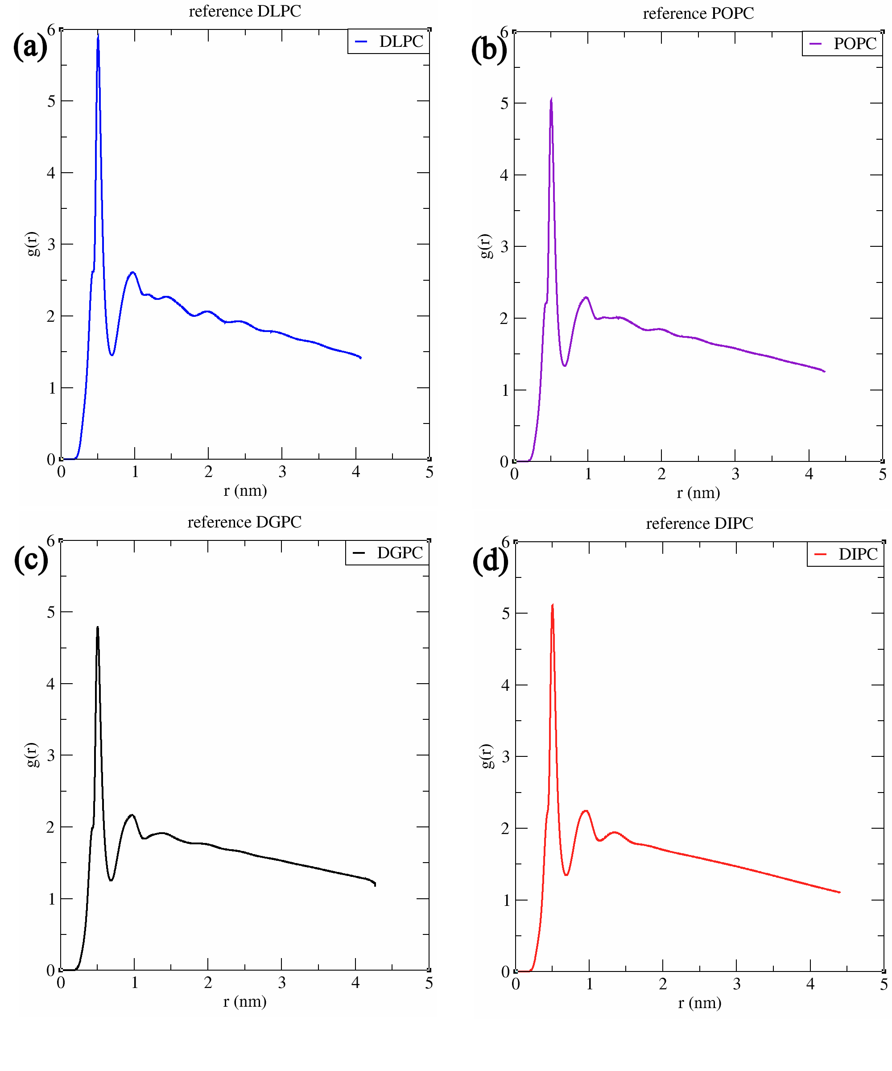**Fig S1.** The Radial Distribution Function (RDF) study of lipid-lipid interaction.