Supplementary Information
Unravelling Conformational Thermodynamics of Ligand Binding to Fluoride Riboswitch Aptamer: Implications for Therapeutic Design

Author: Soumi Das^{1*}
¹Department of Physics of Complex Systems, S. N. Bose National Centre for Basic Sciences, Block-JD, Sector-III, Salt Lake, Kolkata 700106, India.

Correspondence: Soumi Das
E-mail: iammandovi@gmail.com
Institutional email address: soumi.das@bose.res.in
ORCID ID: https://orcid.org/0009-0005-2869-5849

A list of all the microscopic conformational variables of RNA used in our study is described:
- Inter-bp step parameters: tilt (τ), roll (ρ), twist (ω), shift (D_{x}), slide (D_{y}), and rise (D_{z}).
- Intra-bp step parameters: buckle (κ), open (σ), propeller (π), stagger (S_{x}), shear (S_{y}), stretch (S_{z}).
- Sugar-phosphate backbone torsion angles: α, β, γ, δ, ε, ζ and sugar-base backbone torsion angle χ.
- Pseudo torsion angle (ƞ and θ).
- Sugar pucker: (ν₀, ν₁, ν₂, ν₃, ν₄)

Comprehensive descriptions of all microscopic conformational variables of RNA can be found in references [S1–S5].

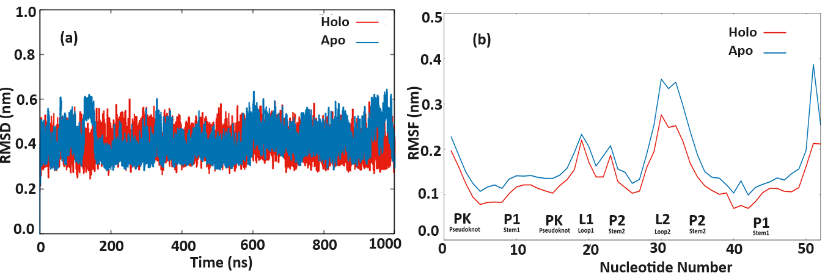
Fig. S1 (a) Root mean square deviation (RMSD) plots of backbone atoms of Holo (red) and Apo (blue) Fluoride riboswitch aptamer as a function of simulation time. (b) Root Mean Square Fluctuation (RMSF) around the average nucleotide position of 1 µs trajectories of Holo (red) and Apo (blue) riboswitches.

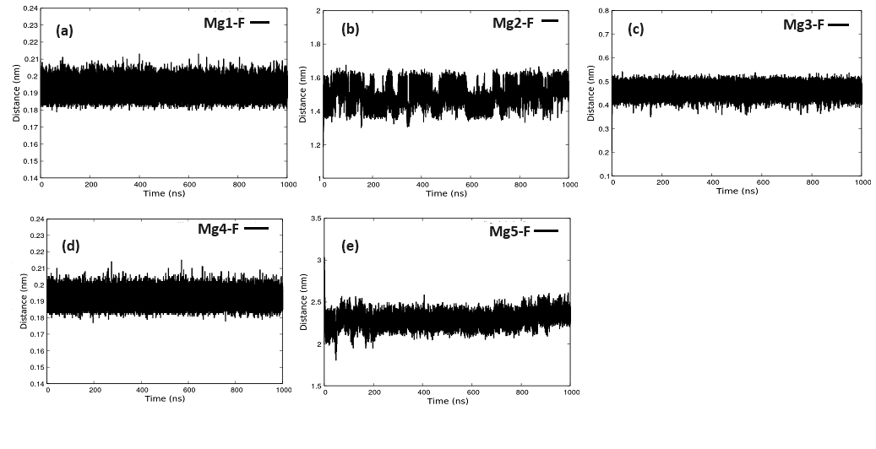
Fig. S2 (a) Distance between Mg1 and F, (b) Distance between Mg2 and F, (c) Distance between Mg3 and F, (d) Distance between Mg4 and F, and (e) Distance between Mg5 and F
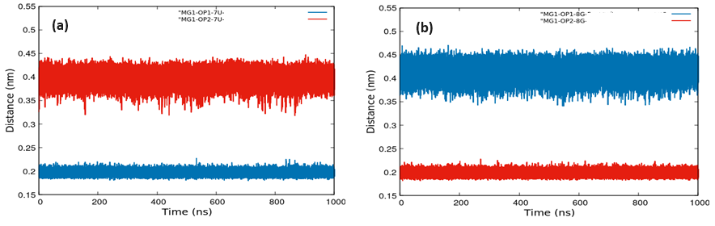
Fig. S3 (a) Distance between Mg1 and OP1/OP2-7U, and (b) Distance between Mg1 and OP1/OP2-8G
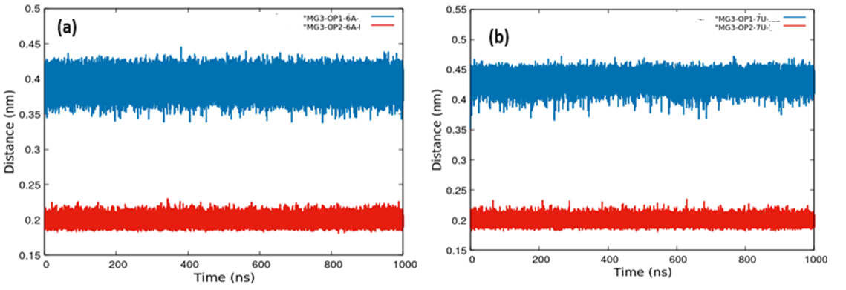
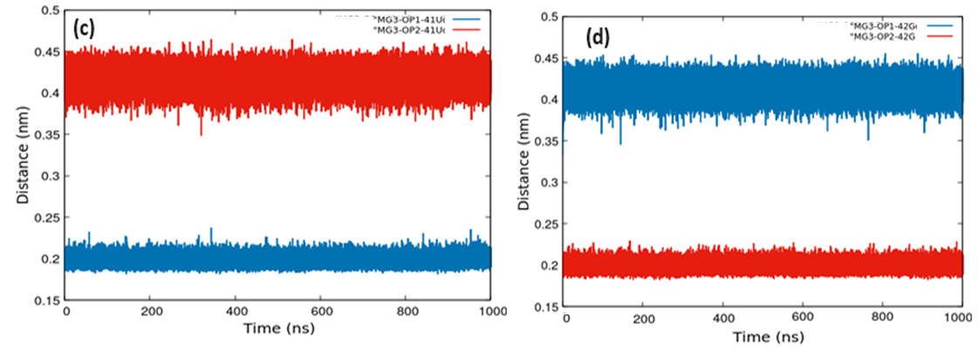
Fig. S4 (a) Distance between Mg3 and OP1/OP2-6A, (b) Distance between Mg3 and OP1/OP2-7U,
(c) Distance between Mg3 and OP1/OP2-41U, and (d) Distance between Mg3 and OP1/OP2-42G
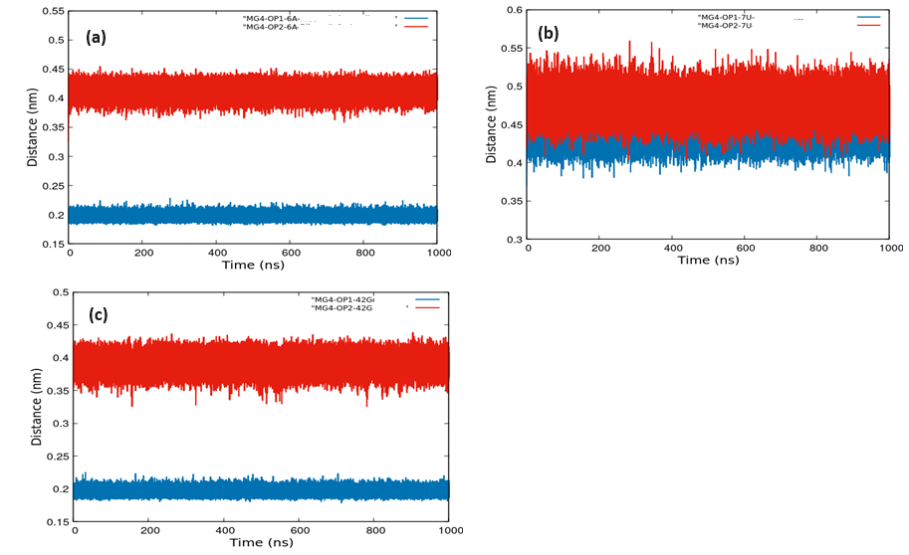
Fig. S5 (a) Distance between Mg4 and OP1/OP2-6A, (b) Distance between Mg4 and OP1/OP2-7U, and (c) Distance between Mg4 and OP1/OP2-42G
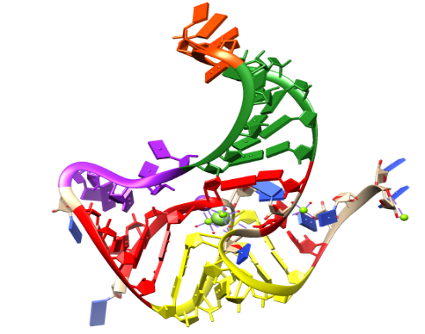
Fig S6: Colour coding of domain-wise conformational thermodynamics for the holo fluoride riboswitch with respect to the apo form:
Red: Pseudoknot (highly stable and ordered)
Yellow: Stem1 (highly stable and ordered)
Green: Stem2 (highly unstable and disordered)
Purple: Loop1 (highly unstable and disordered)
Orange: Loop2 (highly unstable and disordered)

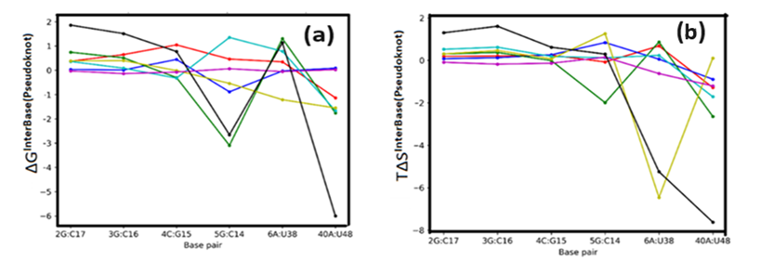
Fig. S7: Free energy (ΔG, panel a) and entropic contribution (TΔS, panel b) arising from inter–base pair step parameters in the pseudoknot region. Parameters are colour-coded as follows: Tilt (red), Roll (blue), Twist (green), Shift (cyan), Slide (yellow), Rise (magenta), and Total (black). Data are presented for the holo system relative to the apo system, with all values expressed in kilojoules per mole (kJ/mol). The black ‘Total’ line represents the overall change for each base pair.
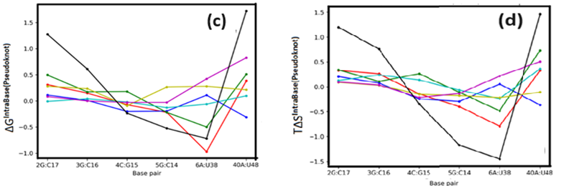
Fig. S7: Free energy (ΔG, panel c) and entropic contribution (TΔS, panel d) arising from intra–base pair parameters in the pseudoknot region. Parameters are colour-coded as follows: Buckle (red), Open (blue), Propeller (green), Shear (cyan), Stagger (yellow), Stretch (magenta), and Total (black). Data are presented for the holo system relative to the apo system, with all values expressed in kilojoules per mole (kJ/mol). The black ‘Total’ line represents the overall change for each base pair.
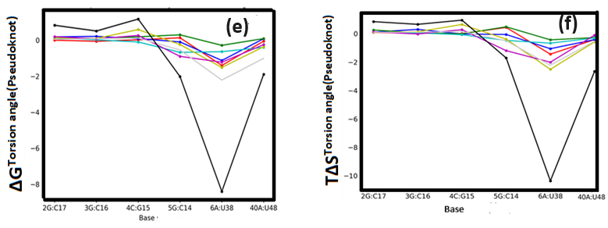
Fig. S7: Free energy (ΔG, panel e) and entropic contribution (TΔS, panel f) arising from torsion angles in the pseudoknot region. Parameters are colour-coded as follows: α (red), β (blue), γ (green), δ (cyan), ε (yellow), ζ (magenta), χ (light grey), and Total (black). Data are presented for the holo system relative to the apo system, with all values expressed in kilojoules per mole (kJ/mol). The black ‘Total’ line represents the overall change for each base.
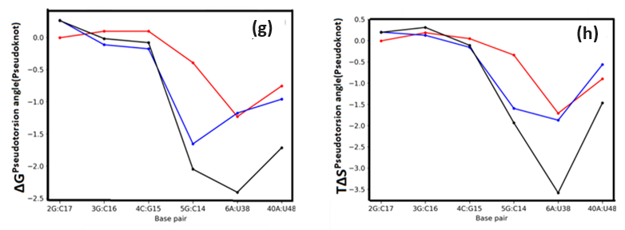
Fig. S7: Free energy (ΔG, panel g) and entropic contribution (TΔS, panel h) arising from pseudo torsion angles in the pseudoknot region. Parameters are colour-coded as follows: η (red), θ (blue), and Total (black). Data are presented for the holo system relative to the apo system, with all values expressed in kilojoules per mole (kJ/mol). The black ‘Total’ line represents the overall change for each base.
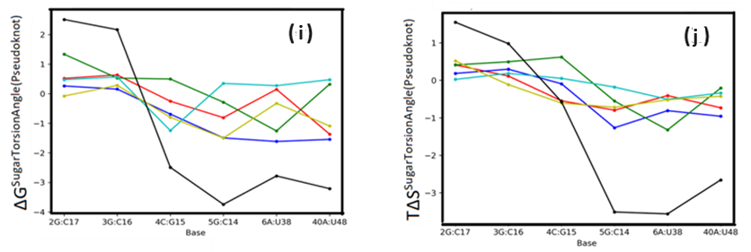
Fig. S7: Free energy (ΔG, panel i) and entropic contribution (TΔS, panel j) arising from sugar torsion angles in the pseudoknot region. Parameters are colour-coded as follows: ν0 (red), ν1 (blue), ν2 (green), ν3 (cyan), ν4 (yellow), and Total (black). Data are presented for the holo system relative to the apo system, with all values expressed in kilojoules per mole (kJ/mol). The black ‘Total’ line represents the overall change for each base.
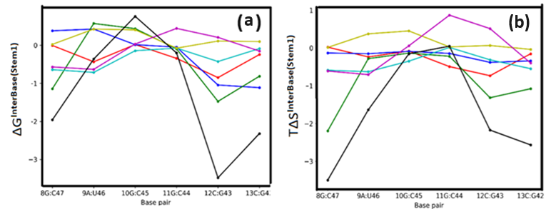
Fig. S8: Free energy (ΔG, panel a) and entropic contribution (TΔS, panel b) arising from inter–base pair step parameters in Stem1. Parameters are colour-coded as follows: Tilt (red), Roll (blue), Twist (green), Shift (cyan), Slide (yellow), Rise (magenta), and Total (black). Data are presented for the holo system relative to the apo system, with all values expressed in kilojoules per mole (kJ/mol). The black ‘Total’ line represents the overall change for each base pair.
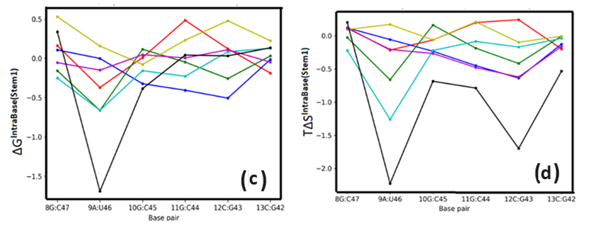
Fig. S8: Free energy (ΔG, panel c) and entropic contribution (TΔS, panel d) arising from intra–base pair parameters in Stem1. Parameters are colour-coded as follows: Buckle (red), Open (blue), Propeller (green), Shear (cyan), Stagger (yellow), Stretch (magenta), and Total (black). Data are presented for the holo system relative to the apo system, with all values expressed in kilojoules per mole (kJ/mol). The black ‘Total’ line represents the overall change for each base pair.
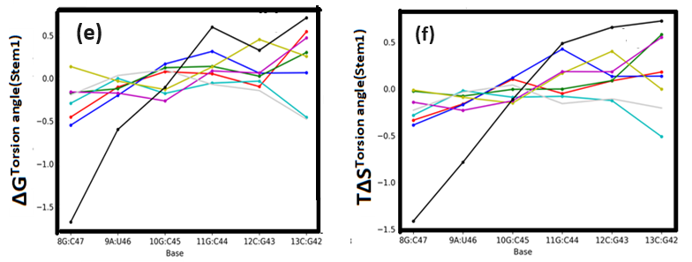
Fig. S8: Free energy (ΔG, panel e) and entropic contribution (TΔS, panel f) arising from torsion angles in Stem1. Parameters are colour-coded as follows: α (red), β (blue), γ (green), δ (cyan), ε (yellow), ζ (magenta), χ (light gray), and Total (black). Data are presented for the holo system relative to the apo system, with all values expressed in kilojoules per mole (kJ/mol). The black ‘Total’ line represents the overall change for each base.
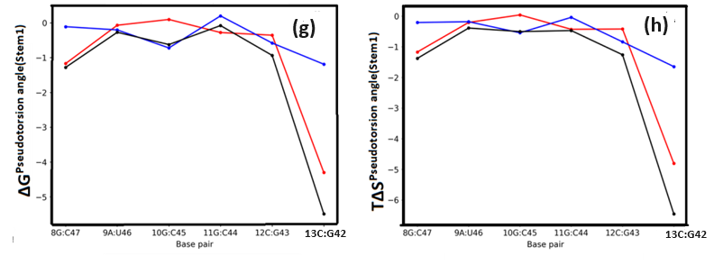
Fig. S8: Free energy (ΔG, panel g) and entropic contribution (TΔS, panel h) arising from pseudo torsion angles in Stem1. Parameters are colour-coded as follows: η (red), θ (blue), and Total (black). Data are presented for the holo system relative to the apo system, with all values expressed in kilojoules per mole (kJ/mol). The black ‘Total’ line represents the overall change for each base.
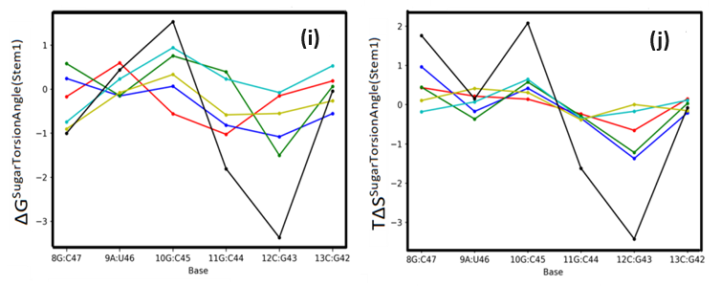
Fig. S8: Free energy (ΔG, panel i) and entropic contribution (TΔS, panel j) arising from sugar torsion angles in Stem1. Parameters are colour-coded as follows: ν0 (red), ν1 (blue), ν2 (green), ν3 (cyan), ν4 (yellow), and Total (black). Data are presented for the holo system relative to the apo system, with all values expressed in kilojoules per mole (kJ/mol). The black ‘Total’ line represents the overall change for each base.
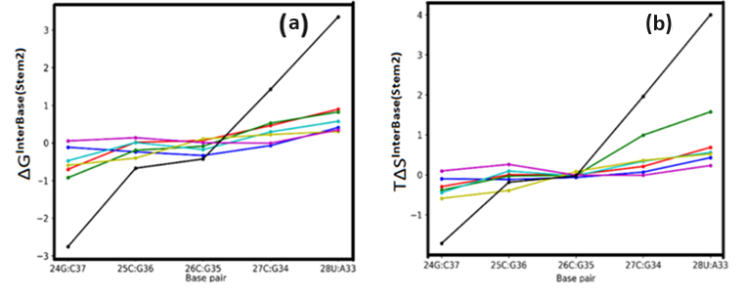
Fig. S9: Free energy (ΔG, panel a) and entropic contribution (TΔS, panel b) arising from inter–base pair step parameters in Stem2. Parameters are colour-coded as follows: Tilt (red), Roll (blue), Twist (green), Shift (cyan), Slide (yellow), Rise (magenta), and Total (black). Data are presented for the holo system relative to the apo system, with all values expressed in kilojoules per mole (kJ/mol). The black ‘Total’ line represents the overall change for each base pair.
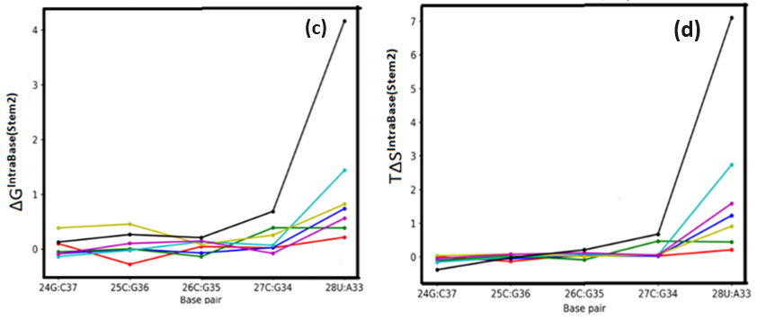
Fig. S9: Free energy (ΔG, panel c) and entropic contribution (TΔS, panel d) arising from intra–base pair parameters in Stem2. Parameters are colour-coded as follows: Buckle (red), Open (blue), Propeller (green), Shear (cyan), Stagger (yellow), Stretch (magenta), and Total (black). Data are presented for the holo system relative to the apo system, with all values expressed in kilojoules per mole (kJ/mol). The black ‘Total’ line represents the overall change for each base pair.
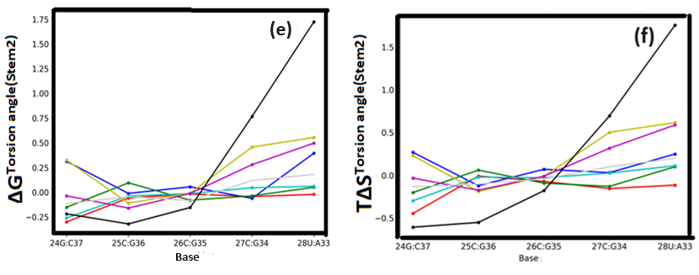
Fig. S9: Free energy (ΔG, panel e) and entropic contribution (TΔS, panel f) arising from torsion angles in Stem2. Parameters are colour-coded as follows: α (red), β (blue), γ (green), δ (cyan), ε (yellow), ζ (magenta), χ (light grey), and Total (black). Data are presented for the holo system relative to the apo system, with all values expressed in kilojoules per mole (kJ/mol). The black ‘Total’ line represents the overall change for each base.
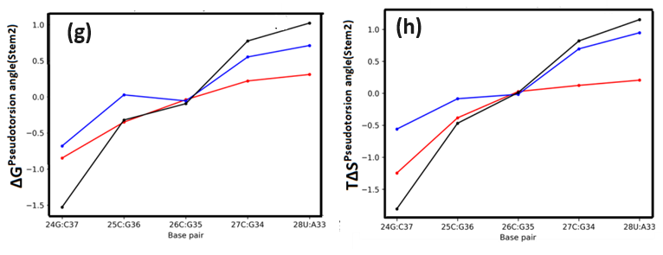
Fig. S9: Free energy (ΔG, panel g) and entropic contribution (TΔS, panel h) arising from pseudo torsion angles in Stem2. Parameters are colour-coded as follows: η (red), θ (blue), and Total (black). Data are presented for the holo system relative to the apo system, with all values expressed in kilojoules per mole (kJ/mol). The black ‘Total’ line represents the overall change for each base.
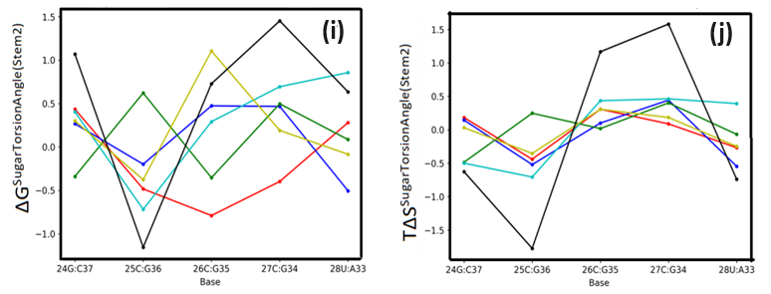
Fig. S9: Free energy (ΔG, panel i) and entropic contribution (TΔS, panel j) arising from sugar torsion angles in Stem2. Parameters are colour-coded as follows: ν0 (red), ν1 (blue), ν2 (green), ν3 (cyan), ν4 (yellow), and Total (black). Data are presented for the holo system relative to the apo system, with all values expressed in kilojoules per mole (kJ/mol). The black ‘Total’ line represents the overall change for each base.
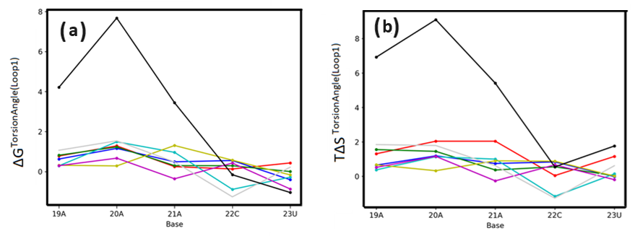
Fig. S10: Free energy (ΔG, panel a) and entropic contribution (TΔS, panel b) arising from torsion angles in Loop1. Parameters are colour-coded as follows: α (red), β (blue), γ (green), δ (cyan), ε (yellow), ζ (magenta), χ (light grey), and Total (black). Data are presented for the holo system relative to the apo system, with all values expressed in kilojoules per mole (kJ/mol). The black ‘Total’ line represents the overall change for each base.
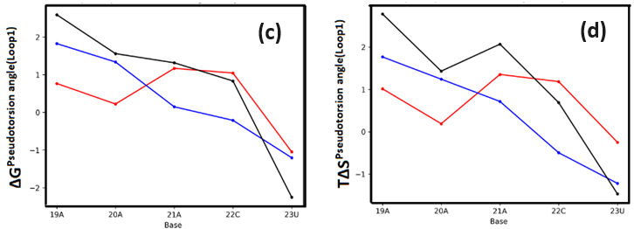
Fig. S10: Free energy (ΔG, panel c) and entropic contribution (TΔS, panel d) arising from pseudo torsion angles in Loop1. Parameters are colour-coded as follows: η (red), θ (blue), and Total (black). Data are presented for the holo system relative to the apo system, with all values expressed in kilojoules per mole (kJ/mol). The black ‘Total’ line represents the overall change for each base.
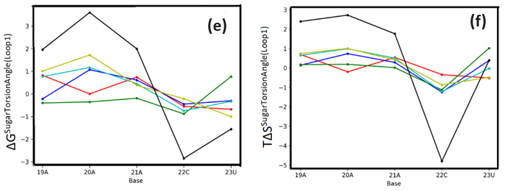
Fig. S10: Free energy (ΔG, panel e) and entropic contribution (TΔS, panel f) arising from sugar torsion angles in Loop1. Parameters are colour-coded as follows: ν0 (red), ν1 (blue), ν2 (green), ν3 (cyan), ν4 (yellow), and Total (black). Data are presented for the holo system relative to the apo system, with all values expressed in kilojoules per mole (kJ/mol). The black ‘Total’ line represents the overall change for each base.
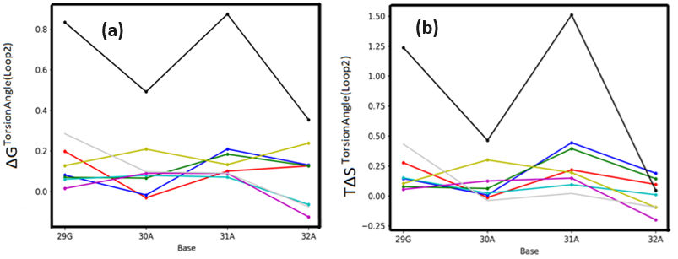
Fig. S11: Free energy (ΔG, panel a) and entropic contribution (TΔS, panel b) arising from torsion angles in Loop2. Parameters are colour-coded as follows: α (red), β (blue), γ (green), δ (cyan), ε (yellow), ζ (magenta), χ (light grey), and Total (black). Data are presented for the holo system relative to the apo system, with all values expressed in kilojoules per mole (kJ/mol). The black ‘Total’ line represents the overall change for each base.
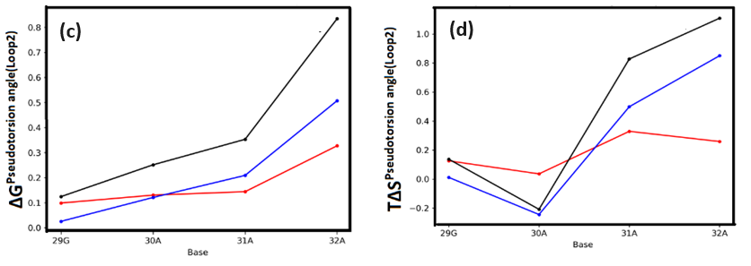
Fig. S11: Free energy (ΔG, panel c) and entropic contribution (TΔS, panel d) arising from pseudo torsion angles in Loop2. Parameters are colour-coded as follows: η (red), θ (blue), and Total (black). Data are presented for the holo system relative to the apo system, with all values expressed in kilojoules per mole (kJ/mol). The black ‘Total’ line represents the overall change for each base.
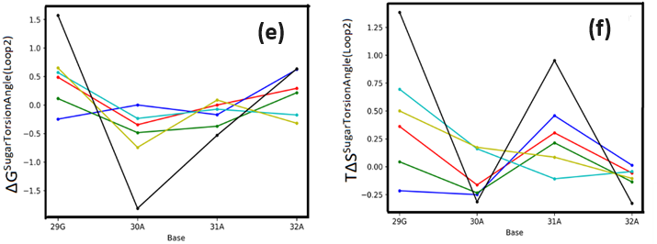
Fig. S11: Free energy (ΔG, panel e) and entropic contribution (TΔS, panel f) arising from sugar torsion angles in Loop2. Parameters are colour-coded as follows: ν0 (red), ν1 (blue), ν2 (green), ν3 (cyan), ν4 (yellow), and Total (black). Data are presented for the holo system relative to the apo system, with all values expressed in kilojoules per mole (kJ/mol). The black ‘Total’ line represents the overall change for each base.
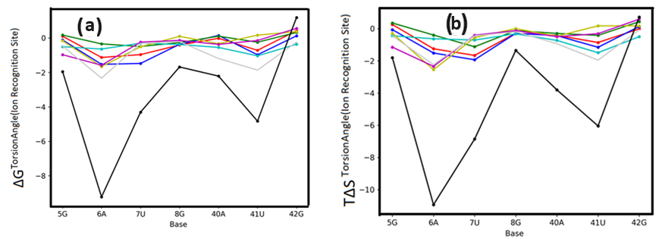
Fig. S12: Free energy (ΔG, panel a) and entropic contribution (TΔS, panel b) arising from torsion angles in the ion recognition site. Parameters are colour-coded as follows: α (red), β (blue), γ (green), δ (cyan), ε (yellow), ζ (magenta), χ (light grey), and Total (black). Data are presented for the holo system relative to the apo system, with all values expressed in kilojoules per mole (kJ/mol). The black ‘Total’ line represents the overall change for each base.
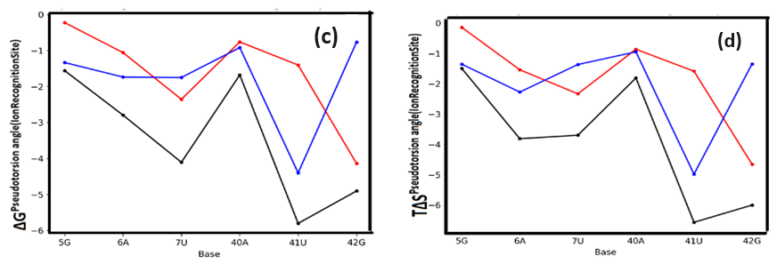
Fig. S12: Free energy (ΔG, panel c) and entropic contribution (TΔS, panel d) arising from pseudo torsion angles in the ion recognition site. Parameters are colour-coded as follows: η (red), θ (blue), and Total (black). Data are presented for the holo system relative to the apo system, with all values expressed in kilojoules per mole (kJ/mol). The black ‘Total’ line represents the overall change for each base.
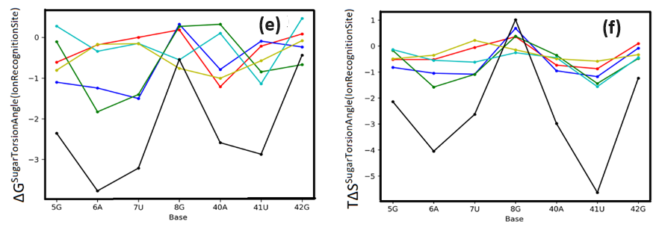
Fig. S12: Free energy (ΔG, panel e) and entropic contribution (TΔS, panel f) arising from sugar torsion angles in the ion recognition site. Parameters are colour-coded as follows: ν0 (red), ν1 (blue), ν2 (green), ν3 (cyan), ν4 (yellow), and Total (black). Data are presented for the holo system relative to the apo system, with all values expressed in in kilojoules per mole (kJ/mol). The black ‘Total’ line represents the overall change for each base.

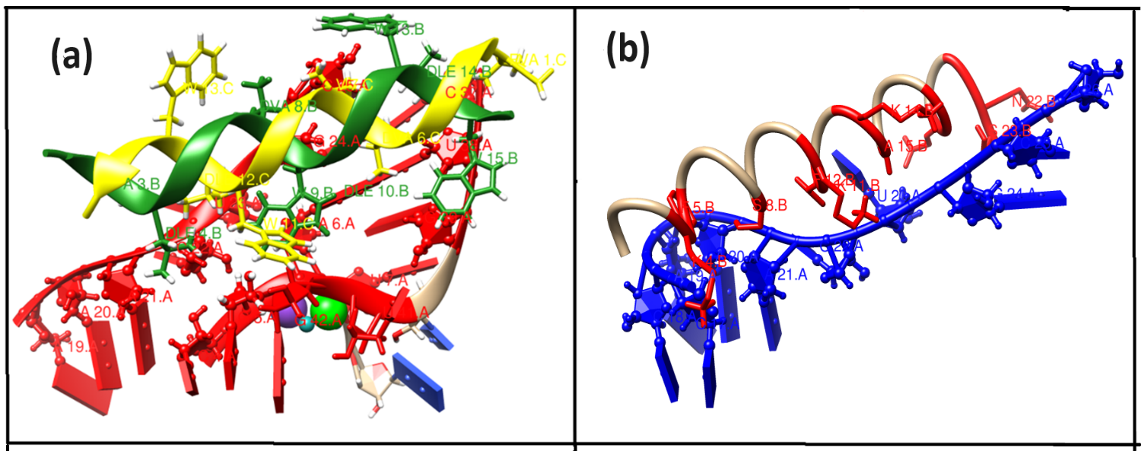
Fig. S13: Zoomed view of the interface of the energy-minimized docked complex (a) GramidinD-Fluoride riboswitch (holo) (b) Magainin 2 and Fluoride riboswitch (holo).

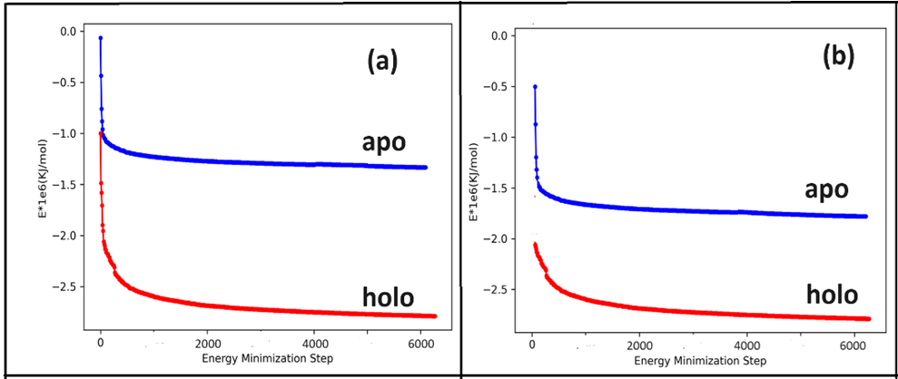
Fig. S14 The energy-minimization plots corresponding to (a) Gramicidin D, (b) Magainin 2 complexes with apo (blue) and holo (red) Fluoride riboswitch

Table S1 (a): RMSD (Mean and Standard Deviation (within first bracket)) of region wise Fluoride riboswitch aptamer in nm
Region | System | RMSD (mean and SD) in nm
Pseudoknot | Holo | 0.21 (0.04)
Pseudoknot | Apo | 0.19 (0.04)
Stem1 | Holo | 0.09 (0.01)
Stem1 | Apo | 0.13 (0.02)
Stem2 | Holo | 0.11 (0.02)
Stem2 | Apo | 0.11 (0.02)
Loop1 | Holo | 0.10 (0.02)
Loop1 | Apo | 0.13 (0.02)
Loop2 | Holo | 0.08 (0.02)
Loop2 | Apo | 0.07 (0.01)
Ligand Binding Site | Holo | 0.12 (0.04)
Ligand Binding Site | Apo | 0.34 (0.03)

Table S1 (b): % of Hydrogen bond occupancy within base pairs constituting different region of the holo and apo form of Fluoride riboswitch aptamer
 |  |  | Occupancy (%)
Region | Base Pairing | donor-acceptor | Holo | Apo
Pseudoknot | 2 G:C 17 (W:W C) | 2G (N2-H21) - 17 C (O2 ) | 99.9 | 29.9
Pseudoknot | 2 G:C 17 (W:W C) | 2G (N1-H1) - 17 C (N3 ) | 99.9 | 15.9
Pseudoknot | 3 G:C 16 (W:W C) | 3G (N1-H1 ) - 16 C (N3 ) | 99.8 | 27.3
Pseudoknot | 3 G:C 16 (W:W C) | 3G (N2-H21) - 16 C (O2 ) | 99.9 | 12.9
Pseudoknot | 4 C:G 15 (W:W C) | 4C (N4-H41) - 15 G (O6 ) | 94.0 | 21.3
Pseudoknot | 4 C:G 15 (W:W C) | 15G (N2-H21) - 4 C (O2 ) | 99.6 | 19.6
Pseudoknot | 4 C:G 15 (W:W C) | 15G (N1-H1) - 4 C (N3 ) | 99.8 | 29.8
Pseudoknot | 5 G:C 14 (W:W C) | 5G (N1-H1 ) - 14 C (N3 ) | 99.9 | 10.9
Pseudoknot | 5 G:C 14 (W:W C) | 5G (N2-H21) - 14 C (O2 ) | 99.5 | 26.7
Pseudoknot | 6 A:U 38 (W:W T) | 6A (N6-H61) - 38 U (O2 ) | 98.1 | 25.1
Pseudoknot | 6 A:U 38 (W:W T) | 38U (N3-H3) - 6 A (N1 ) | 99.1 | 21.9
Pseudoknot | 40 A:U 48  (H:W T) | 40A (N6-H61) - 48 U (O2 ) | 99.6 | 23.5
Pseudoknot | 40 A:U 48  (H:W T) | 48U (N3-H3) - 40 A (N7 ) | 98.9 | 22.3
Stem 1 | 8 G:C 47 (W:W C) | 8G (N1-H1) - 47 C (N3 ) | 99.9 | 24.9
Stem 1 | 8 G:C 47 (W:W C) | 8G (N2-H21) - 47 C (O2 ) | 99.8 | 22.7
Stem 1 | 9 A:U 46 (W:W C) | 46U (N3-H3) - 9 A (N1 ) | 98.9 | 23.1
Stem 1 | 9 A:U 46 (W:W C) | 9A (N6-H61) - 46 U (O4 ) | 87.8 | 26.7
Stem 1 | 10 G:C 45 (W:W C) | 10G (N1-H1) - 45 C (N3 ) | 99.9 | 23.9
Stem 1 | 10 G:C 45 (W:W C) | 10G (N2-H21) - 45 C (O2 ) | 99.6 | 23.5
Stem 1 | 11 G:C 44 (W:W C) | 11G (N1-H1) - 44 C (N3 ) | 99.9 | 21.8
Stem 1 | 11 G:C 44 (W:W C) | 11G (N2-H21) - 44 C (O2 ) | 99.7 | 22.7
Stem 1 | 12 C:G 43 (W:W C) | 12C (N4-H41) - 43 G (O6 ) | 96.6 | 24.1
Stem 1 | 12 C:G 43 (W:W C) | 43G (N2-H21) - 12 C (O2 ) | 99.8 | 26.7
Stem 1 | 12 C:G 43 (W:W C) | 43G (N1-H1 ) - 12 C (N3 ) | 99.8 | 28.2
Stem 1 | 13 C:G 42 (W:W C) | 42G (N2-H21) - 13 C (O2 ) | 99.9 | 27.8
Stem 1 | 13 C:G 42 (W:W C) | 42G (N1-H1) - 13 C (N3 ) | 99.9 | 24.9
Stem 2 | 24 G:C 37 (W:W C) | 24G (N1-H1) - 37 C (N3 ) | 69.9 | 19.8
Stem 2 | 24 G:C 37 (W:W C) | 24G (N2-H21) - 37 C (O2 ) | 69.8 | 19.9
Stem 2 | 24 G:C 37 (W:W C) | 37C (N4-H41) - 24 G (O6 ) | 78.8 | 28.4
Stem 2 | 25 C:G 36 (W:W C) | 25C (N4-H41) - 36 G (O6 ) | 78.1 | 28.2
Stem 2 | 25 C:G 36 (W:W C) | 36G (N2-H21) - 25 C (O2 ) | 59.8 | 19.9
Stem 2 | 25 C:G 36 (W:W C) | 36G (N1-H1 ) - 25 C (N3 ) | 49.8 | 21.8
Stem 2 | 26 C:G 35 (W:W C) | 26C (N4-H41) - 35 G (O6 ) | 78.3 | 28.3
Stem 2 | 26 C:G 35 (W:W C) | 35G (N2-H21) - 26 C (O2 ) | 79.8 | 23.9
Stem 2 | 26 C:G 35 (W:W C) | 35G (N1-H1 ) - 26 C (N3 ) | 79.7 | 29.8
Stem 2 | 27 C:G 34 (W:W C) | 27C (N4-H41) - 34 G (O6 ) | 77.8 | 27.8
Stem 2 | 27 C:G 34 (W:W C) | 34G (N2-H21) - 27 C (O2 ) | 79.7 | 29.8
Stem 2 | 27 C:G 34 (W:W C) | 34G (N1-H1 ) - 27 C (N3 ) | 79.8 | 29.8
Stem 2 | 28 U:A 33 (W:W C) | 28U (N3-H3 ) - 33 A (N1 ) | 77.9 | 28.8
Stem 2 | 28 U:A 33 (W:W C) | 33A (N6-H61) - 28 U (O4 ) | 77.7 | 28.5

Table S1(c): Mean and Standard Deviation (within first bracket) of Bond distance (nm) between the ions (ligand) and the ligand binding nucleotides in the holo Fluoride riboswitch

 | Bond distance (nm) | X-ray (nm)
Mg1-F | 0.19(0.003) | 0.19
Mg2-F | 1.50(0.06) | 1.17
Mg3-F | 0.46(0.02) | 0.18
Mg4-F | 0.19(0.003) | 0.19
Mg5-F | 2.30(0.08) | 2.55
Mg1-OP1-7U | 0.19(0.004) | 0.21
Mg1-OP2-7U | 0.39(0.01) | 0.34
Mg1-OP1-8G | 0.42(0.01) | 0.42
Mg1-OP2-8G | 0.19(0.004) | 0.19
Mg3-OP1-6A | 0.39(0.01) | 0.36
Mg3-OP2-6A | 0.19(0.005) | 0.19
Mg3-OP1-7U | 0.43(0.009) | 0.36
Mg3-OP2-7U | 0.19(0.005) | 0.21
Mg3-OP1-41U | 0.19(0.005) | 0.19
Mg3-OP2-41U | 0.41(0.01) | 0.43
Mg3-OP1-42G | 0.41(0.01) | 0.32
Mg3-OP2-42G | 0.19(0.005) | 0.20
Mg4-OP1-6A | 0.19(0.004) | 0.20
Mg4-OP2-6A | 0.41(0.01) | 0.33
Mg4-OP1-7U | 0.44(0.01) | 0.35
Mg4-OP2-7U | 0.48(0.02) | 0.42
Mg4-OP1-42G | 0.20(0.004) | 0.20
Mg4-OP2-42G | 0.39(0.01) | 0.37
K-OP1-5G | 2.28(1.17) | 0.25
K-OP2-5G | 2.28(1.19) | 0.39
K-OP1-6A | 2.27(1.18) | 0.28
K-OP2-6A | 2.29(1.16) | 0.43
K-OP1-7U | 2.29(1.18) | 0.23
K-OP2-7U | 2.31(1.17) | 0.44

Table S2 (a): Mean and Standard Deviation (within first bracket) of Inter Base pair parameter (holo)
Base pairing | Tilt | Roll | Twist | Shift | Slide | Rise
Pseudoknot
2 G:C 17 (W:W C) | 0.83(2.59) | 6.77(4.57) | 28.94(2.75) | 0.06(0.35) | -2.12(0.31) | 3.23(0.22)
3 G:C 16 (W:W C) | 0.33(2.45) | 2.99(3.95) | 31.71(2.82) | -0.24(0.37) | -1.87(0.41) | 3.23(0.21)
4 C:G 15 (W:W C) | -0.16(2.40) | 9.30(6.05) | 31.24(2.65) | -0.27(0.43) | -1.31(0.36) | 3.40(0.22)
5 G:C 14 (W:W C) | 3.98(7.38) | 11.01(6.49) | 19.58(4.33) | -1.21(0.43) | 0.36(0.42) | -1.16(3.56)
6 A:U 38 (W:W T) | -6.02(7.30) | -6.68(8.5) | -22.01(9.21) | -3.48(0.67) | -3.57(0.75) | 6.49(0.32)
40 A:U 48 (H:W T) | -1.74(5.11) | 8.83(7.40) | 36.37(8.49) | -1.80(0.80) | -3.18(0.50) | 3.41(0.3)
Stem1
8 G:C 47 (W:W C) | -1.47(2.63) | 10.73(5.16) | 30.37(3.04) | -0.38(0.42) | -1.92(0.34) | 3.28(0.24)
9 A:U 46 (W:W C) | -1.71(2.75) | 12.56(5.01) | 28.93(3.22) | -0.61(0.47) | -1.55(0.38) | 3.22(0.23)
10 G:C 45 (W:W C) | 0.32(2.43) | 14.37(4.89) | 29.71(2.74) | 0.10(0.39) | -1.57(0.31) | 3.24(0.21)
11 G:C 44 (W:W C) | 2.47(2.33) | 6.31(4.14) | 31.92(2.77) | 0.35(0.35) | -1.39(0.39) | 3.27(0.22)
12 C:G 43 (W:W C) | 3.18(2.51) | 5.36(4.18) | 34.50(2.60) | 0.74(0.32) | -1.48(0.34) | 3.53(0.19)
13 C:G 42 (W:W C) | -0.42(2.25) | 3.17(4.46) | 27.30(2.60) | -0.43(0.32) | -1.80(0.30) | 3.40(0.22)
Stem2
24 G:C 37 (W:W C) | 0.023(2.59) | 2.44(4.14) | 32.06(3.54) | -0.13(0.37) | -2.13(0.42) | 3.23(0.23)
25 C:G 36 (W:W C) | 0.589(2.53) | 7.16(4.85) | 29.41(2.96) | -0.04(0.39) | -2.02(0.33) | 3.31(0.23)
26 C:G 35 (W:W C) | 0.18(2.53) | 7.86(5.12) | 29.67(3.13) | -0.05(0.41) | -1.94(0.34) | 3.61(0.27)
27 C:G 34 (W:W C) | -0.90(2.93) | 7.62(5.95) | 25.30(6.42) | -0.15(0.53) | -1.61(0.41) | 3.06(0.33)
28 U:A 33 (W:W C) | 11.98(7.8) | 17.01(9.27) | 44.80(6.35) | 1.08(0.66) | -0.83(0.49) | 1.93(1.88)
Loop1
18 C: | 6.12(30.78) | -23.56(57.64) | -27.19(18.27) | -8.07(2.24) | -2.36(1.85) | 0.88(3.27)
19 A: | 10.88(110.25) | 12.90(51.92) | -2.63(17.37) | 1.95(2.50) | 3.18(1.17) | 4.73(0.59)
20 A:Cs:s C | 2.41(6.60) | 19.84(6.72) | 3.72(5.69) | -0.64(0.44) | 0.88(0.53) | 5.42(0.90)
21 A:G 3 (s:s T) | -38.59(12.71) | 47.07(19.39) | 50.82(14.54) | 3.04(1.07) | 3.84(0.82) | 2.69(1.61)
22 C: | -12.69(41.60) | -7.49(60.3) | 15.03(23.18) | 0.03(2.08) | -0.35(1.3) | 1.55(3.95)
23 U: | 26.25(77.71) | -32.04(64.76) | -28.05(30.92) | -10.47(3.59) | 8.91(6.8) | 3.28(0.22)
Loop2
29 G: | 81.49(65.9) | -52.86(50.61) | 21.62(21.79) | -4.92(1.06) | 6.49(1.12) | 3.21(0.32)
30 A: | 9.82(6.72) | -3.0(11.5) | 37.85(15.01) | 1.01(1.29) | -1.47(0.75) | 3.30(0.28)
31 A: | 5.90(6.81) | -2.63(8.85) | 33.51(10.33) | 0.06(1.06) | -1.59(0.64) | 2.11(0.75)
32 A: | 16.2 (9.11) | 10.17(13.89) | 76.41(9.14) | 8.09(0.88) | -1.24(0.69) | 3.61(0.27)
Ion recognition-site
5 G:C 14 (W:W C) | 7.77(49.85) | -124.38(42.73) | -43.39(25.49) | -12.03(4.34) | 15.51(7.16) | 6.85(4.95)
6 A:U 38 (W:W T) | -6.02(7.30) | -6.68(8.5) | -22.01(9.21) | -3.48(0.67) | -3.57(0.75) | 6.49(0.32)
7 U: | -76.78(7.94) | 4.5(8.4) | 43.16(8.96) | -1.07(0.73) | -2.98(0.65) | 9.60(0.50)
8 G:C 47 (W:W C) | -1.47(2.63) | 10.73(5.16) | 30.37(3.04) | -0.38(0.42) | -1.92(0.34) | 3.28(0.24)
40 A:U 48 (H:W T) | -1.74(5.11) | 8.83(7.40) | 36.37(8.49) | -1.80(0.80) | -3.18(0.50) | 3.41(0.3)
41 U:Cs:h T | 10.00(4.05) | -6.74(5.74) | -6.71(4.23) | -3.65(0.52) | -3.5(0.43) | 3.27(0.22)
42 G:C 13 (W:W C) | -3.18(2.51) | 5.36(4.18) | 34.50(2.60) | -0.74(0.32) | -1.48(0.34) | 3.24(0.21)

Table S2 (b): Mean and Standard Deviation (within first bracket) of Intra Base pair parameter (holo)
Base pairing | Buckle | Open | Propeller | Stagger | Shear | Stretch
Pseudoknot
2 G:C 17 (W:W C) | -3.66(8.02) | 0.35(3.28) | -5.9(7.4) | -0.15(0.29) | -0.15(0.26) | 2.91(0.08)
3 G:C 16 (W:W C) | -8.07(8.65) | 0.20(3.29) | -11.30(6.35) | -0.07(0.31) | -0.002(0.32) | 2.91(0.09)
4 C:G 15 (W:W C) | -6.19(7.87) | -0.63(3.36) | -12.23(6.93) | 0.01(0.3) | -0.02(0.31) | 2.91(0.08)
5 G:C 14 (W:W C) | -2.89(7.36) | -2.23(3.07) | -1.70(6.39) | 0.04(0.29) | -0.04(0.29) | 2.93(0.08)
6 A:U 38 (W:W T) | -2.95(8.47) | -1.06(5.79) | -6.90(7.85) | -0.20(0.37) | -0.17(0.27) | 2.93(0.13)
40 A:U 48 (H:W T) | -5.05(9.1) | 4.87(5.32) | -12.20(7.37) | -0.08(0.39) | -0.07(0.28) | 2.91(0.12)
Stem1
8 G:C 47 (W:W C) | -3.36(8.48) | -0.78(3.30) | -9.23(6.89) | 0.01(0.3) | 0.04(0.28) | 2.93(0.09)
9 A:U 46 (W:W C) | -5.09(8.69) | 4.56(6.10) | -14.36(7.77) | -0.16(0.41) | 0.04(0.27) | 2.89(0.11)
10 G:C 45 (W:W C) | -5.02(8.25) | -0.99(3.35) | -11.08(7.42) | -0.19(0.31) | -0.006(0.30) | 2.90(0.08)
11 G:C 44 (W:W C) | -7.27(9.25) | -0.09(3.29) | -12.21(6.50) | -0.18(0.31) | -0.02(0.29) | 2.90(0.08)
12 C:G 43 (W:W C) | -3.24(9.38) | -0.10(3.48) | -13.14(6.19) | -0.13(0.31) | 0.08(0.30) | 2.90(0.08)
13 C:G 42 (W:W C) | -4.59(7.30) | -1.15(3.22) | -9.68(6.43) | -0.004(0.3) | 0.14(0.30) | 2.91(0.08)
Stem2
24 G:C 37 (W:W C) | 2.48(8.68) | -1.20(3.17) | -4.36(6.78) | -0.01(0.31) | -0.11(0.29) | 2.92(0.08)
25 C:G 36 (W:W C) | 3.37(8.18) | 0.32(3.45) | -8.49(6.60) | -0.14(0.31) | 0.05(0.30) | 2.91(0.09)
26 C:G 35 (W:W C) | 0.96(8.09) | 0.005(3.54) | -7.89(6.58) | -0.17(0.29) | 0.17(0.31) | 2.91(0.09)
27 C:G 34 (W:W C) | 0.55(8.15) | -0.53(3.44) | -4.63(7.91) | -0.15(0.31) | 0.10(0.30) | 2.92(0.09)
28 U:A 33 (W:W C) | 9.16(9.78) | -1.17(7.40) | 3.57(9.83) | 0.03(0.50) | 1.05(2.24) | 2.87(0.29)
Loop1
18 C: | 0.0 | 0.0 | 0.0 | 0.0 | 0.0 | 0.0
19 A: | 0.0 | 0.0 | 0.0 | 0.0 | 0.0 | 0.0
20 A:Cs:s C
21 A:G 3 (s:s T) | -30.41(12.2) | -57.78(6.3) | -24.1(7.5) | 1.16(0.5) | -2.48(0.3) | 2.46(0.3)
22 C: | 0.0 | 0.0 | 0.0 | 0.0 | 0.0 | 0.0
23 U: | 0.0 | 0.0 | 0.0 | 0.0 | 0.0 | 0.0
Loop2
29 G: | 0.0 | 0.0 | 0.0 | 0.0 | 0.0 | 0.0
30 A: | 0.0 | 0.0 | 0.0 | 0.0 | 0.0 | 0.0
31 A: | 0.0 | 0.0 | 0.0 | 0.0 | 0.0 | 0.0
32 A: | 0.0 | 0.0 | 0.0 | 0.0 | 0.0 | 0.0
Ion recognition-site
5 G:C 14 (W:W C) | -2.89(7.36) | -2.23(3.07) | -1.70(6.39) | 0.04(0.29) | -0.04(0.29) | 2.93(0.08)
6 A:U 38 (W:W T) | -2.95(8.47) | -1.06(5.79) | -6.90(7.85) | -0.20(0.37) | -0.17(0.27) | 2.93(0.13)
7 U: | 0.0 | 0.0 | 0.0 | 0.0 | 0.0 | 0.0
8 G:C 47 (W:W C) | -3.36(8.48) | -0.78(3.30) | -9.23(6.89) | 0.01(0.3) | 0.04(0.28) | 2.93(0.09)
40 A:U 48 (H:W T) | -5.05(9.1) | 4.87(5.32) | -12.20(7.37) | -0.08(0.39) | -0.07(0.28) | 2.91(0.12)
41 U:Cs:h T | 22.32(12.96) | 39.26(9.13) | -5.57(12.10) | -0.01(0.86) | 2.25(0.59) | 3.98(0.57)
42 G:C 13 (W:W C) | 4.59(7.30) | -1.15(3.22) | -9.68(6.43) | -0.004(0.30) | -0.15(0.30) | 2.91(0.09)

Table S2(c): Mean and Standard Deviation (within first bracket) of torsion and pseudo torsion angles for holo
Base | CHI | PHASE | ETA | THETA
Pseudoknot
2G
  -156.49 | (57.32)
  10.75 | (10.01)
  158.56 | (46.33)
  -148.83 | (13.64)
3G
  -145.97 | (85.41)
  8.37 | (9.91)
  120.08 | (123.24)
  -146.96 | (19.55)
4C
  -160.67 | (26.69)
  12.20 | (9.43)
  139.43 | (98.78)
  -151.07 | (12.92)
5G
  -160.42 | (29.23)
  6.47 | (9.48)
  141.06 | (97.09)
  76.92 | (5.02)
6A
  -13.98 | (173.38)
  9.31 | (11.15)
  -154.31 | (3.84)
  145.18 | (95.92)
14C
  -158.04 | (16.87)
  17.60 | (10.81)
  152.69 | (72.13)
  -152.1 | (15.64)
15G
  -158.63 | (31.59)
  8.82 | (10.28)
  160.18 | (37.20)
  -142.27 | (7.86)
16C
  -159.64 | (23.22)
  13.63 | (10.29)
  153.68 | (67.66)
  -146.83 | (9.51)
17C
  -159.91 | (23.96)
  16.09 | (10.09)
  146.85 | (84.20)
  -155.04 | (14.24)
38U
  -158.41 | (15.56)
  17.05 | (10.43)
  159.40 | (42.67)
  -137.06 | (10.68)
40A
  -121.53 | (9.27)
  121.27 | (14.49)
  -56.36 | (7.83)
  -112.96 | (6.57)
48U
  -158.03 | (24.67)
  19.50 | (27.50)
  161.29 | (30.56)
  -146.60 | (44.74)
Stem1
8G
  -128.77 | (111.53)
  21.04 | (12.52)
  123.23 | (118.65)
  -149.69 | (19.00)
9A
  -157.55 | (18.51)
  18.16 | (13.00)
  153.35 | (62.43)
  -152.35 | (26.51)
10G
  -157.96 | (22.63)
  14.30 | (10.92)
  159.58 | (28.37)
  -148.53 | (10.64)
11G
  -159.27 | (32.80)
  13.28 | (11.03)
  153.93 | (66.31)
  -144.54 | (8.58)
12C
  -159.74 | (28.30)
  13.49 | (10.59)
  156.85 | (54.78)
  -143.11 | (11.87)
13C
  -160.34 | (20.01)
  16.14 | (11.41)
  160.06 | (47.51)
  -152.11 | (14.40)
42G
  35.88 | (170.42)
  -26.57 | (12.07)
  3.68 | (5.04)
  -113.99 | (4.72)
43G
  -158.2 | (23.26)
  14.06 | (15.41)
  156.80 | (8.95)
  -134.80 | (7.04)
44C
  -153.68 | (9.32)
  24.48 | (13.08)
  155.36 | (7.29)
  -149.97 | (9.74)
45C
  -155.45 | (9.13)
  21.37 | (10.68)
  159.39 | (29.09)
  -144.06 | (9.32)
46U
  -155.77 | (11.66)
  21.93 | (11.27)
  160.29 | (27.61)
  -151.06 | (12.69)
47C
  -158.71 | (21.78)
  21.79 | (11.05)
  153.29 | (68.45)
  -148.05 | (15.34)
Stem2
24G
  -28.19 | (171.21)
  -9.77 | (14.24)
  -122.24 | (113.44)
  -124.44 | (12.61)
25C
  -159.96 | (31.50)
  14.98 | (12.59)
  152.81 | (55.71)
  -145.57 | (12.61)
26C
  -160.15 | (23.76)
  18.69 | (12.38)
  153.56 | (66.20)
  -148.57 | (16.57)
27C
  -157.52 | (14.39)
  22.77 | (13.13)
  147.45 | (81.42)
  -147.04 | (21.61)
28U
  -149.85 | (10.97)
  22.26 | (12.09)
  158.90 | (38.50)
  -139.93 | (28.25)
33A
  -157.53 | (44.67)
  8.87 | (9.51)
  157.38 | (16.20)
  -143.71 | (8.77)
34G
  -157.78 | (43.65)
  11.40 | (10.39)
  149.73 | (77.99)
  -149.26 | (9.76)
35G
  -157.85 | (51.39)
  11.47 | (9.97)
  151.20 | (72.46)
  -149.42 | (9.13)
36G
  -148.28 | (80.75)
  9.42 | (10.43)
  150.02 | (76.91)
  -144.89 | (9.12)
37C
  -160.38 | (30.25)
  14.45 | (10.44)
  90.08 | (147.73)
  -143.82 | (9.61)
Loop1
18C
  -132.98 | (10.97)
  139.35 | (60.91)
  -153.11 | (8.33)
  109.87 | (16.25)
19A
  -87.99 | (110.45)
  81.61 | (142.84)
  -138.81 | (24.25)
  122.20 | (32.13)
20A
  -103.35 | (24.18)
  -13.80 | (91.30)
  119.37 | (108.07)
  -9.98 | (157.93)
21A
  -96.98 | (14.00)
  -2.48 | (26.11)
  -43.85 | (161.59)
  -98.96 | (16.29)
22C
  -138.61 | (15.07)
  32.16 | (27.44)
  135.45 | (76.94)
  -141.10 | (31.28)
23U
  -99.46 | (79.72)
  43.92 | (46.14)
  150.91 | (35.00)
  72.72 | (21.06)
Loop2
29G
  -146.54 | (13.09)
  18.06 | (11.78)
  156.21 | (17.63)
  -125.65 | (15.33)
30A
  -114.23 | (120.75)
  0.61 | (17.66)
  35.91 | (12.49)
  -124.53 | (11.03)
31A
  -151.66 | (45.70)
  9.69 | (13.04)
  127.59 | (97.29)
  -117.48 | (93.22)
32A
  -154.54 | (35.83)
  9.97 | (10.12)
  155.93 | (62.84)
  -100.90 | (9.98)
Ion recognition-site
5G
  -160.42 | (29.23)
  6.47 | (9.48)
  141.06 | (97.09)
  76.92 | (5.02)
6A
  -13.98 | (173.38)
  9.31 | (11.15)
  -154.31 | (3.84)
  145.18 | (95.92)
7U
  -130.59 | (9.38)
  86.94 | (12.75)
  -127.88 | (4.25)
  -143.08 | (7.12)
8G
  -128.77 | (111.53)
  21.04 | (12.52)
  123.23 | (118.65)
  -149.69 | (19.00)
40A
  -121.53 | (9.27)
  121.27 | (14.49)
  -56.36 | (7.83)
  -112.96 | (6.57)
41U
  -153.24 | (51.08)
  13.77 | (16.59)
  -162.99 | (8.61)
  -90.60 | (4.16)
42G
  35.88 | (170.42)
  -26.57 | (12.07)
  3.68 | (5.04)
  -113.99 | (4.72)

Table S3 (a): Mean and Standard Deviation (within first bracket) of Inter Base parameter (apo)
Base pairing | Tilt | Roll | Twist | Shift | Slide | Rise
Pseudoknot
2 G:C 17 (W:W C) | 1.32(2.53) | 7.37(4.35) | 28.29(2.51) | 0.11(0.28) | -2.16(0.30) | 3.20(0.21)
3 G:C 16 (W:W C) | 0.92(2.51) | 3.15(3.85) | 32.06(2.67) | -0.06(0.34) | -1.93(0.35) | 3.19(0.20)
4 C:G 15 (W:W C) | 1.33(2.62) | 8.37(5.51) | 30.49(2.82) | -0.08(0.42) | -1.43(0.40) | 3.52(0.24)
5 G:C 14 (W:W C) | 5.23(7.19) | 11.47(6.42) | 18.50(4.17) | -1.34(0.43) | 0.42(0.39) | 3.16(0.29)
6 A:U 38 (W:W T) | -10.97(8.81) | 11.29(9.66) | -24.32(9.27) | -4.25(0.97) | -1.53(0.87) | 6.62(0.50)
40 A:U 48 (H:W T) | -56.43(59.3) | 33.32(14.62) | 15.52(16.38) | 5.17(1.20) | -0.47(4.10) | 8.53(2.74)
Stem1
8 G:C 47 (W:W C) | -1.52(2.78) | 13.06(5.49) | 32.81(3.82) | -0.30(0.47) | -1.93(0.32) | 3.13(0.24)
9 A:U 46 (W:W C) | -0.92(2.91) | 13.04(5.14) | 28.72(3.92) | -0.29(0.56) | -1.66(0.35) | 3.23(0.23)
10 G:C 45 (W:W C) | 0.97(2.47) | 15.26(5.01) | 28.53(2.99) | 0.36(0.39) | -1.77(0.28) | 3.26(0.22)
11 G:C 44 (W:W C) | 0.80(2.34) | 5.84(4.38) | 30.50(3.11) | 0.53(0.36) | -1.53(0.43) | 3.46(0.22)
12 C:G 43 (W:W C) | 2.71(2.47) | 9.74(4.54) | 28.67(3.27) | 0.23(0.37) | -1.91(0.31) | 3.23(0.22)
13 C:G 42 (W:W C) | 0.27(2.45) | 7.22(4.59) | 26.55(3.11) | -0.26(0.37) | -1.99(0.34) | 3.36(0.21)
Stem2
24 G:C 37 (W:W C) | -0.03(2.53) | 2.26(4.24) | 31.80(3.51) | -0.24(0.36) | -1.91(0.50) | 3.34(0.22)
25 C:G 36 (W:W C) | 0.61(2.54) | 7.88(5.00) | 29.63(2.94) | 0.01(0.38) | -1.95(0.32) | 3.25(0.23)
26 C:G 35 (W:W C) | 0.26(2.55) | 8.67(5.08) | 29.56(3.07) | -0.01(0.42) | -1.92(0.33) | 3.29(0.23)
27 C:G 34 (W:W C) | -1.60(2.62) | 7.26(5.79) | 28.10(3.24) | -0.29(0.45) | -1.73(0.36) | 3.60(0.26)
28 U:A 33 (W:W C) | 9.83(5.88) | 14.27(7.81) | 42.63(4.60) | 1.01(0.61) | -0.89(0.44) | 3.13(0.29)
Loop1
18 C: | 13.43(14.46) | -50.76(18.93) | -34.1(10.13) | -9.14(0.81) | -2.58(0.82) | -0.17(1.49)
19 A: | -50.8 (29.13) | -104.58(57.74) | 26.16(18.73) | 6.02(1.93) | 7.37(1.25) | 1.64(1.29)
20 A:Cs:s C | 11.82(3.35) | 4.36(4.70) | 68.22(3.31) | 2.29(0.32) | -0.91(0.28) | 3.42(0.27)
21 A:G 3 (s:s T) | -44.1 (17.07) | 44.66(21.56) | 61.98(25.69) | 3.35(1.88) | 4.34(1.13 ) | 5.73(1.43)
22 C: | 19.63(17.05) | 0.45(15.87) | 10.90(20.60) | -2.31(2.21) | -1.26(1.19) | 3.17(0.87)
23 U: | 76.38(60.08) | -56.01(34.49) | -33.8(27.09) | -8.98(3.93) | 9.28(5.90) | 4.77(2.37)
Loop2
29 G: | 81.41(66.57) | -53.02(49.77) | 20.24(20.58) | -4.82(1.06) | 6.43(1.09) | 2.10(1.83)
30 A: | 9.13(7.37) | -2.22(12.24) | 40.30(13.44) | 1.21(1.18) | -1.40(0.86) | 3.24(0.36)
31 A: | 6.96(6.50) | -3.32(8.63) | 31.63(9.21) | -0.06(0.90) | -1.50(0.69) | 3.27(0.27)
32 A: | 16.74(8.71) | 11.68(13.86) | 73.58(5.89) | 8.24(0.76) | -0.99(0.49) | 2.04(0.72)
Ion recognition-site
5 G:C 14 (W:W C) | 35.09(23.0) | -43.67(83.39) | -8.57(41.78) | -4.45(4.81) | 17.18(2.88) | 3.56(2.17)
6 A:U 38 (W:W T) | -10.97(8.81) | 11.29(9.66) | -24.32(9.27) | -4.25(0.97) | -1.53(0.87) | 6.62(0.50)
7 U: | -77.23(9.22) | 7.70(10.49) | 42.95(10.20) | -1.30(0.85) | -3.18(0.78) | 9.37(0.52)
8 G:C 47 (W:W C) | -1.52(2.78) | 13.06(5.49) | 32.81(3.82) | -0.30(0.47) | -1.93(0.32) | 3.13(0.24)
40 A:U 48 (H:W T) | -56.43(59.3) | 33.32(14.62) | 15.52(16.38) | 5.17(1.20) | -0.47(4.10) | 8.53(2.74)
41 U:Cs:h T | 26.85(6.49) | -27.76(19.75) | -25.51(7.65) | -3.20(1.29) | -3.46(0.49) | 6.94(0.44)
42 G:C 13 (W:W C) | -2.71(2.47) | 9.74(4.54) | 28.67(3.27) | -0.23(0.37) | -1.91(0.31) | 3.23(0.22)

Table S3 (b): Mean and Standard Deviation (within first bracket) of Intra Base parameter (apo)
Base pairing | Buckle | Open | Propeller | Stagger | Shear | Stretch
Pseudoknot
2 G:C 17 (W:W C) | -2.64(7.50) | -0.01(3.08) | -4.62(6.91) | -0.14(0.29) | -0.17(0.25) | 2.91(0.08)
3 G:C 16 (W:W C) | -10.02(8.20) | 0.56(3.25) | -12.95(6.21) | -0.12(0.31) | 0.08(0.31) | 2.90(0.08)
4 C:G 15 (W:W C) | -9.62(8.09) | 0.22(3.50) | -12.80(6.56) | 0.08(0.32) | 0.09(0.30) | 2.91(0.09)
5 G:C 14 (W:W C) | -2.62(7.97) | -0.62(3.29) | -4.17(6.53) | 0.003(0.31) | 0.05(0.29) | 2.93(0.09)
6 A:U 38 (W:W T) | -3.56(9.94) | -2.36(5.92) | -7.86(8.67) | -0.07(0.39) | -0.17(0.38) | 2.91(0.15)
40 A:U 48 (H:W T) | -3.72(8.53) | 0.83(5.71) | -10.42(6.34) | -0.02(0.40) | -0.16(0.27) | 2.87(0.11)
Stem1
8 G:C 47 (W:W C) | -1.75(8.28) | -1.76(3.23) | -9.42(6.92) | -0.01(0.31) | -0.07(0.30) | 2.92(0.09)
9 A:U 46 (W:W C) | -7.62(9.07) | 2.55(6.11) | -13.01(8.88) | -0.24(0.40) | -0.21(1.07) | 2.89(0.12)
10 G:C 45 (W:W C) | -9.06(8.36) | -0.57(3.49) | -8.62(7.18) | -0.23(0.31) | 0.002(0.32) | 2.91(0.09)
11 G:C 44 (W:W C) | -9.45(8.90) | 1.26(3.67) | -10.55(6.76) | -0.19(0.30) | -0.08(0.30) | 2.93(0.10)
12 C:G 43 (W:W C) | 0.91(8.92) | 1.34(4.46) | -9.32(6.74) | -0.05(0.32) | 0.005(0.34) | 2.94(0.11)
13 C:G 42 (W:W C) | 0.98(7.60) | -0.41(3.33) | -10.25(6.44) | -0.14(0.30) | 0.08(0.30) | 2.91(0.09)
Stem2
24 G:C 37 (W:W C) | -0.90(8.68) | -0.88(3.34) | -5.85(6.92) | -0.01(0.31) | -0.11(0.31) | 2.91(0.08)
25 C:G 36 (W:W C) | 2.87(8.40) | 0.26(3.48) | -8.41(6.57) | -0.01(0.31) | 0.07(0.31) | 2.91(0.09)
26 C:G 35 (W:W C) | 2.04(7.97) | -0.12(3.49) | -8.85(6.70) | -0.16(0.29) | 0.14(0.30) | 2.91(0.09)
27 C:G 34 (W:W C) | 1.38(8.11) | -0.34(3.46) | -6.73(7.18) | -0.14(0.31) | 0.07(0.30) | 2.92(0.09)
28 U:A 33 (W:W C) | 9.24(9.37) | -1.09(5.37) | 3.06(8.95) | 0.06(0.41) | -0.07(0.28) | 2.92(0.14)
Loop1
18 C: | 0.0 | 0.0 | 0.0 | 0.0 | 0.0 | 0.0
19 A: | 0.0 | 0.0 | 0.0 | 0.0 | 0.0 | 0.0
20 A:Cs:s C | 31.22(8.30) | -36.38(6.23) | 0.54(6.52) | -2.06(0.39) | 1.09(0.28) | 3.81(0.23)
21 A:G 3 (s:s T) | -29.67(7.66) | -61.69(4.57) | -26.05(6.16) | 1.19(0.36) | -2.57(0.28) | 2.42(0.20)
22 C: | 0.0 | 0.0 | 0.0 | 0.0 | 0.0 | 0.0
23 U: | 0.0 | 0.0 | 0.0 | 0.0 | 0.0 | 0.0
Loop2
29 G: | 0.0 | 0.0 | 0.0 | 0.0 | 0.0 | 0.0
30 A: | 0.0 | 0.0 | 0.0 | 0.0 | 0.0 | 0.0
31 A: | 0.0 | 0.0 | 0.0 | 0.0 | 0.0 | 0.0
32 A: | 0.0 | 0.0 | 0.0 | 0.0 | 0.0 | 0.0
Ion recognition-site
5 G:C 14 (W:W C) | -2.62(7.97) | -0.62(3.29) | -4.17(6.53) | 0.003(0.31) | 0.05(0.29) | 2.93(0.09)
6 A:U 38 (W:W T) | -3.56(9.94) | -2.36(5.92) | -7.86(8.67) | -0.07(0.39) | -0.17(0.38) | 2.91(0.15)
7 U: | 0.0 | 0.0 | 0.0 | 0.0 | 0.0 | 0.0
8 G:C 47 (W:W C) | -1.75(8.28) | -1.76(3.23) | -9.42(6.92) | -0.01(0.31) | -0.07(0.30) | 2.92(0.09)
40 A:U 48 (H:W T) | -3.72(8.53) | 0.83(5.71) | -10.42(6.34) | -0.02(0.40) | -0.16(0.27) | 2.87(0.11)
41 U:Cs:h T | 11.65(29.60) | 67.79(23.18) | 59.27(20.43) | 2.80(1.25) | 2.69(1.35) | 2.07(1.32)
42 G:C 13 (W:W C) | -0.98(7.60) | -0.41(3.33) | -10.25(6.44) | -0.14(0.30) | -0.08(0.30) | 2.91(0.09)

Table S3(c): Mean and Standard Deviation (within first bracket) of the torsion and pseudo torsion angles for apo
Base | CHI | PHASE | ETA | THETA
Pseudoknot
2G
  -156.72 | (57.13)
  10.72 | (10.12)
  159.31 | (42.04)
  -147.95 | (21.48)
3G
  -140.14 | (96.66)
  7.71 | (9.95)
  113.25 | (130.49)
  -145.33 | (11.51)
4C
  -160.75 | (30.89)
  12.56 | (9.52)
  119.35 | (124.53)
  -146.78 | (7.13)
5G
  -148.62 | (8.74)
  18.58 | (11.73)
  159.86 | (45.14)
  30.30 | (9.00)
6A
  -118.87 | (90.82)
  11.83 | (16.50)
  -105.40 | (7.75)
  -150.75 | (30.59)
14C
  -158.56 | (18.42)
  21.78 | (11.32)
  148.92 | (78.69)
  -154.75 | (24.29)
15G
  -158.98 | (32.10)
  9.96 | (10.72)
  159.34 | (44.81)
  -144.05 | (9.69)
16C
  -159.12 | (18.37)
  12.59 | (9.51)
  154.05 | (67.62)
  -145.71 | (7.79)
17C
  -160.01 | (22.12)
  18.57 | (9.54)
  150.57 | (76.13)
  -157.71 | (13.53)
38U
  -159.25 | (28.14)
  15.71 | (10.40)
  156.21 | (53.70)
  -145.18 | (15.07)
40A
  -110.18 | (13.67)
  126.22 | (81.13)
  -37.37 | (11.57)
  -116.38 | (9.92)
48U
  -159.71 | (21.58)
  14.56 | (10.12)
  161.30 | (20.87)
  -147.15 | (12.08)
Stem1
8G
  -99.06 | (139.99)
  5.96 | (11.97)
  -107.75 | (128.02)
  -137.82 | (14.64)
9A
  -158.44 | (30.63)
  13.07 | (11.45)
  151.47 | (64.93)
  -146.58 | (14.61)
10G
  -159.34 | (23.69)
  16.05 | (10.91)
  158.85 | (29.83)
  -146.52 | (14.07)
11G
  -159.36 | (28.09)
  18.83 | (12.20)
  148.01 | (79.11)
  -147.02 | (14.52)
12C
  -158.94 | (19.89)
  19.10 | (11.23)
  158.39 | (48.64)
  -148.92 | (15.88)
13C
  -159.05 | (17.13)
  21.72 | (11.86)
  154.56 | (65.90)
  -152.75 | (16.41)
42G
  87.74 | (148.88)
  -45.10 | (14.27)
  39.42 | (36.98)
  -83.96 | (9.36)
43G
  -158.26 | (29.30)
  46.70 | (15.14)
  137.33 | (9.10)
  -158.57 | (28.28)
44C
  -152.20 | (10.17)
  25.79 | (12.83)
  159.47 | (21.37)
  -153.03 | (11.61)
45C
  -155.00 | (10.18)
  21.07 | (11.20)
  160.16 | (33.18)
  -145.52 | (10.60)
46U
  -156.22 | (13.85)
  20.12 | (12.06)
  159.79 | (26.39)
  -149.95 | (14.85)
47C
  -158.93 | (21.80)
  18.57 | (10.69)
  155.39 | (60.78)
  -146.36 | (9.18)
Stem2
24G
  -52.593 | (164.68)
  -9.66 | (16.48)
  -128.09 | (92.46)
  -126.12 | (15.79)
25C
  -159.83 | (26.15)
  14.76 | (12.04)
  152.37 | (51.88)
  -145.08 | (13.31)
26C
  -159.66 | (21.69)
  18.75 | (12.11)
  155.61 | (59.80)
  -148.44 | (14.67)
27C
  -157.52 | (15.89)
  22.77 | (13.37)
  152.86 | (68.75)
  -150.95 | (23.38)
28U
  -151.69 | (11.17)
  21.32 | (11.39)
  159.47 | (41.70)
  -138.89 | (10.03)
33A
  -157.91 | (41.77)
  9.12 | (9.49)
  157.39 | (9.53)
  -146.08 | (7.64)
34G
  -159.51 | (34.01)
  11.78 | (10.27)
  153.33 | (69.91)
  -149.63 | (10.24)
35G
  -157.76 | (50.43)
  11.61 | (10.16)
  150.83 | (73.88)
  -149.60 | (11.09)
36G
  -155.29 | (60.67)
  10.53 | (10.85)
  138.61 | (97.84)
  -143.86 | (9.55)
37C
  -160.64 | (30.34)
  14.38 | (10.46)
  146.03 | (83.48)
  -143.79 | (12.98)
Loop1
18C
  -131.31 | (10.85)
  138.93 | (67.87)
  -154.19 | (7.49)
  97.94 | (8.52)
19A
  -141.1 | (68.93)
  78.37 | (148.08)
  -151.32 | (17.99)
  147.50 | (22.92)
20A
  -120.27 | (11.66)
  30.57 | (44.52)
  59.95 | (157.65)
  101.30 | (129.27)
21A
  -100.69 | (10.15)
  -13.59 | (20.93)
  -120.63 | (121.23)
  -90.41 | (10.98)
22C
  -129.19 | (28.14)
  35.62 | (100.13)
  155.60 | (39.16)
  -78.84 | (131.61)
23U
  -125.03 | (22.58)
  37.92 | (24.24)
  117.71 | (110.74)
  86.31 | (47.06)
Loop2
29G
  -149.54 | (11.10)
  19.30 | (11.24)
  157.37 | (15.79)
  -125.34 | (14.48)
30A
  -121.68 | (111.93)
  1.59 | (20.11)
  34.06 | (12.50)
  -124.56 | (10.27)
31A
  -153.03 | (35.47)
  9.78 | (12.37)
  139.84 | (77.63)
  -128.60 | (76.42)
32A
  -153.92 | (33.55)
  9.73 | (10.08)
  154.77 | (69.09)
  -97.03 | (6.66)
Ion-Recognition-Site
5G
  -148.62 | (8.74)
  18.58 | (11.73)
  159.86 | (45.14)
  30.30 | (9.00)
6A
  -118.87 | (90.82)
  11.83 | (16.50)
  -105.40 | (7.75)
  -150.75 | (30.59)
7U
  -128.78 | (12.47)
  68.81 | (23.51)
  -94.47 | (139.42)
  -54.67 | (159.95)
8G
  -99.06 | (139.99)
  5.96 | (11.97)
  -107.75 | (128.02)
  -137.82 | (14.64)
40A
  -110.18 | (13.67)
  126.22 | (81.13)
  -37.37 | (11.57)
  -116.38 | (9.92)
41U
  -121.85 | (42.28)
  15.28 | (46.54)
  139.42 | (87.29)
  -106.38 | (59.29)
42G
  87.74 | (148.88)
  -45.10 | (14.27)
  39.42 | (36.98)
  -83.96 | (9.36)

Table S4: Mean and Standard Deviation (within first bracket) of Overlap
Base pairing | holo |  | apo
 | Mean | SD | Mean | SD
Pseudoknot
2 G:C 17 (W:W C) | 48.58 | 5.25 | 48.11 | 4.67
3 G:C 16 (W:W C) | 48.14 | 4.72 | 44.58 | 6.92
4 C:G 15 (W:W C) | 45.55 | 6.65 | 45.00 | 6.70
5 G:C 14 (W:W C) | 45.55 | 6.65 | 48.11 | 4.67
6 A:U 38 (W:W T) | 30.01 | 4.95 | 0.00
38 U:A 6 (W:W T) | 30.01 | 4.95 | 0.00
40 A:U 48 (H:W T) | 32.18 | 5.47 | 18.37 | 5.43
Stem1
8 G:C 47 (W:W C) | 45.84 | 5.56 | 45.37 | 5.45
9 A:U 46 (W:W C) | 43.73 | 6.14 | 47.22 | 5.46
10 G:C 45 (W:W C) | 48.04 | 5.62 | 44.93 | 5.32
11 G:C 44 (W:W C) | 47.66 | 4.94 | 49.13 | 5.16
12 C:G 43 (W:W C) | 47.53 | 5.22 | 47.90 | 5.54
13 C:G 42 (W:W C) | 47.28 | 5.64 | 44.58 | 6.92
Stem2
24 G:C 37 (W:W C) | 47.80 | 4.80 | 49.02 | 5.21
25 C:G 36 (W:W C) | 48.86 | 5.22 | 47.45 | 4.73
26 C:G 35 (W:W C) | 47.37 | 5.66 | 42.57 | 6.19
27 C:G 34 (W:W C) | 41.95 | 6.41 | 28.67 | 5.85
28 U:A 33 (W:W C) | 27.61 | 6.07 | 0.00
Loop1
18 C: | 0.00 |  | 0.00
19 A: | 14.49 | 7.26 | 34.87 | 4.49
20 A:Cs:s C | 17.94 | 3.29 | 5.78 | 4.30
21 A:G 3 (s:s T) | 8.97 | 3.49 | 10.03 | 7.00
22 C: | 12.13 | 5.03 | 0.00
23 U: | 0.00 |  | 0.00
Loop2
29 G: | 0.00 |  | 0.0 | 4.81
30 A: | 21.06 | 4.83 | 21.02 | 4.02
31 A: | 21.11 | 4.05 | 8.21 | 4.04
32 A: | 9.89 | 5.14 | 42.57 | 6.19
Ion-Recognition-Site
5G | 45.55 | 6.65 | 48.11 | 4.67
6A | 30.01 | 4.95 | 0.00
7U | 0.00 |  | 0.00
8G | 49.33 | 5.52 | 31.48 | 5.00
40A | 32.18 | 5.47 | 18.37 | 5.43
41U | 0.00 |  | 0.0
42G | 47.53 | 5.22 | 44.93 | 5.32

Table S5 (a): Docking results from HDOCK
Peptide-RNA complex | Docking Score | Confidence Score | Receptor interface residue pair
Docked complex of GramidinD and Fluoride riboswitch | -393.89 | 0.99 | Stem2: 24,25,26,27,37  Loop1: 21,22,23,  Ion Recognition Site: 5,6,7, 41,42
Docked complex of Magainin 2 and Fluoride riboswitch | -340.88 | 0.97 | Stem2: 24,25,26,27  Loop1: 18,19,20,21,22,23

Table S5 (b): Docking results from HADDOCK
Peptide-RNA complex | Cluster used in study | HADDOCK score | Cluster size | RMSD | Van der Waals energy | Electrostatic energy | Desolavation energy | Restraints violation energy | Buried Surface Area | Z-score
Chain A of Docked complex of Gramidin D and Fluoride riboswitch | Cluster 4 | -90.9 +/- 10.0 | 4 | 11.5 +/- 0.7 | -11.8 +/- 1.3 | -376.9 +/- 39.6 | -6.2 +/- 7.3 | 24.1 +/- 1.5 | 1372.9 +/- 56.9 | -1.0
Chain B of Docked complex of Gramidin D and Fluoride riboswitch | Cluster 2 | -111.6 +/- 15. | 12 | 11.7 +/- 0.3 | -42.7 +/- 6.2 | -265.8 +/- 28.7 | -20.3 +/- 6.5 | 45.7 +/- 17.6 | 1521.4 +/- 173.3 | -1.3
Docked complex of Magainin 2 and Fluoride riboswitch | Cluster 1 | -110.8 +/- 4.5 | 21 | 9.4 +/- 0.3 | -44.9 +/- 3.4 | -410.5 +/- 23.2 | 3.1 +/- 6.6 | 31.0 +/- 3.9 | 1629.0 +/- 18.2 | -2.5

References

S1. Bansal, M.; Bhattacharyya, D.; Ravi, B. NUPARM and NUCGEN: software for analysis and generation of sequence dependent nucleic acid structures. Bioinformatics 1995, 11 (3), 281–287. https://doi.org/10.1093/bioinformatics/11.3.281.
S2. Mukherjee, S.; Bansal, M.; Bhattacharyya, D. Conformational specificity of non-canonical base pairs and higher order structures in nucleic acids: crystal structure database analysis. Journal of Computer-Aided Molecular Design 2006, 20 (10–11), 629–645. https://doi.org/10.1007/s10822-006-9083-x.
S3. Schlick, T. Molecular Modeling and Simulation: an Interdisciplinary guide; 2010. https://doi.org/10.1007/978-1-4419-6351-2. Chapter 5: Nucleic Acids Structure Minitutorial
S4. Keating, K. S.; Humphris, E. L.; Pyle, A. M. A new way to see RNA. Quarterly Reviews of Biophysics 2011, 44 (4), 433–466. https://doi.org/10.1017/s0033583511000059.
S5. Bhattacharyya, D.; Halder, S.; Basu, S.; Mukherjee, D.; Kumar, P.; Bansal, M. RNAHelix: computational modeling of nucleic acid structures with Watson–Crick and non-canonical base pairs. Journal of Computer-Aided Molecular Design 2017, 31 (2), 219–235. https://doi.org/10.1007/s10822-016-0007-0.

