Supplementary information

Title: Advanced subtractive manufacturing, micromilling, and laser micromachinery in dentistry: Current applications, limitations, and future perspectives.

Authors (blinded)

Supplementary Table 1: the most commonly used chairside milling machines as complete systems or depending on third-party data acquisition and CAD software, with brief description.

Main system and model | Company and country of origin and release date | CAM driving software | View of the machine | Milling Burs | Milling speed and time for a single crown | Fabrication Materials | Main features | Drawbacks | Research findings
CEREC 1* | Siemens Germany  1985 | CEREC SW | 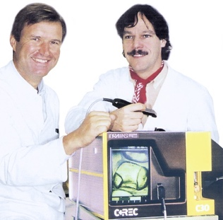 |  |  | Feldspar | 3-axis milling  Complete digital workflow  The first milling machine in dentistry | Used for simple inlay restorations, can only soft ceramic blocks milling from feldspar. | System description [1] and historical reviews [2]
CEREC 2 | Siemens Germany  1994 | CEREC SW |  |  |  | Ceramic materials (e.g., feldspathic ceramic | 3-axis milling machine  Complete digital workflow  Can produce more delicate restorations as laminate veneers | Vintage machine  Used only for simple intracoronal restorations and laminate veneers | Marginal fit values typically range from 50 to 120 micrometers [3].  Boasts a 30% fit accuracy enhancement compared with CEREC 1, with 56 µm average luting interfaces [4].
CEREC 3 | Sirona Germany  2000 | CEREC SW | 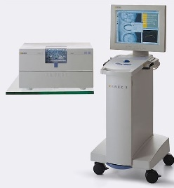 | 2 stepping motors  Step Bur 10  Step bur 12  Cylinder Pointed Bur Cylinder Bur 1.2 mm Cylinder Bur 1.6 mm | 40.000rpm | Feldspathic ceramic blocks, specifically Vita Mark II. | 4-axis milling, both wet and dry milling, complete chairside system, high precision | Limited to specific ceramic blocks (Vita Mark II), potentially limiting material options | CEREC 3 reliably produces dental restorations with good marginal fit [5].  Crowns maintain good accuracy with a luting space set at 30 µm [6].
CEREC MC X Mill | Sirona Germany  2007 | CEREC SW | 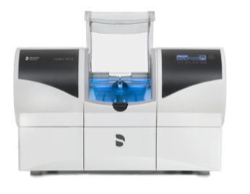 | Step Bur 12 and 12S  Cylinder Pointed Bur 12S and 12 EF  Step Bur 20  Cylinder Pointed Bur 20  Shaper 25 RZ  Finisher 10  Shaper 25 | approximately 10 minutes | Feldspar ceramic, Glass-ceramics, Full contour zirconia, Hybrid ceramic, Polymer blocks | 4-axis milling  Complete digital workflow  Precise and fast, can take 10 minutes for a single crown  Can produce a surgical guide  Can be used for lab. | The limited block size for chairside treatment. Restricted to 40 millimeters | The study found similar margin accuracy for both CEREC 3 and CEREC MC X Mill machines [5].
CEREC Primemill | Sirona Germany  2019 | CEREC Software 5 | 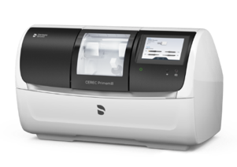 | Bur 2.5 ZrO2 CS  Bur 2.5 PMMA CS  Bur 1.0 CS  Bur 0.5 CS | about five minutes | Zirconia, glass, and hybrid ceramics | 4- axis milling  Multiple-speed, including superfast milling, finishing zirconia crown in less than 5 minutes.  Can mill a wide variety of materials. | Very expensive  Provides only dry milling  Limited to simple restorations and prostheses. | Superfast, fast, and fine milling all produce surface roughness within the acceptable range [7].
Planmeca Planmill 30s one spindle | Planmeca Oy.  Finland  2017 | Planmeca Romexis® software | 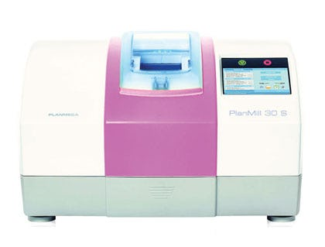 | Diamond Grinders  ( tapered, conical, ellipsoidal ) | 100,000 RPM  16 to 18 min/crown | Glass-ceramics, hybrid materials, zirconia | single-spindle milling unit designed for wet milling. Offering affordability, precision, and ease of use for dental practices. | Limited to wet processing only | Demonstrated a marginal discrepancy averaging 85-96 microns, suggesting good accuracy for ceramic restorations [8].
Planmeca Planmill 40s two spindles | Planmeca Oy.  Finland  2020 | PlanCAD Easy |  | Diamond Grinders  ( tapered, conical, ellipsoidal ) | 100,000 RPM  10 min/ crown | Ceramics, Hybrid Ceramics, Zirconia and Resin-Based Materials | 5-axis, wet and dry milling, automatic changer for 12 tools, integrated PC with touchscreen, Open platform for importing and editing files | Relatively high weight (160 lbs). | The Planmeca PlanMill 40S offers higher accuracy compared to the PlanMill 30S model [8].
Planmeca  PlanMill 35 Milling Unit | Planmeca Oy.  Finland  2023 | Planmeca PlanCAD | 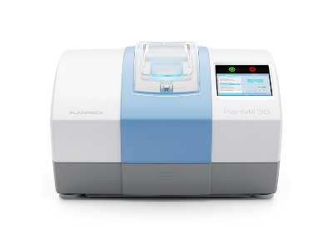 | CUTTER 1 MM BALL END  Grinder ellipsoidal tip RTI 4mm shank | 100,000 rpm /  11-13 minutes | Glass-ceramic  PMMA  Composite  Hybrid ceramic  Zirconia | 4-axis, wet and dry milling, high precision, future-proof investment, easy operation, Compatible with various parties | Require additional setup for dry milling capabilities
Planmeca  PlanMill 50 S | Planmeca Oy.  Finland  2020 | Planmeca PlanCAM™ software | 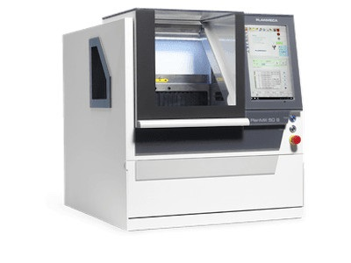 | Shaft-milling tool 1.5mm universal, 2 cutters long.  Radius milling tool PMMA/plastics (Single blade) 1.0mm and 2.5mm.  Radius milling tool Zr diamond 1.0mm and 2.5mm.  Radius milling tool Zr/PMMA/Wax 0.6mm, conical, 1.0mm, and 2.5mm.  Glass-ceramics grinding tool 1.0mm, 2.5mm, and 0.6mm, conical | 60,000 rpm time | Zirconia, IPS e.max, glass ceramics, temporary materials | 5-axis milling machine, Wet or dry processing, Handles discs or blocks, High-speed spindle, Integrated PC with touchscreen, Open platform for file formats | Relatively high initial investment cost compared to simpler milling units.
Carestream Dental  CS 3000 | Carestream Dental  United States, 2013 | Carestream Dental imaging software | 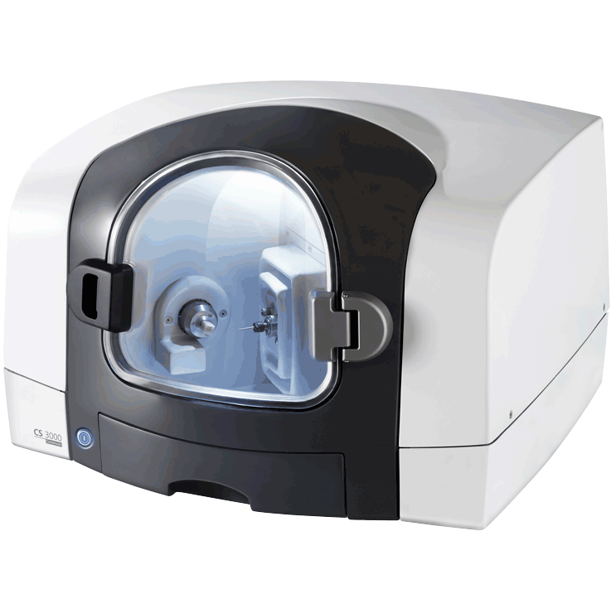 | Single bur milling  Four-axis brushless motor | Up to 60,000 RPM  15 min/ crown | VITABLOCS Mark II | 4-axis milling, wet milling, complete chairside system for single-unit restorations | Limited milling capabilities (single-unit restorations only), may require separate acquisition unit
Carestream Dental  CS 3100 | Carestream Dental  United States , 2019 | exocad ChairsideCAD software | 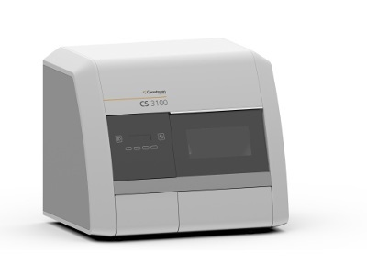 |  | Up to 100,000 rpm / Less than an hour. | Hybrid resin, ceramic, and zirconia. | A self-contained 4-axis wet milling with CAD software; Suited for crowns, bridges, inlays, onlays, and veneers; Smart Milling Queue Management | The system may limited compatibility with certain CAD software or scanners.
Chairman from Robots and Design  MAXX Series | Robots and Design  , South Korea, 2021 | Go2CAM | 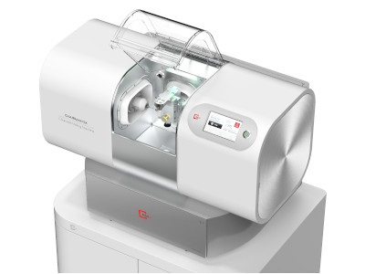 | Shank diameter : 3 mm, ATC 6 tools  3 tools for left and 3 tools for right spindles | 100,000 RPM, 8 to 15 minutes | Glass-ceramic (Lithium Silicate, Lithium Disilicate), Zirconia, PMMA, Hybrid ceramic | 3-axis with dual spindles, integrated with Exocad and featuring remote operation via MAXXLink, streamlines workflow effortlessly. Produce ultra-thin veneers (0.3 mm or less) | The lack of automatic material-changing functionality means that users must manually switch materials
Versamill the chairmaxx  From axsys dental solution | axsys dental solution, USA, 2023 | Open system | 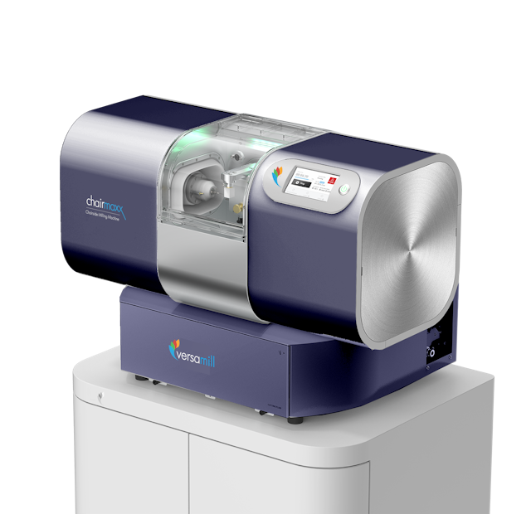 | Shank diameter : 3 mm, ATC 6 tools  3 tools for left and 3 tools for right spindles | 100,000 rpm, 8-15 minutes | glass-ceramic, hybrid-ceramic, zirconia, and PMMA. | 5-axis, easy, high accuracy (precision up to less than 20 micrometers)  Open system, compact and quiet design | Limited to wet milling only
Glidewell Laboratories  IOS TS150 Chairside Mill | Glidewell Laboratories, USA, 2013 | Open system | 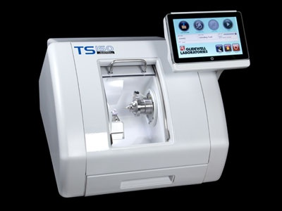 | BUR WRENCH 11mm X 9mm – 3mm shank | 150,000 RPM, 20 minutes | Obsidian™ Lithium Silicate Ceramic, BruxZir® Solid Zirconia | Open-system, for glass ceramic crowns, resin nano ceramic, and PMMA materials. | Primarily for crowns, limiting its versatility.
Ivoclar Programill one | Ivoclar vivadent , Liechtenstein , 2017 | PrograMill CAM | 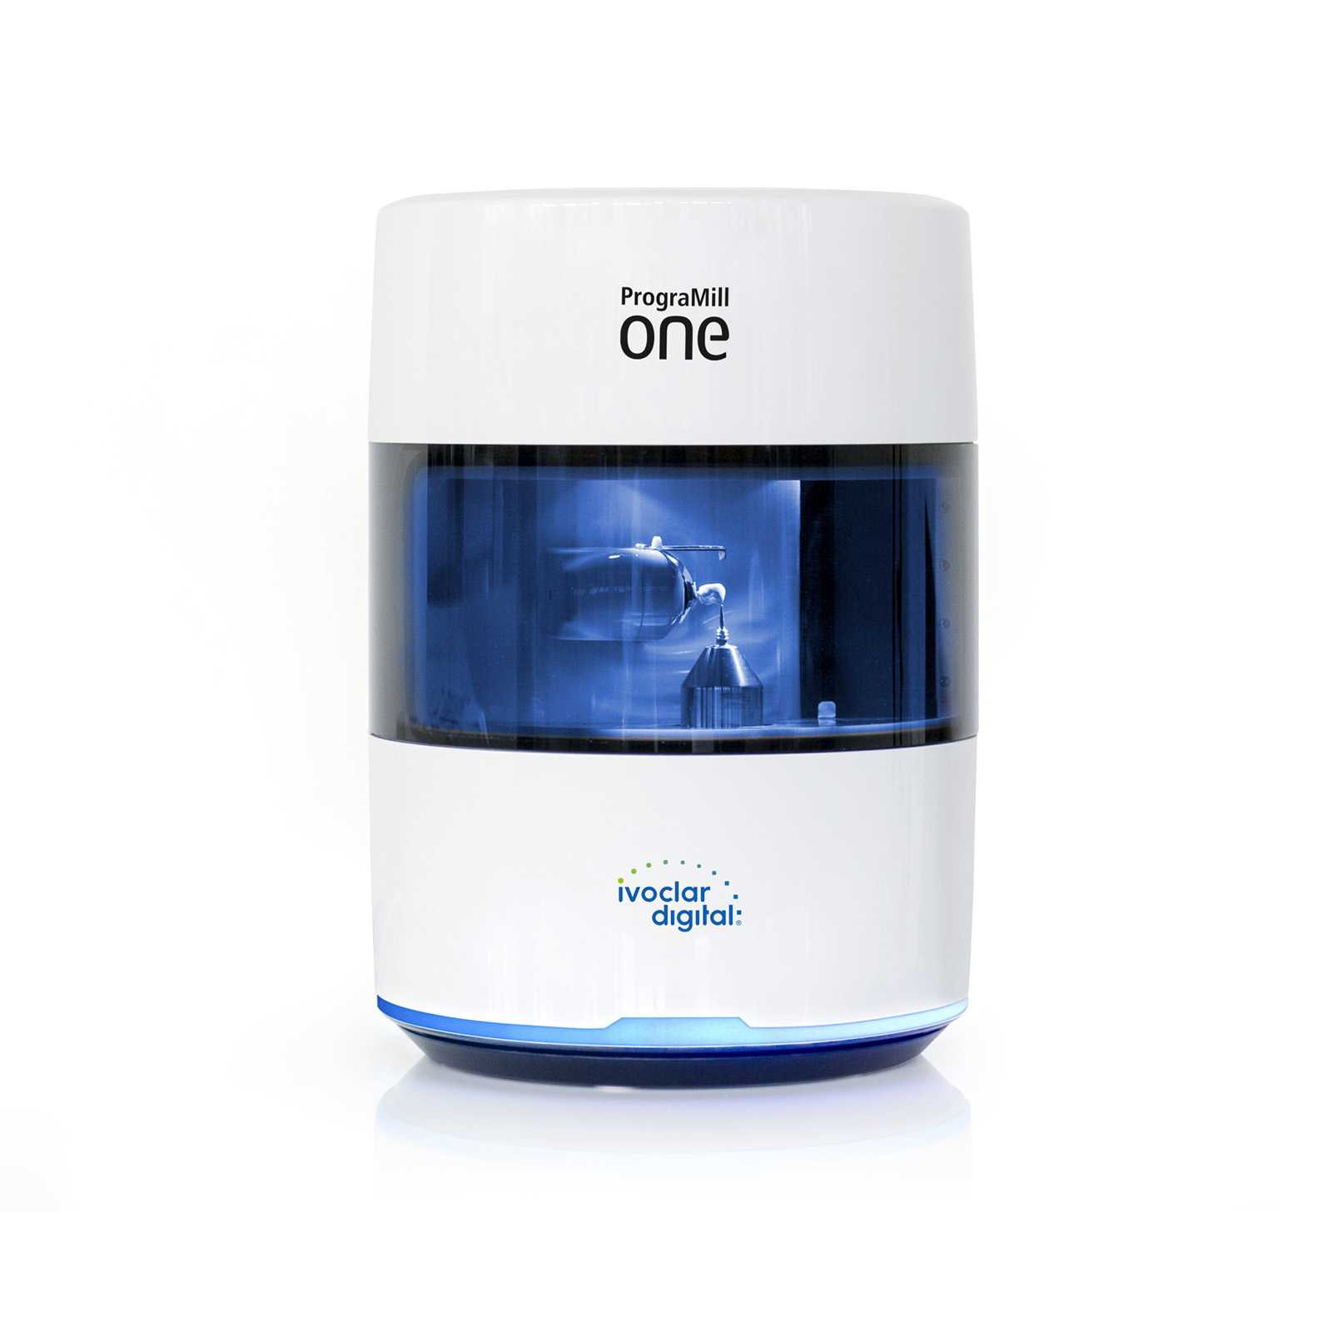 | Automatic tool changer for 8 tools | 80,000 rpm /  15-20 minutes | IPS e.max CAD, IPS e.max ZirCAD, IPS Empress CAD, Telio CAD | Compact 5-axis machine, wireless, integrated camera for data recording, 5-block magazine, 5XT technology for superior milling quality | Limited to milling single units, restricted to Ivoclar Blocks for material compatibility
VHF N4+ | vhf, Germany, 2015 | DENTALCAM | 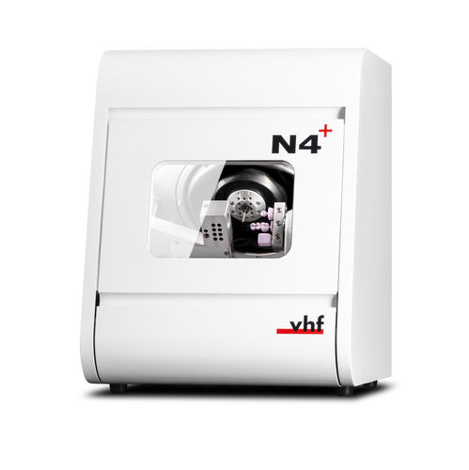 | Radius cutter, cylindrical and torus cutter, grinding tools different (zirconia, glass ceramic, resin, metal)  Specific sizes: 0.6mm, 1.0mm, 1.2mm, 2.0mm, 2.4mm) | Up to 80,000rpm | Glass-ceramic, composite, zircon, CoCr, titanium abutments | 4-axis, Wet grinding, Ultra-compact, premium spindle with four-fold ball bearing for high concentricity, Precision with 3 μm repetition accuracy, Water-cooled spindle | High initial cost
VHF E4 | vhf, Germany, 2023 | DENTALCAM | 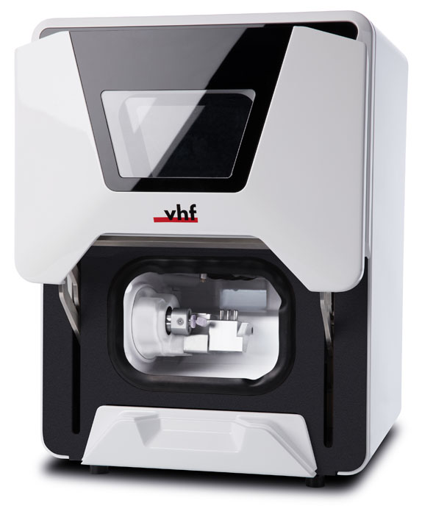 | Radius cutter, cylindrical and torus cutter, grinding tools different (zirconia, glass ceramic, resin, metal)  Specific sizes: 0.6mm, 1.0mm, 1.2mm, 2.0mm, 2.4mm) | 60,000 rpm | Glass-ceramics, PMMA, zirconia, composites, plastics | 4-axis wet and dry milling,- 3 μm repetition accuracy,  Suitable for almost all block materials up to 45 mm, Sustainable operation with PURE WATER technology- Compact and easy to install anywhere | Limited to block materials only, no disc milling
VHF Z4 | vhf, Germany , 2020 | DENTALCAM | 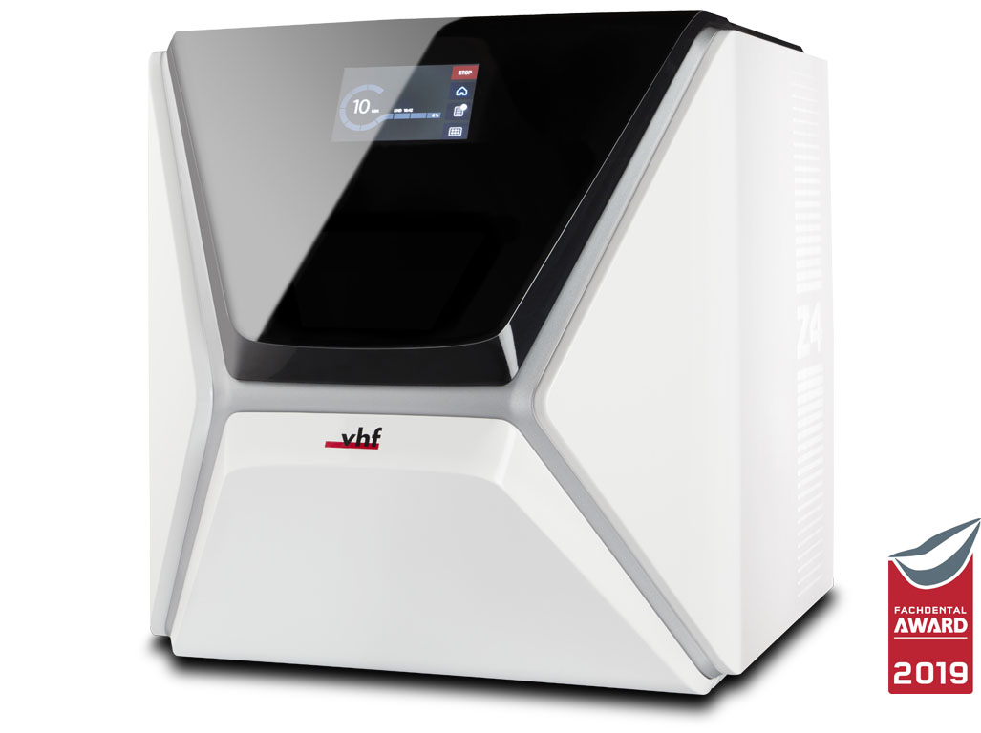 | Radius cutter, cylindrical and torus cutter, grinding tools different (zirconia, glass ceramic, resin, metal)  Specific sizes: 0.6mm, 1.0mm, 1.2mm, 2.0mm, 2.4mm) | Up to 100,000 rpm, restorations in under 10 minutes | Glass-ceramic, PMMA, zirconia, composite, titanium abutments, CoCr | 4-axis wet milling, ultra-compact housing with closed fluid circuit, Premium spindle with four-fold ball bearing for high concentricity, Precision with 3 μm repetition accuracy | High initial cost, limited to wet milling
Dynamic Chairside milling machine | Dynamic Medical Technology, China, 2023 |  | 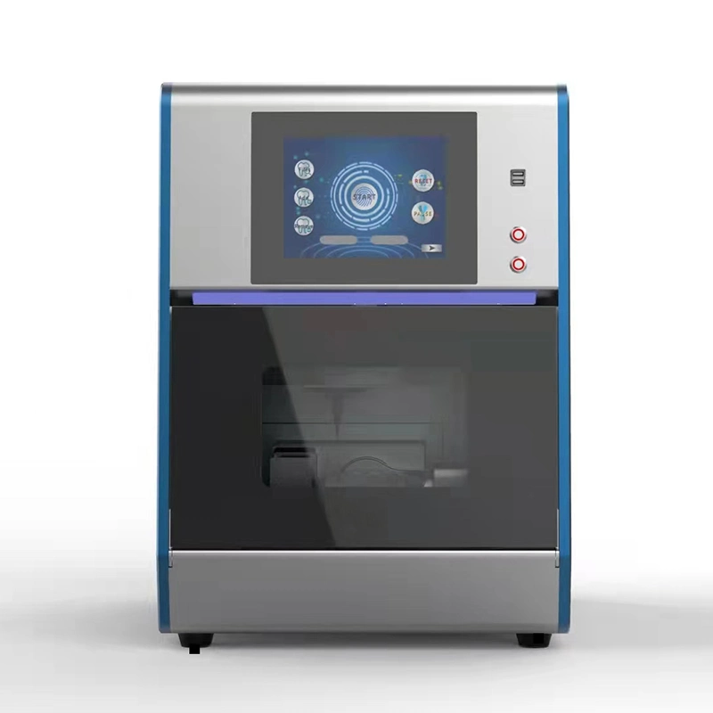 | Three models included: 0.5mm, 1.0mm, 2.0mm. | Up to 60,000 rpm / | Zirconia, PMMA, Wax, Hybrid, feldspathic and glass ceramics, etc. | Five-axis wet and dry milling, high precision spindle, large angle cutting, compact design, flexible and efficient cutting thickness down to 0.3mm for ultra-thin veneer. | Air compressor required (minimum air pressure 0.45Mpa), limited to three bur sizes.
LEOMED TECHNOLOGY Chairside milling machine | LEOMED TECHNOLOGY, China |  | 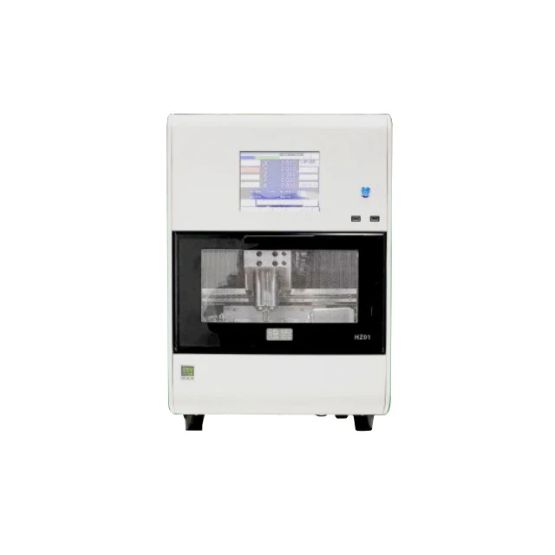 | 4mm diameter, 8 station tool magazine capacity |  | Titanium columns, glass ceramics, wax, resin, zirconia, etc | 5-axis milling machine, Automatic tool changer, Water cooling system for increased production capacity, Stable performance, small error, and high precision | High initial cost
imes-icore CORiTEC one chairside milling machine | imes-icore, Germany, 2018 | iCAM one | 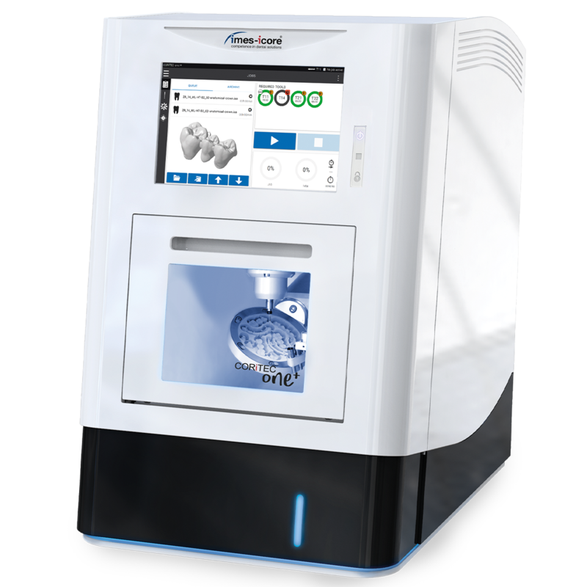 | 0.6mm, 1.0mm, 2.5mm, and 4.0mm dental milling burs with 3mm or 6mm shank, 1 flute, available for various imes-icore systems | 100.000 rpm, less than 15 minutes | Sintered and pre-sintered zirconia, pre-milled abutment (Ti and CoCr), glass- and hybrid ceramic, composite, polyetheretherketone (PEEK), PMMA, wax | 5-axis dry milling, ergonomic handling with 10.1", self-sufficient, Auto-calibration, and cleaning, automatic tool changer, integrated PC with windows | Limited to 1 block or 1 pre-milled abutment at a time
CDM5C | Shenzhen Comment Medical Technology Co, China, 2022 | Open system | 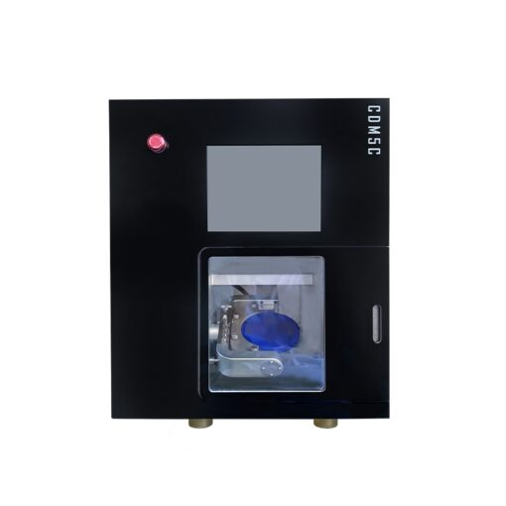 | Dental milling tools: 45mm length, 4mm shaft diameter, sizes: 0.6mm, 1.0mm, 2.0mm | 60,000 rpm | zirconia, PMMA, PEEK, and wax blocks | 5-axis dry milling. Compatibility with open dentistry CAD/CAM systems.  It delivers high-quality restoration | Limited to dry milling only.
DDS  Speed+ | DDS Inc, South Korea, 2020 | D+ CAM Software | 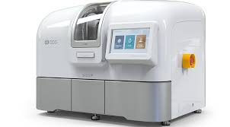 | DDS Bur only | 60,000 rpm/  13 minutes. | Glass Ceramic, Lithium Disilicate, Hybrid Materials, PMMA, Modeling wax | 4-axis, wet milling, 1.8-2.2KW spindle power, 60,000 rpm spindle speed, water cooling, high precision and durability, servo motor, persistent operation | Limited to wet milling only, heavyweight 116 kg.
Jiny  F5Z-5 | Shanghai Jiny CAD/CA, China , 2023 |  | 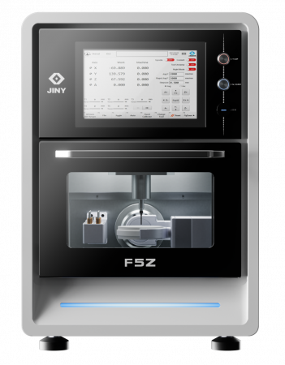 |  | Up to 60,000 rpm، 10-20 minutes per piece | Zirconia, PMMA, PEEK, wax, HPP, etc. | 5-axis milling, for teeth and implant-supported restorations,  . 90-degree anterior teeth milling,  B-axis tilt angle up to +/-30°, 8 tools, and servo motors | Limited to dry milling only.
Jiny  F5G | Shanghai Jiny CAD/CA, China , 2023 |  | 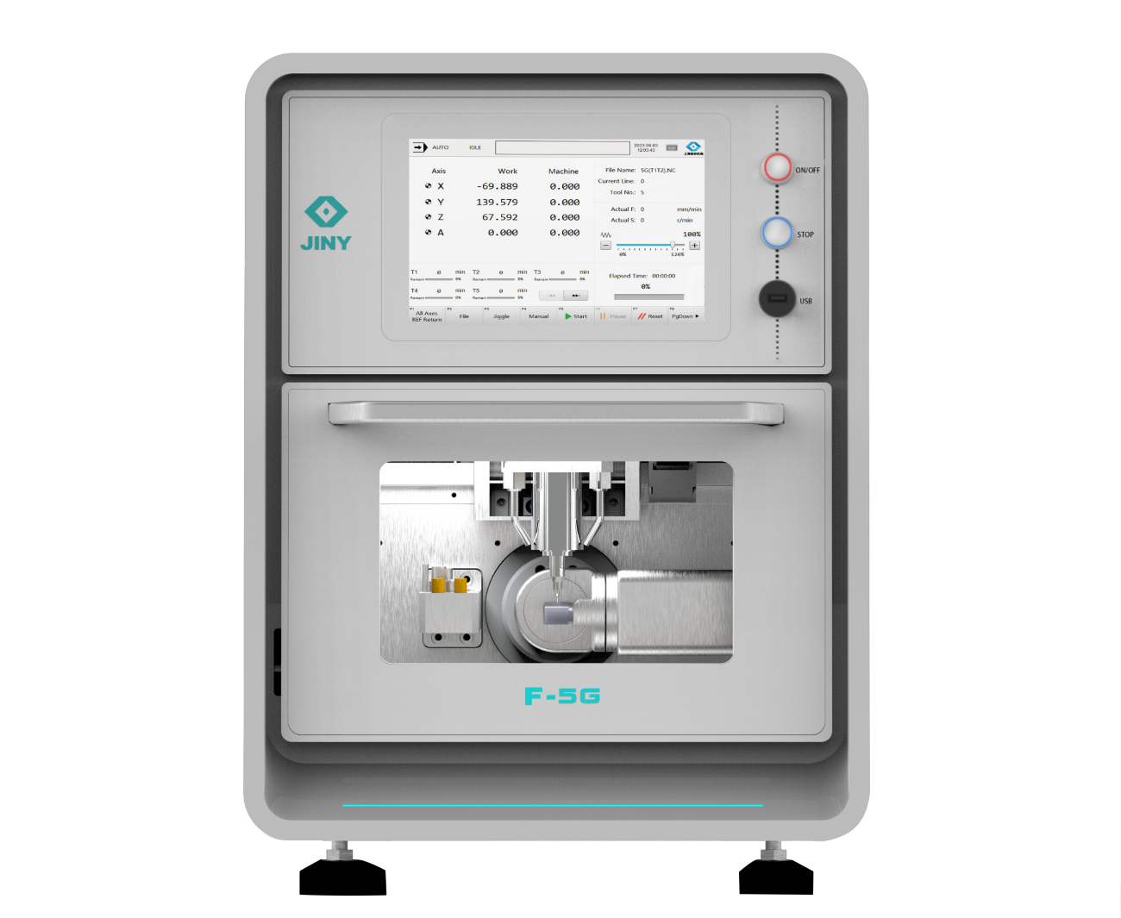 |  | Up to 60,000 rpm, 10-20 minute | Zirconia, PMMA, PEEK, wax, HPP, etc. | 5-axis milling, various single restorations, and bridges including veneer (0.2mm thickness), implant bridge (All-on-4 or all-on-6 bridge), and screw-retained zirconia crown. With a B-axis tilt angle up to +/-30°, 8 tools magazines, | Limited to wet milling only.
Jiny  F4T | Shanghai Jiny CAD/CA, China , 2023 |  | 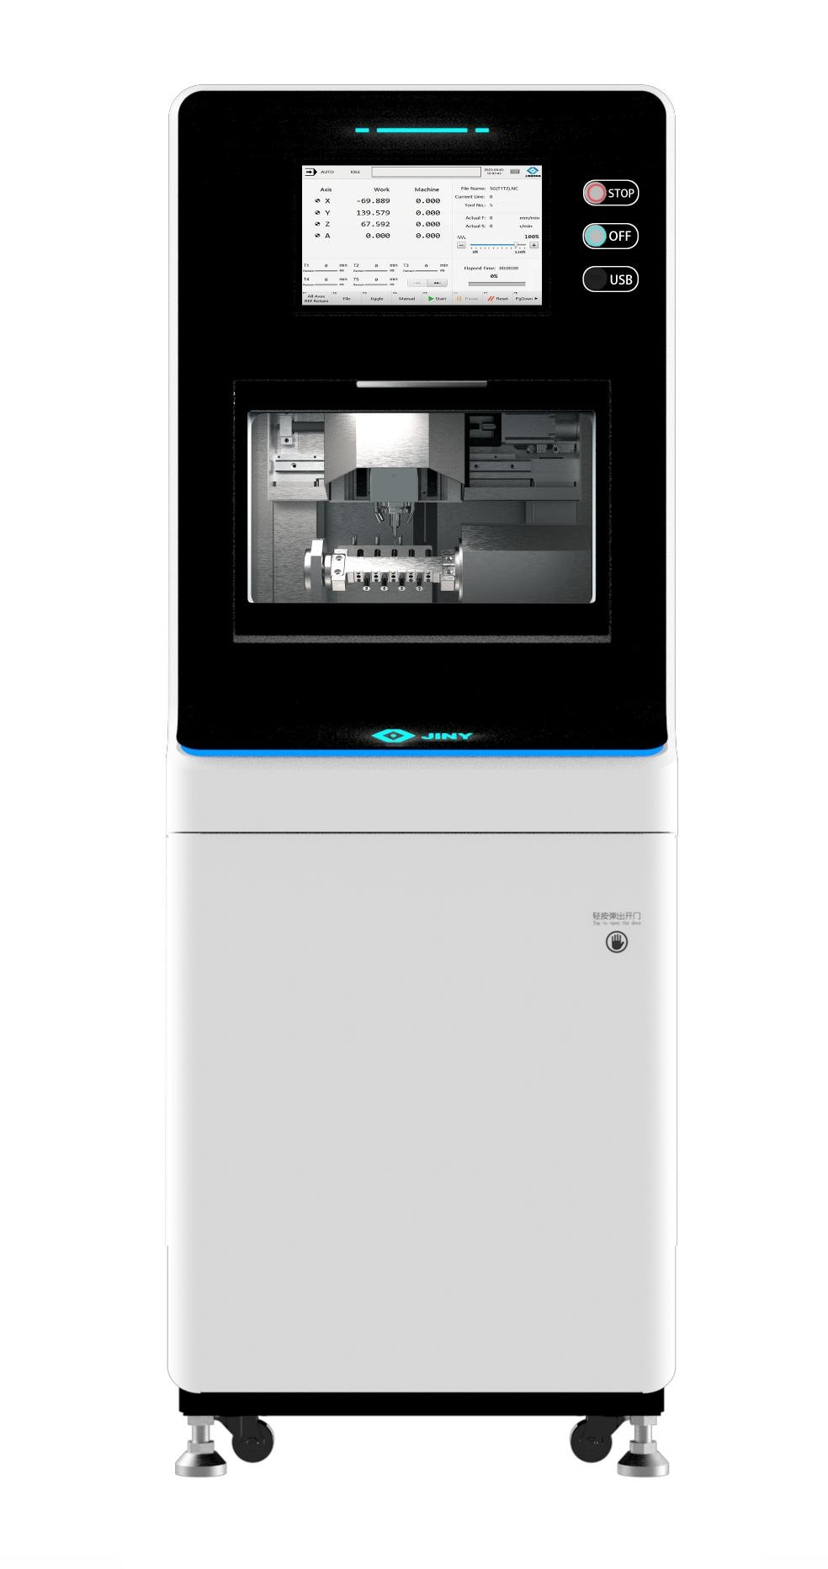 |  | Up to 60,000 rpm, 10-20 minute | Zirconia, Wax, PMMA, Soft Metal, PEEK, Titanium Premill Abutment, Glass Ceramics | 4-axis wet milling, High precision, and durability, Servo motor with built-in absolute encoder and auxiliary support, Suitable for dental laboratories and clinics | Heavyweight (400kg)
*The image of the CEREC1 machine showed the photos of the brilliant inventors of the CEREC systems and the fathers of the CAD/CAM in dentistry to the left Prof. Dr. Werner Mörmann and the right Dr. Marco Brandestini

References:

[1] Abdullah A, Muhammed F, Zheng B, Liu Y. An overview of computer aided design/computer aided manufacturing (cad/cam) in restorative dentistry. Journal of Dental Materials and Techniques 2018/03/01;7.
[2] Stutes RD. The history and clinical application of a chairside cad/cam dental restoration system. Shanghai Kou Qiang Yi Xue 2006;15:449-55.
[3] Kakade P, Zambre G, Mhatre S, Srichand R, Joshi M, Gholap P. Evolution of intraoral scanners in dentistry: An overview. Chem Bull 2023;12:4267-76.
[4] Andersson M, Razzoog ME, Oden A, Hegenbarth EA, Lang BR. Procera: A new way to achieve an all-ceramic crown. Quintessence Int 1998;29:285-96.
[5] Afiqah Hamzah N, Razak NAA, Sayuti Ab Karim M, Gholizadeh H. A review of history of cad/cam system application in the production of transtibial prosthetic socket in developing countries (from 1980 to 2019). Proc Inst Mech Eng H 2021;235:1359-74.
[6] Vafaee F, Firouz F, Mohajeri M, Hashemi R, Ghorbani Gholiabad S. In vitro comparison of the accuracy (precision and trueness) of seven dental scanners. J Dent (Shiraz) 2021;22:8-13.
[7] Nedelcu R, Olsson P, Nystrom I, Ryden J, Thor A. Accuracy and precision of 3 intraoral scanners and accuracy of conventional impressions: A novel in vivo analysis method. J Dent 2018;69:110-8.
[8] Emir F, Ayyildiz S. Evaluation of the trueness and precision of eight extraoral laboratory scanners with a complete-arch model: A three-dimensional analysis. J Prosthodont Res 2019;63:434-9.
[9] Nulty AB. A comparison of full arch trueness and precision of nine intra-oral digital scanners and four lab digital scanners. Dent J (Basel) 2021;9.
[10] Ezmek B, Sipahi OC. Evaluation the scanning accuracy of blue-light laboratory scanners in complete edentulous maxilla with multiple implants with titanium scan bodies. Odovtos - International Journal of Dental Sciences 2023:360-71.
[11] Diker B, Tak Ö. Accuracy of six intraoral scanners for scanning complete-arch and 4-unit fixed partial dentures: An in vitro study. J Prosthet Dent 2022;128:187-94.
[12] Diker B, Tak Ö. Accuracy of digital impressions obtained using six intraoral scanners in partially edentulous dentitions and the effect of scanning sequence. Int J Prosthodont 2021;34:101-8.
[13] Gurpinar B, Tak O. Effect of pulp chamber depth on the accuracy of endocrown scans made with different intraoral scanners versus an industrial scanner: An in vitro study. J Prosthet Dent 2022;127:430-7.
[14] Ender A, Zimmermann M, Mehl A. Accuracy of complete- and partial-arch impressions of actual intraoral scanning systems in vitro. Int J Comput Dent 2019;22:11-9.

