Supplementary information

Title: Advanced subtractive manufacturing, micromilling, and laser micromachinery in dentistry: Current applications, limitations, and future perspectives.

Authors (blinded)

Supplementary Table 2.
The mostly known laboratory milling machines with a brief description

Main package | Model name | Company  And country | CAM driving software | Milling speed | Automatic change  Tool/ material | Milling time for a single crown | Fabrication Materials | View | Main features | Drawbacks
CEREC | inLab MC X5 Dental Mill | Sirona Germany | CEREC SW | Max. 60,000 rpm | Automated tool changer for six tools. | Zirconia crown 20 to 40 minutes | Zirconia, polymers, composites, wax, CoCr, titanium, PMMA, glass hybrid ceramic, lithium disilicate. | 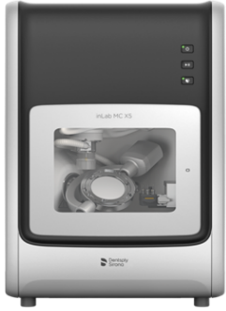 | 5-axis dry and wet production, multi-block holder, Spindle Touch Technology for precision, open system with CAM module, seamless dry-to-wet transitions, intelligent suction, and tool cleaning. | Requires compressed air (min. 50 l/min); noisy with PMMA milling.
CEREC | inLab MC X Milling Unit | Sirona Germany | CEREC Software |  | Equipped with 2 motors and a touchscreen interface. | Approximately 11 minutes | Plastic, ceramic, metal, and zirconia. | 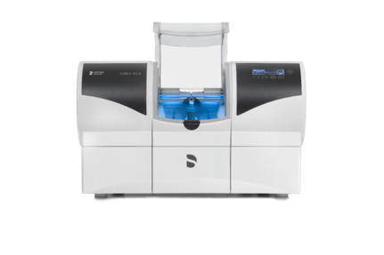 | 4-axis wet and dry milling, high precision, integrated vacuum system. | Restricted to specific block sizes.
CEREC | inLab MC XL Milling Unit | Sirona Germany | CEREC Software | 42,000 rpm | Equipped with 4 motors and a touchscreen interface. | 4-12 minutes | Plastic, ceramic, metal, and zirconia. | 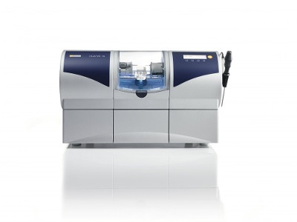 | 4-axis milling with extra-fine grinding, wet and dry processing, and integrated vacuum. | High cost, restricted to specific block sizes, frequent software updates required.
Planmeca | Planmill 60s | Planmeca, Finland | PlanCAM™ software | 60,000 rpm | Automatic 10-tool changer. | Average milling time for a molar crown (IPS e.max 20 min | Zirconia, PMMA, wax, lithium disilicate, glass ceramics, hybrid ceramics, feldspar ceramic, titanium, and cobalt-chrome | 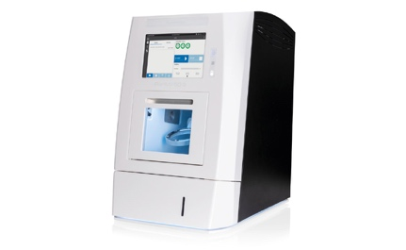 | 5-axis wet and dry milling for discs, blocks, and abutments, with precision for restorations, bars, splints, and dentures. Features C-clamp adapter, open architecture, and tool wear indicator. | High cost; complex setup for new users.
Planmeca | Planmill 50s | Planmeca, Finland | PlanCAM™ software | 60,000 rpm | Automatic 12-tool changer. | 10-15 minutes | Lithium disilicate, glass ceramics, zirconia, PMMA, and wax. | 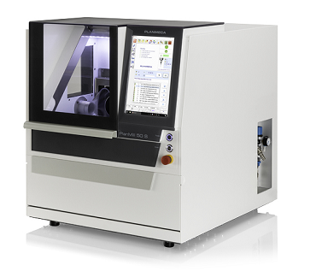 | Similar to PlanMill 60S with an automatic bur changer for 10 tools. | Lower precision than PlanMill 60S.
Planmeca | Planmill 30S | Planmeca, Finland | PlanCAM | 100,000 rpm | 5-tool capacity. | Average milling time for molar crown (IPS e.max)  11 min | Glass-ceramics, PMMA, composites, hybrid ceramics, and zirconia. | 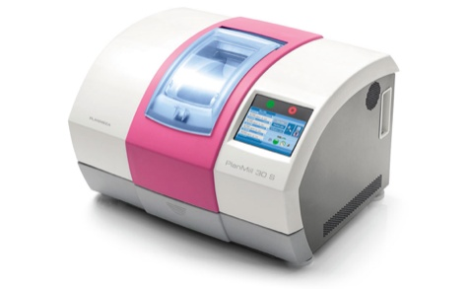 | 4-axis wet milling for crowns, inlays/onlays, veneers, bridges (up to 6 units), and hybrid abutments | Lower precision and slower milling speeds compared to 40S and 35.
Planmeca | Planmeca PlanMill® 35 | Planmeca , Finland | PlanCAM™ software | 100,000 rpm | 5-tool capacity. | Average milling time for molar crown (IPS e.max)  11 min | Zirconia, composites, ceramics, PMMA, and hybrid composites. | 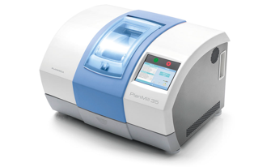 | 4-axis wet and dry milling for crowns, inlays/onlays, veneers, bridges (up to 6 units), and hybrid abutments.  Hybrid abutment crowns (Viteo).  Tool wear indicator.  The single-spindle uni. | Good precision but slower speed and lower accuracy than 40S.  The milling speed is generally slower than the 40 S.
Planmeca | Planmill 40S | Planmeca, Finland | PlanCAM™ software | 100,000 RP | Equipped with a 10-tool changer. | 10 minutes | Ceramics, Hybrid Ceramics, Zirconia, and Resin-Based Materials | 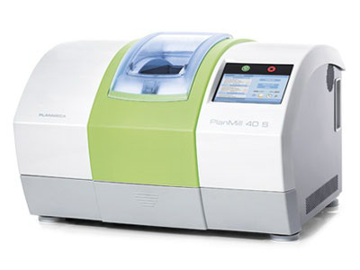 | Designed for dental clinics with 4-axis dual spindles and linear motion. Supports crowns, veneers, bridges (up to 6 units), and hybrid abutment crowns. | High cost
Dentsply Sirona | Cercon® brain expert | Dentsply Sirona, Germany | Cercon Art Version 3.0.3 software | 60,000 rpm | Automatic tool changer | NA | Translucent zirconia | 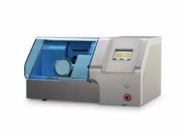 | 4-axis milling with a linear drive motor for high-speed precision supports up to 9 burs and automatic tool exchange for unattended milling. Accommodates up to 30 units per disc, including 16-unit bridges. Includes Cercon eye scanner, Cercon art software, and sintering ovens. | Limited to zirconia; a closed system with high cost.
Zenotec | Zenotec Mini Milling Machine | WIELAND Dental, Germany | Zenotec CAM program | Up to 60,000 rpm | 6-tool capacity | NA | Zirconia, acrylic, wax | 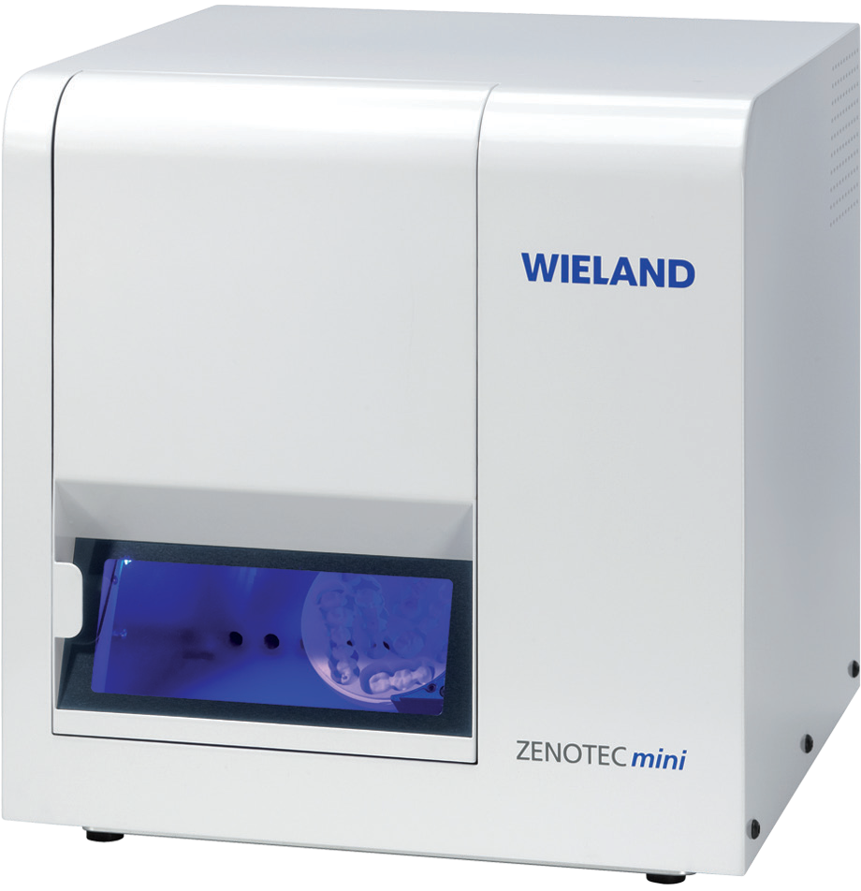 | 4-axis milling with high-speed spindle and AC servo motor for zirconia, acrylic, and wax. Offers high precision, minimal post-processing, and long-term calibration stability. | Cannot process metal materials.
Zenotec | Zenotec select | WIELAND Dental, Germany | Zenotec CAM program | 60,000 rpm | Equipped with a 16-tool changer. | NA | Ceramics, Acrylic resins (PMMA, PU), Wax | 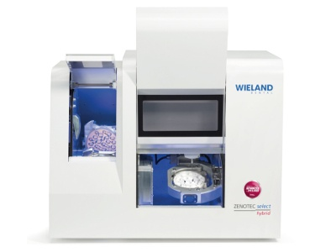 | 5-axis simultaneous milling with an 8-disc changer, wet and dry grinding, high precision, and efficient tool management. | High cost; steep learning curve for operation and maintenance.
Ceramill | Motion 2 Milling Machine | AmannGirrbach GmbH , Germany | Millbox | 100,000 rpm | 6-tool capacity with replacement tool management. | NA | Polymers, Metals, Zirconia | 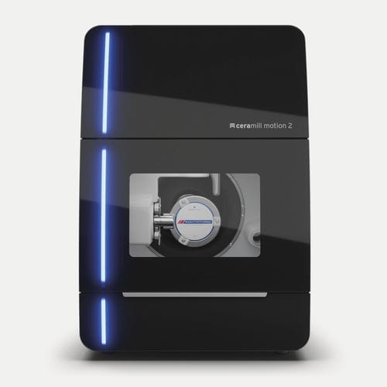 | 5-axis wet and dry milling for high-performance grinding, carving, and full denture processing. Features rotational titanium milling and protected electronic components for wet operation. | High power usage; costly initial setup.
Ceramill | Ceramill Motion 3 | AmannGirrbach GmbH , Germany | Millbox | 100,000 rpm | Fully automated 6-tool changer with sister tool management. | NA | Dental wax, zirconia, dental composites, ceramics, PMMA | 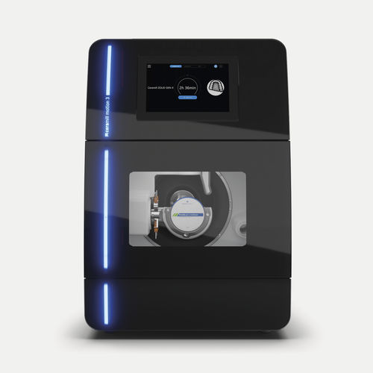 | 5-axis hybrid milling for versatile materials and indications. Features workflow optimization, HMI and RFID technology, and advanced carving for dental arch restorations. | High power usage; costly initial setup.
Ceramill | Ceramill Motion DRS | AmannGirrbach GmbH , Germany | Ceramill Mind DRS design software | 100,000 RPM | 5-tool RFID changer for intelligent management. |  | Compatible with Polymers, Ceramics, and Zirconia blocks | 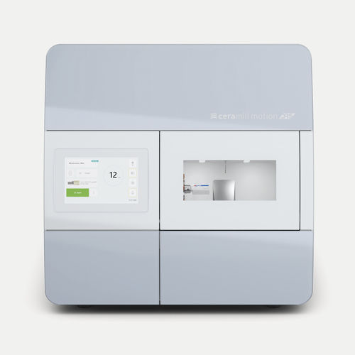 | 4-axis wet milling for custom restorations with a 2.7kW spindle, ideal for dental labs. Supports titanium blanks, metal discs, and glass ceramics with minimal post-processing. | Limited to 4-axis control and wet processing mode.
Ceramill | Ceramill Matron | AmannGirrbach GmbH , Germany | Match 2.0 software | 80,000 RPM | 8-tool RFID blank changer. | NA | Plastic, metal, ceramics, hybrids, zirconia | 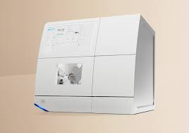 | 5+3-axis control with Vmax arm, curved touch display, RFID technology, HD camera, and zero-point clamping system. | high cost
VHF | E3 | Vhf Germany | TRIMCAM software | spindle with 60,000 RPM | ONETOOL technology eliminates the need for tool changes. | Processing of aligners in under 60 seconds | Thermo-formed plastic foil | 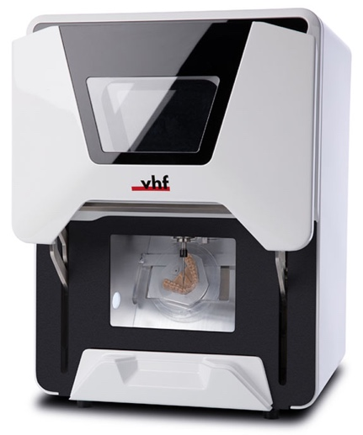 | 4-axis milling for wet and dry machining, AIRTOOL for no compressed air, and 3 μm accuracy. PUREWATER technology removes the need for grinding additives. | Limited to dry milling.
VHF | bes | Vhf Germany | DENTALCAM | 60,000 rpm | Equipped with a 6-tool AIRTOOL system. | NA | Composites, plastics/wax, glass ceramics, zirconia.  PMMA | 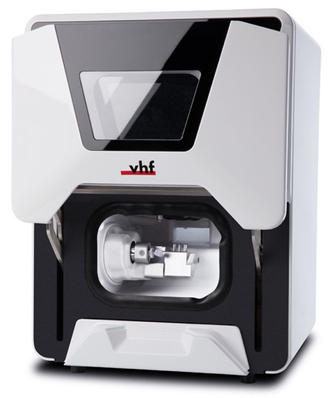 | 4-axis milling for wet and dry machining with 3 μm accuracy. Features AIRTOOL for no compressed air, PUREWATER for grinding additive-free cooling, and integrated block holder for crowns, bridges, veneers, and abutments. | May struggle with niche materials or large restorations; slower milling speeds.
VHF | E5 | Vhf Germany | DENTALCAM | 60,000 rpm | 16-tool AIRTOOL system. | NA | Composites, plastics/wax, zirconia, CoCr sintered metals | 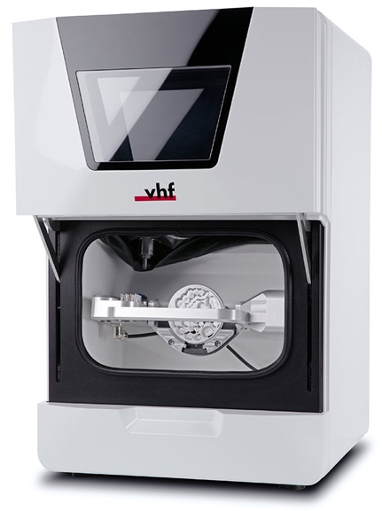 | 5-axis dry machining for dental labs with 3 μm accuracy. Features AIRTOOL for no compressed air supports discs and blocks and handles crowns, bridges, dentures, abutments, surgery guides, and more. | Limited to dry machining; slower milling speed.
VHF | N4+ | Vhf Germany | DentalCAM | 80,000 rpm | 8-tool capacity. | NA | Glass-ceramics, titanium, zirconia, composites, plastic materials | 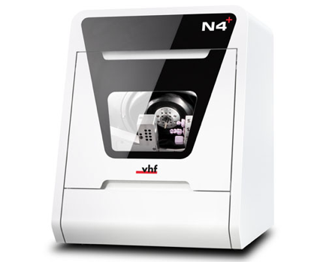 | 4-axis wet machining for dental labs with a high-frequency spindle and pneumatic tool clamping. Ensures 3 μm accuracy, supports up to three blocks, and features PUREWATER technology for grinding additive-free cooling (except titanium). | Limited to wet milling.
VHF | K5+ | Vhf Germany | DENTALCAM | 60,000 rpm spindle | 16-tool capacity | NA | Plastic materials, wax, zirconia, composites, CoCr, model plaster | 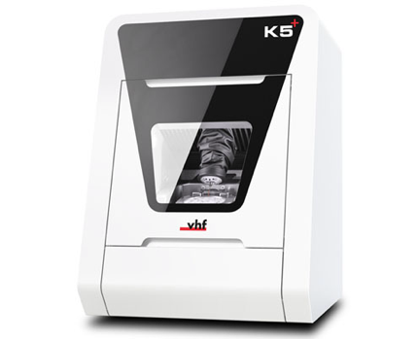 | 5-axis dry machining with 3 μm accuracy. Features remote support camera, 30-tool ATB, 3-fold block holder, and tool-free blank clamping for efficient changes. | Limited to dry milling
VHF | S5 | Vhf Germany | DENTALCAM | 60,000 rpm | 16-tool capacity with 8-position blank changer. | NA | Plastic materials, wax, zirconia, composites, CoCr, model plaster, glass ceramics, titanium, PMMA | 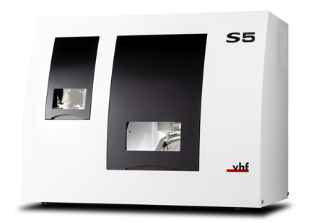 | 5-axis wet and dry machining for dental labs with 3 μm accuracy. Includes ionizers for static control, QuickFrame magnetic disc holder, and high-frequency spindle with pneumatic tool clamping. | The milling speed is generally slower than the other machine
VHF | Z4 | Vhf Germany | DENTALCAM | 100,000 rpm | 6-tool capacity. | under 10 minutes | Glass-ceramics, titanium, zirconia, composites, plastic materials  CoCr | 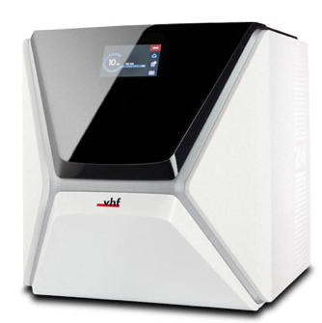 | 4-axis wet machining for dental labs with 3 μm accuracy, PUREWATER technology, and integration with TRIOS and exocad ChairsideCAD. Features a camera system, high-frequency spindle, and titanium abutment blank compatibility. | Limited to wet milling.
VHF | R5 | Vhf Germany | DENTALCAM | 80,000 rpm | Supports 10 discs, 60 blocks, or 60 prefab abutments. | NA | Plastic materials, wax, zirconia, composites, CoCr, model plaster, glass ceramics, titanium | 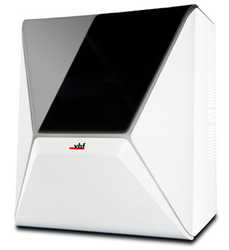 | 5-axis wet and dry machining with 3 μm accuracy. Features DIRECTCLEAN technology, remote monitoring webcam, and high-frequency spindle. | High initial cost
Programill | Programill PM3 | Ivoclar Vivadent, Liechtenstein | PrograMill CAM Software | 60,000 rpm | 13-tool automatic changer. | NA | Glass-ceramics, zirconium oxide, PMMA, composite resin, PEEK, gypsum, CoCr sinter metal, fiber-reinforced resin, and others | 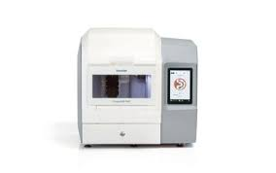 | 5-axis wet and dry milling with RFID material management, touchscreen display, PrograMill CAM software, and Ivoclar Monitoring App compatibility. | High initial cost
Programill | Programill PM7 | Ivoclar Vivadent, Liechtenstein | PrograMill CAM Software | 60,000 rpm | 20-tool automatic changer. | NA | Glass-ceramics, zirconium oxide, PMMA, composite resin, PEEK, gypsum, CoCr sinter metal, fiber-reinforced resin, and others | 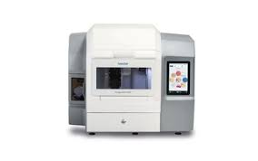 | 5-axis wet and dry milling with hybrid operation, RFID material management, self-cleaning, and high-performance spindle. Compatible with PrograMill CAM and Ivoclar Monitoring App. | High initial cost
DWX series | DWX-4 Compact Dental Mill | Roland DG, Japan | EasyShape CAM Software | 6,000 to 30,000 rpm | 2-tool changer (optional 4-tool capacity). | NA | Wax, PMMA, zirconia, hybrid ceramic, resins | 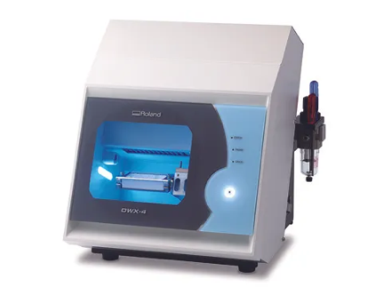 | 4-axis milling with one-button operation, automatic tool changer, VPanel, open architecture, and dust control system. | Limited tool capacity.
DWX series | DWX-42W plus | Roland DG, Japan | MillBox | 15,000 to 60,000 rpm | 6-tool automatic changer. | NA | Composite resin, glass ceramics, Amber Mill Direct, Chairside Zirconia | 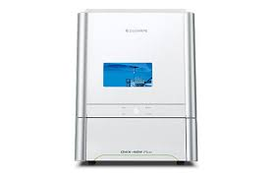 | Wet milling of harder materials with high precision and remote management via DGSHAPE CLOUD. Includes dual filters, coolant tank, and CAM software. | High initial cost, wet milling only, limited to certain materials.
DWX series | DWX-52DC | Roland DG, Japan | MillBox | 15,000 rpm | 6-disc Automatic Disc Changer with 15-bur capacity. | NA | Zirconia, wax, PMMA, composite resin, PEEK, gypsum, CoCr sinter metal, fiber-reinforced resin | 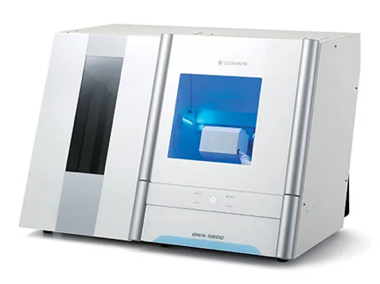 | 5-axis milling with a 6-disc changer, 15-bur capacity, unattended overnight milling, automatic calibration, and an adjustable air pressure system. | High initial cost
DWX series | DWX-52D Plus | Roland DG, Japan | hyperDENT, MillBox | 6,000 to 30,000 rpm | 15-tool automatic changer. | NA | PMMA, zirconia, composite resin, PEEK, CoCr sinter metal, gypsum, glass fiber reinforced resin | 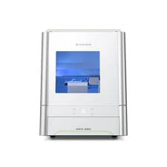 | 5-axis milling with redesigned spindle, Snap-In Clamp System, pre-loadable adapters, ITC, remote management via DGSHAPE CLOUD, and internal dust collection. | High initial cost, dry milling only
DWX series | DWX-53DC | Roland DG, Japan | hyperDENT, MillBox | Up to 60,000 rpm | 6-disc Automatic Disc Changer. | NA | PMMA, zirconia, wax, composite resin, PEEK, CoCr, etc | 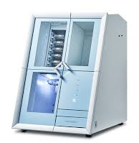 | 5-axis milling with redesigned spindle, remote monitoring, integrated webcam, and eco-system with extraction unit. Offers 24-hour unattended milling. | High initial cost, dry milling only
MAXX Series | DS200-4WX | Robots and Design, South Korea | open system | 60,000 RPM | Tool-specific support. | NA | Metal, Ti pre-mills, CoCr, Zirconia, Wax, PMMA, Hybrid ceramic, Glass ceramic | 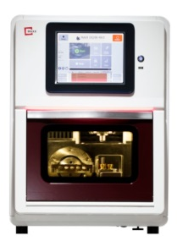 | 4-axis wet milling for custom abutments with a 2.7kW spindle. Designed for dental labs with long-term calibration stability and reduced post-processing. | Limited for wet milling.
MAXX Series | DS200-5Zc Dental Mill | Robots and Design, South Korea | open system | 60,000 RPM | Tool-specific support. | NA | Zirconia, Wax, PMMA, Hybrid ceramic | 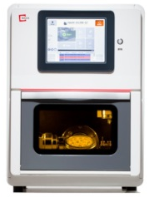 | 5-axis dry milling for precise zirconia milling with reduced post-processing and long-term calibration stability. | Limited for dry milling.
MAXX Series | DM200-5M Dental Mill | Robots and Design, South Korea | MAXX CAM Software | Up to 60,000 rpm | Auto-loader can load up to 20 disc-type materials | NA | Metal disc, Ti pre-milled blank, model, zirconia, etc. | 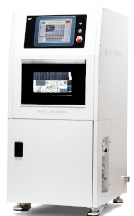 | 5-axis wet and dry milling with high productivity and optimized for complex prostheses. Features user-friendly software and remote services. | Heavy and requires significant space.
MAXX Series | DM200-5AW Dental Mill | Robots and Design, South Korea | MAXX CAM Software | Up to 60,000 rpm | Auto-loader for multiple pre-milled bars and discs | NA | Pre-milled blank & metal, zirconia, wax, PMMA, hybrid ceramic | 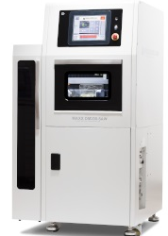 | A 5-axis industrial mill designed for wet machining, specialized for hard materials, granite base for high stability, spindle with 1.2 KW (max 2.7 KW), embedded PC controller, AC servo motor, suitable for Ø98 discs. | Heavy and requires significant space.
Tizian milling machine | Tizian 1.5 Pro | Schütz Dental , germany | Tizian CAM Software | 100,000 rpm | 10-tool automatic changer. | NA | Wet and dry machining, metal processing | 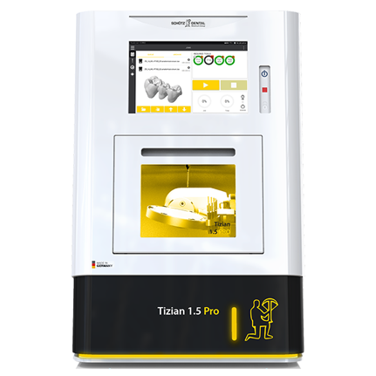 | 5-axis simultaneous machining with auto-calibration, cleaning, and compact design. Suitable for turn-milling and grinding. | High initial investment
Tizian milling machine | Tizian 5.5 Loader | Schütz Dental , germany | Tizian CAM Software | NA | 15-blank automatic loader. | NA | Non-precious metals, titanium, zirconium dioxide, aluminum oxide, PMMA, plastics, PEEK, composites, wax, glass ceramics/hybrid ceramics, sintered metal | 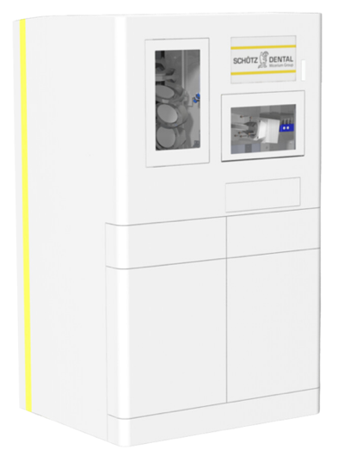 | 5-axis milling with a 3.6 kW spindle for high-speed precision. Features water nozzles for cooling, vibration-minimizing clamping, 20-slot tool bench, and improved suction and coolant drainage for maintenance ease. | high initial cost
Tizian milling machine | Tizian Cut 5 Smart | Schütz Dental , germany | Tizian CAM Software | Up to 60,000 rpm | 16-tool automatic changer | NA | Wax, CoCr, PMMA, composites, zirconia reinforced composites, PEEK, zirconium dioxide | 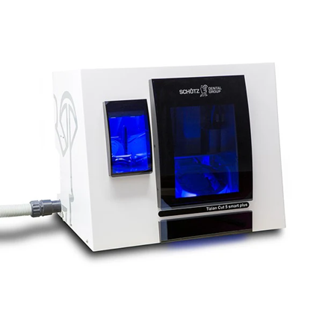 | Mills up to 300 units with an 8-unit blank changer, +/- 3 µm precision, and economic blank yield optimization. Supports open STL files and plug-and-play operation." | Potential high initial cost
Tizian milling machine | Tizian 2.5 Loader Pro | Schütz Dental , germany | Tizian CAM Software | Up to 100,000 rpm | 7-blank automatic changer (optional 9) and 16-tool automatic changer. | NA | zirconia, plastics, glass ceramics, and pre-fabricated abutments | 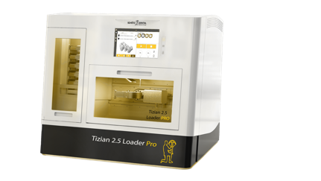 | 5-axis simultaneous milling in a compact design with a spindle up to 100,000 RPM and temperature compensation for consistent precision. Supports versatile materials, including zirconia and abutments. | steep learning curve
Tizian milling machine | Tizian 3.5 Loader Pro + | Schütz Dental , germany | Tizian CAM Software | Up to 60,000 rpm | 20-tool automatic changer. | NA | titanium, non-precious alloys, zirconium dioxide, PMMA acrylics, wax, composite, PEEK materials, acetal acrylics, polycarbonate, glass ceramics, lithium disilicate, and prefabricated abutments | 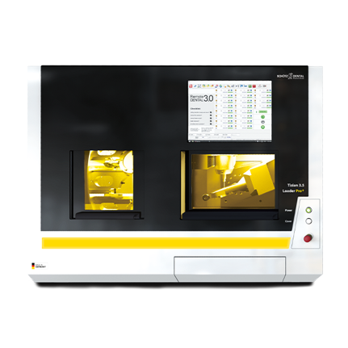 | 5-axis milling with a 60,000 RPM spindle and vibration-reducing polymer housing. Includes zero-point clamping, 12-blank automatic loader, and supports unmanned operation for high productivity. | Complex setup requires significant operator training.
Tizian milling machine | Tizian 3.5 Pro | Schütz Dental , germany | Tizian CAM Software | Up to 60,000 rpm | 20-tool automatic changer with dust protection and zero-point clamping. | NA | CoCr/NEM, titanium, zirconium dioxide, aluminum oxide, PMMA, resins, composites, wax, glass ceramic, hybrid ceramic | 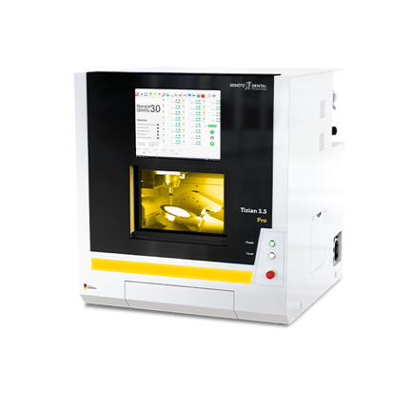 | 5-axis milling with a polymer concrete frame for stability and vibration reduction. High-definition servo motors enable faster, more precise processing. Supports wet and dry milling and versatile dental materials. | high initial cost
Tizian milling machine | Tizian Cut Eco Plus Milling Machine | Schütz Dental , germany | Tizian CAM Software | Up to 60,000 rpm | 6-tool automatic changer. | NA | Wax, PMMA, composites, zirconia reinforced composites, PEEK, zirconium dioxide | 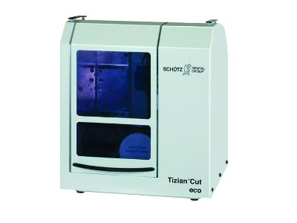 | Compact 4-axis milling with high productivity (up to 75 units/day), low maintenance, and automated blank optimization. | high initial cost
DCS | DC 5 Milling Machine | Dental concept system | DC Concept CONTROL | Up to 60,000 rpm | 10-tool interchangeable magazines with automatic measurement. | NA | Zirconia, ceramics, lithium disilicate, CoCr, titanium, PMMA, composites, wax, model materials | 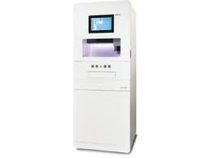 | 5-axis wet/dry milling with modular design and integrated filters for wet processes. Includes automatic calibration and robust German engineering for durability. | Discontinued model, large and heavy, requires a minimum 7 bar compressed air connection.
Zirkonzahn | Milling Unit M1 | Zirkonzahn, Italy | Zirkonzahn Software | NA | 8-tool automatic changer. | NA | Zirconium, Wax, PMMA, Composite, Glass Ceramic, Titanium | 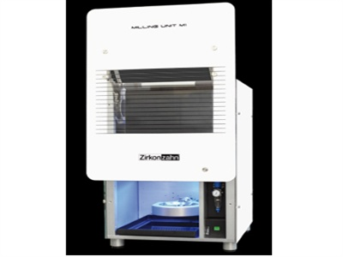 | Compact 5+1 axis design for short milling times. Compatible with Zirkonzahn Scanner S600 ARTI for seamless integration. | May require additional versions for specific material needs.
Zirkonzahn | M2 WET HEAVY METAL MILLING UNIT | Zirkonzahn Italy | Zirkonzahn Software | NA | 21-slot automated changer expandable to 84 slots. | NA | Zirconia, Resin, Wax, Wood, Sinter metal, Chrome-Cobalt, Titanium, Raw-Abutment®, Glass-ceramics, Composite | 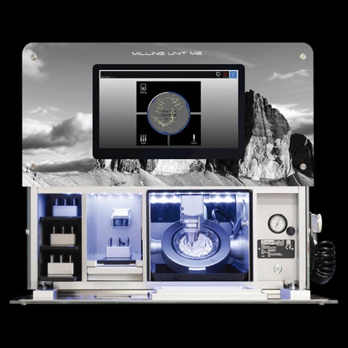 | 5+1 axis wet milling with optimized cooling spindle, tool detection, and touch-screen PC. Includes self-cleaning and drying. | The high initial investment requires specific holders for certain blanks, complex maintenance, and high operating costs.
Zirkonzahn | M2 TELESKOPER MILLING UNIT | Zirkonzahn Italy | Zirkonzahn Software | NA | 21-slot tool changer, expandable to 84 slots. | NA | Zirconia, Resin, Wax, Wood, Sinter Metal, Chrome-Cobalt, Titanium, Raw-Abutment®, Glass Ceramics, Composite | 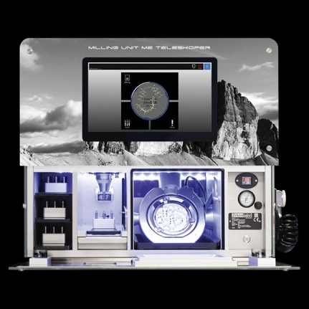 | 5+1 axis milling with high-precision blank repositioning, optimized cooling spindle, wet processing, and integrated PC with touch screen. Includes self-cleaning and drying. | High initial investment, requires specific holders for certain blanks, and high maintenance and operating costs.
Zirkonzahn | M2 DUAL WET HEAVY METAL MILLING UNIT | Zirkonzahn Italy | Zirkonzahn Software | NA | 63-slot automated tool changer. | NA | Zirconia, Resin, Wax, Wood, Sinter Metal, Chrome-Cobalt, Titanium, Raw-Abutment®, Glass Ceramics, Composite | 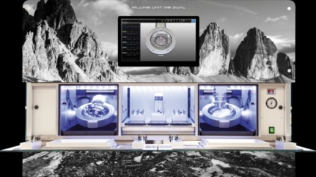 | 5+1 axis milling with separate wet/dry chambers, cooling spindle, self-cleaning, spacious milling area, and optional upgrades for material versatility.chamber, optional upgrades for increased material versatility. | Large and heavy machine (240 kg), high power consumption
Zirkonzahn | M2 DUAL TELESKOPER MILLING UNIT | Zirkonzahn Italy | Zirkonzahn Software | NA | 21-slot tool changer, expandable to 63 slots. | NA | Zirconia, Resin, Wax, Wood, Sinter metal, Chrome-Cobalt, Titanium, Raw-Abutment®, Glass-ceramics, Composite | 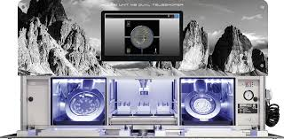 | 5+1 axis milling with dual-chamber wet/dry design, precise blank repositioning, cooling spindle, and self-cleaning functionality. | The high initial investment requires specific holders for certain blanks, complex maintenance, high operating costs, and space consumption.
Zirkonzahn | M2 DUAL DOUBLE TELESKOPER MILLING UNIT | Zirkonzahn Italy | Zirkonzahn Software | NA | 21-slot tool changer, expandable to 63 slots. | NA | Zirconia, Resin, Wax, Wood, Sinter metal, Chrome-Cobalt, Titanium, Raw-Abutment®, Glass-ceramics, Composite | 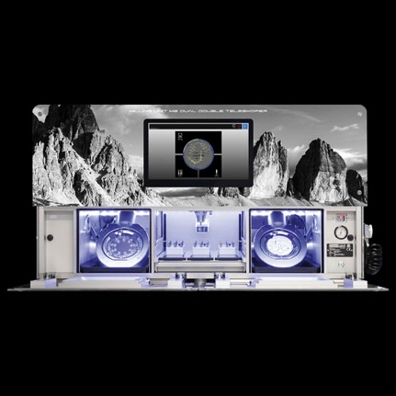 | 5+1 axis milling with dual wet/dry chamber, precise blank repositioning, cooling spindle, and automated self-cleaning. | The high initial investment requires specific holders for certain blanks, complex maintenance, high operating costs, and space consuming.
Zirkonzahn | M4 WET HEAVY METAL MILLING UNIT | Zirkonzahn Italy | Zirkonzahn Software |  | 32-slot tool changer with blank holder options. | NA | Zirconia, Resin, Wax, Wood, Sinter metal, Chrome-Cobalt, Titanium, Raw-Abutment®, Glass-ceramics, Composite | 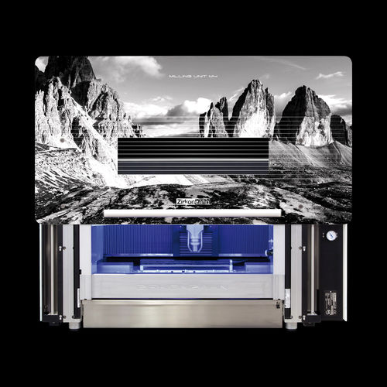 | 5+1 axis wet milling with large milling area, 360° rotatable table, optional PC and optical tool detection, and clean resin processing (optional). | High weight and dimensions, high initial investment, complex setup and operation, high operating costs.
Zirkonzahn | M5 HEAVY METAL MILLING UNIT | Zirkonzahn Italy | Zirkonzahn Software | max. 50,000 R.p.m | 16-slot tool magazine with optional extensions. | NA | Zirconia, Resin, Wax, Wood, Sinter metal, Chrome-Cobalt, Titanium, Raw-Abutment®, Glass-ceramics, Composite | 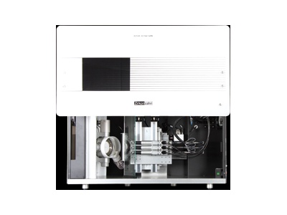 | 5+1 axis milling with optional Ioniser for clean processing and wet milling capabilities | Moderate milling speed compared to some other units, limited tool magazine capacity, may require additional accessories for specific tasks.
Zirkonzahn | M6 TELESKOPER BLANK CHANGER MILLING UNIT | Zirkonzahn Italy | Zirkonzahn Software | 6.000 - 50,000 rpm | 60-slot tool changer with dual storage (30 each). | NA | Various dental materials including resin, metal, zirconia, and composites | 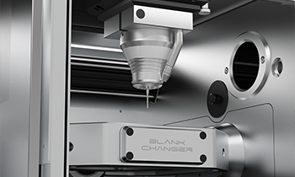 | 5+1 axis milling with large blank storage, automatic blank changer, high-torque spindle, and automated blank management. Includes self-cleaning and easy maintenance access. | High weight and dimensions, high initial investment
 | DWLM | Dental wings | NA | NA | NA | NA | Polymer, Ceramic, Glass Ceramic | 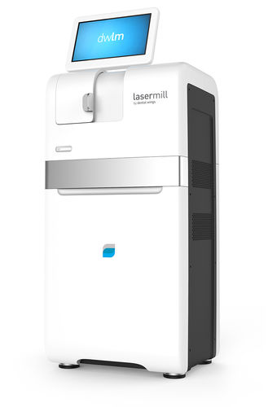 | Laser ablation eliminates traditional tooling, fluids, and post-milling crystallization. Efficient and accurate, with no tool wear or breakage. | high initial cost
DYAMACH | DS1 | DYAMACH, Italy | Dyamach NC | 100,000 RPM | 14-tool automatic changer. | NA | Zirconium, PMMA, Wax | 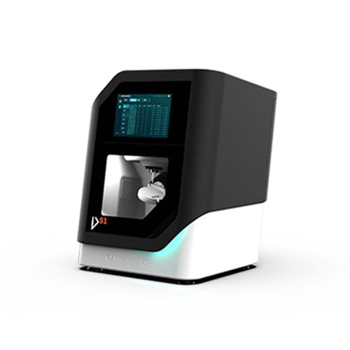 | 5-axis dry milling specialized for crowns and bridges. Features a 0.75 kW spindle, automatic calibration, and 14-tool magazine for soft materials. | No wet grinding option
DYAMACH | DS1 Plus | DYAMACH, Italy | Dyamach NC | 100,000 RPM | 14-tool automatic changer. | NA | Zirconium, PMMA (Dry/Wet), Wax (Dry/Wet), PEEK, Composite, Carbon, Plastic materials, Glass fiber, Glass-ceramic, Pre-milled Titanium/CoCr | 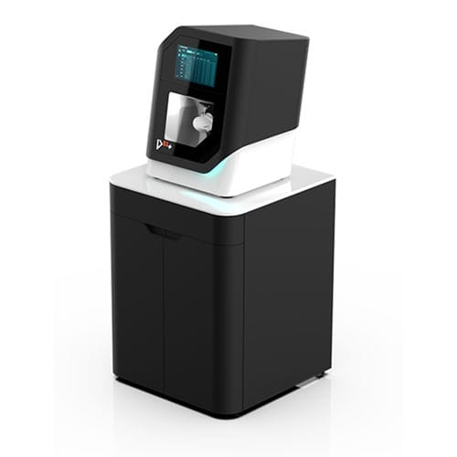 | 5-axis wet/dry milling with a 0.75 kW spindle, intuitive interface, and easy loading/unloading. Supports glass ceramics and SLM machining. | larger and heavier than DS1
DYAMACH | AS1 | DYAMACH, Italy | Dyamach NC | 60,000 RPM | 18-tool automatic changer. | NA | Zirconium, PMMA (Dry/Wet), Wax (Dry/Wet), PEEK, Composite, Carbon, Plastic materials, Glass fiber, Glass-ceramic, Aluminium, Titanium, Cobalt chrome, Pre-milled Titanium/CoCr | 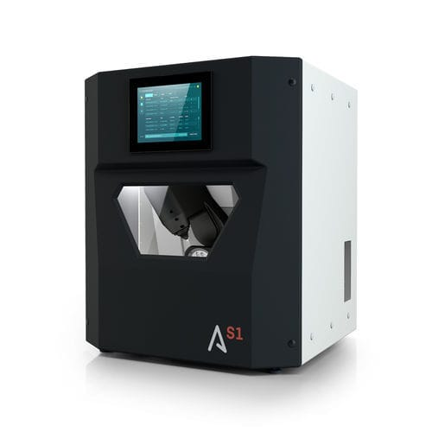 | 5-axis wet/dry milling with a tilting head spindle for soft and hard metals. Includes an 18-tool magazine, disc holder, and compact design. | moderately heavy and large footprint
DYAMACH | AS1 Pro | DYAMACH, Italy | Dyamach NC | 60,000 RPM | 18-tool automatic changer with 8-disc holder. | NA | Zirconium, PMMA (Dry/Wet), Wax (Dry/Wet), PEEK, Composite, Carbon, Plastic materials, Glass fiber, Glass-ceramic, Aluminium, Titanium, Cobalt chrome, Pre-milled Titanium/CoCr | 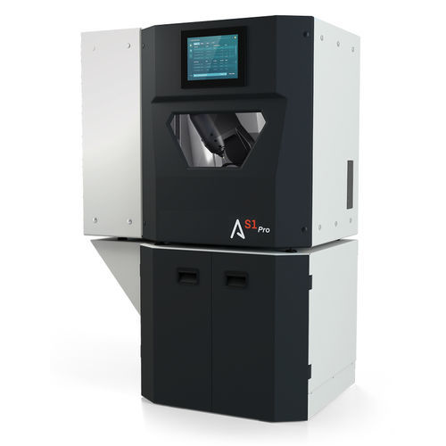 | 5-axis wet/dry milling with a 1 kW spindle and an 8-disc holder. Features include a tilting spindle for soft/hard metals and rapid loading. | significantly larger and heavier than other models
DYAMACH | DT2 | DYAMACH, Italy | Dyamach NC | 50,000 rpm | 36-tool automatic changer. | NA | zirconium, PMMA (Dry/Wet), Wax (Dry/Wet), PEEK, Composite, Carbon, Plastic materials, Glass fiber, Glass-ceramic, Aluminium, Titanium, Cobalt chrome, Pre-milled Titanium/CoCr | 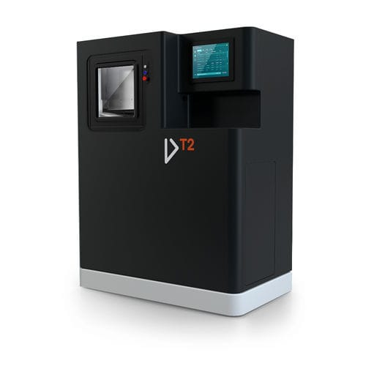 | 5-axis wet/dry milling with a 2.6 kW spindle for titanium and cobalt chrome. Includes 36-tool carousel and robust build. | Heavy and large footprint, higher power consumption (5 kW).
DYAMACH | DT5 | DYAMACH, Italy | Mitsubishi NC | 42,000 rpm | 8-position automatic loader. | NA | Zirconium, PMMA (Dry/Wet), Wax (Dry/Wet), PEEK, Composite, Carbon, Plastic materials, Glass fiber, Glass-ceramic, Aluminium, Titanium, Cobalt chrome, Pre-milled Titanium/CoCr | 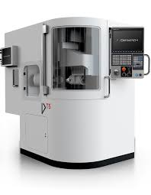 | 5-axis wet/dry milling with a 14 kW spindle for high-volume production. Features HSK-32 spindle and horizontal drive. | High power consumption (20 kW), very large and heavy (2550 Kg)
CADBlu Dental’s line | ezMILL Milling System | CadBlue Inc , USA | NA | 60,000 RPM | NA | Approximately 10 minutes | Zirconia, PMMA, Wax, Nanocomposites | 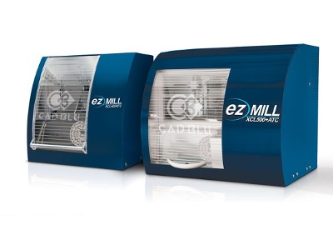 | Compact 4- and 5-axis desktop system for high-speed, precise restorations.
Jensen Dental | Preciso M200 Dental Mill | Jensen Dental, USA | Jensen CAM | 5,000 – 60,000 RPM | 6-tool automatic changer. | NA | Zirconia, wax, nanocomposites, PMMA | 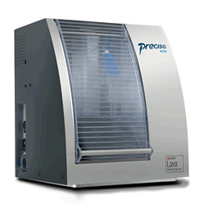 | 4-axis compact desktop milling machine with high-speed Jager Spindle and harmonic drive for precision. | Requires dry compressed air; limited warranty with non-approved CAM software.
imes-icore | CORITEC1 | Dental Arts Laboratories, Inc,  USA | iCAM one | Up to 100,000 rpm. | 6-fold, switches tools automatically. | 10 - 20 minutes | Zirconia, glass ceramics, metals, composites, PEEK, and PMMA. | 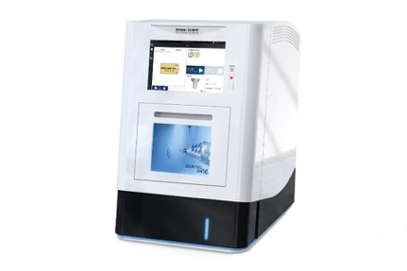 | 4-axis wet milling with a 2.7 kW spindle for custom abutments and metal discs. Precision milling reduces post-processing, ensuring reliable long-term performance. | High cost, training needs, and space requirements.
imes-icore | CORITEC1 Plus | Dental Arts Laboratories, Inc,  USA | iCAM one+ | Up to 100,000 rpm. | 10-tool automatic changer. | 10 to 15 minutes | Zirconia, glass ceramics, metals, composites, PEEK, and PMMA. | 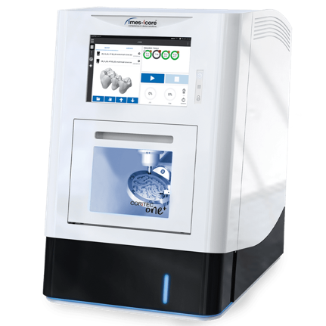 | 4-axis wet milling with a 2.7 kW spindle for custom abutments, metal discs, and ceramics. Precision milling minimizes post-processing and supports high-volume production. | High cost and complexity require training and maintenance.
imes-icore | CORiTEC® 350i X PRO series | Dental Arts Laboratories, Inc,  USA | iCAM V5 | up to 60,000 rpm | 20-fold  tool changer | 10 to 20 minutes | Zirconia  Pre-milled Abutments  Titanium (Ti)  Cobalt-chrome (CoCr)  Cobalt-Chrome  Glass Ceramic  Lithium Disilicate  Hybrid Ceramic  Sintered Metal  Composite  PEEK,  PMMA,  Wax | 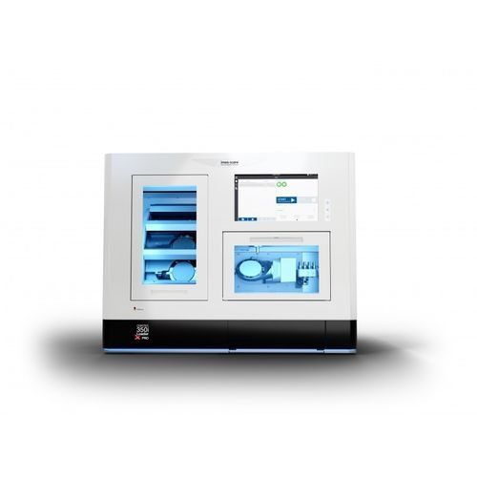 | 5-axis wet/dry milling with a 1 kW spindle. Includes a 20-tool changer, 12-blank changer, servo drives for faster processing, and temperature compensation for precision. | Limited spindle power (1 kW) may not be optimal for extremely hard materials or high-volume production.
Interdent | CC newCOSMO | Interdent, Germany | InterdentCAM | 80,000 rpm | 16-tool automatic changer with 10-disc DirectDiscTechnology. | NA | Composite, zirconium, wax, CoCr, Peek, PMMA, glass ceramic, hybrid ceramic, lithium disilicate, titanium, titanium pre-milled abutments | 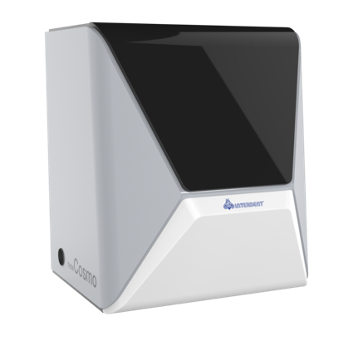 | 5-axis wet/dry milling with 800 W motor, ionizers, webcam monitoring, and disc changer. | High initial cost
Interdent | CC TRENDY | Interdent, Germany | InterdentCAM | 60,000 rpm | 16-tool automatic changer. | NA | Composite, zirconium, wax, CoCr, Peek, PMMA | 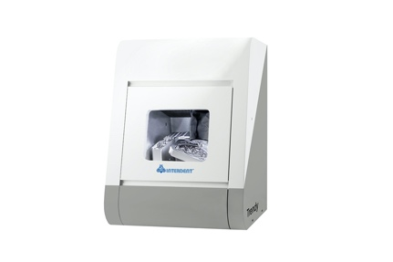 | Compact 5-axis dry milling with 500 W motor and aluminum frame; ideal for smaller labs. | Limited to dry milling only
Interdent | CC TRENDY+ | Interdent, Germany | InterdentCAM | 60,000 rpm | 16-tool automatic changer. | NA | Composite, zirconium, wax, CoCr, Peek, PMMA | 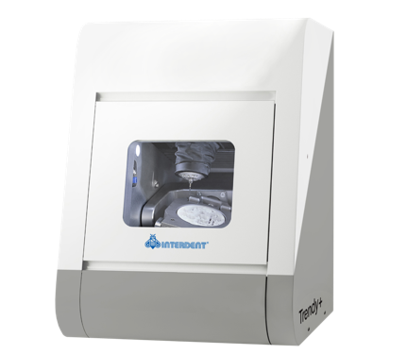 | Compact 5-axis dry milling with 500 W motor, DirectDiscTechnology, and Ethernet connectivity. | Limited to dry milling only
Interdent | CC newCHIC | Interdent, Germany | Windows 10 | 100,000 rpm | 6-tool automatic changer. | NA | Glass-ceramic, hybrid ceramic, lithium disilicate, composite, zirconium, PMMA, titanium pre-milled abutments | 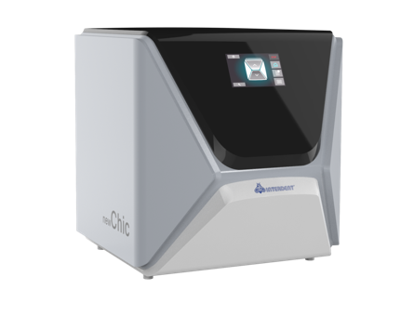 | Mini 4-axis wet milling with 600 W motor, water container, Wi-Fi, and quiet operation. | Limited to milling small blocks, suitable mainly for clinics and as a secondary unit
interdent | CC FASHION | Interdent, Germany | InterdentCAM | 60,000 rpm | 7-tool automatic changer. | NA | CoCr, composite, zirconium, PMMA | 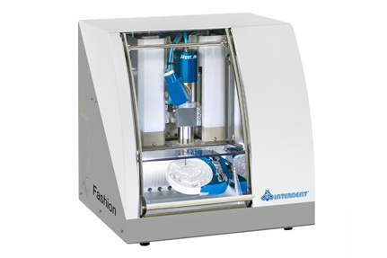 | Compact 4-axis dry milling with 240 W motor, aluminum frame, and 5 μm accuracy. | Limited to dry milling, suitable mainly for small and medium-sized laboratories
interdent | CC UNIVERSE | Interdent, Germany | InterdentCAM | 60,000 rpm | 16-tool automatic changer with a capacity for 8 discs or 48 abutments. | NA | CoCr, glass ceramic, titanium, hybrid ceramic, lithium disilicate, composite, zirconium, PMMA | 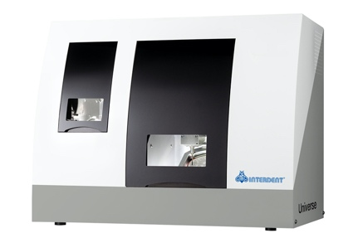 | 5-axis wet/dry milling with 600 W motor, optional wet module, and ionizers for clean operation. | Optional wet-grinding module required for wet processing
88 dent | Enne 4+ | 88 dent, Italy | DentalCAM with DirectMill function | 80,000 rpm | 8-tool automatic changer with 3-block capacity. | NA | Compatible with 38 materials from 20 manufacturers, >1300 prefabricated titanium and CoCr abutments from 11 manufacturers | 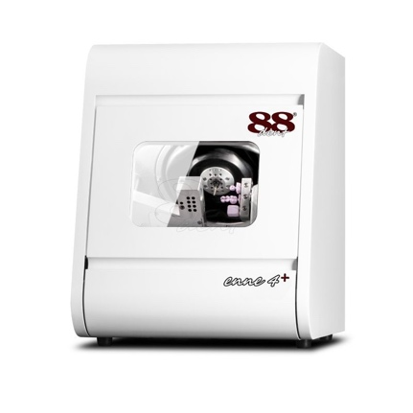 | 4-axis wet milling with 800 W motor, 3 μm accuracy, liquid cooling, Ethernet, and webcam. | Mited CAD software compatibility, complex maintenance, high cost, and large size. Limited support, software learning curve, short warranty
88 dent | Zeta4 | 88 dent, Italy | DentalCAM | 100,000 rpm | 6-tool automatic changer. | Less than 10 minutes | Glass-ceramic, PMMA, zirconium oxide, composites, prefabricated titanium abutments | 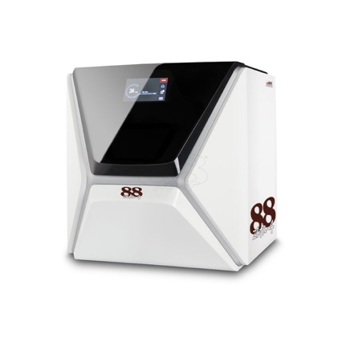 | 4-axis wet milling with 3 μm accuracy, touchscreen, WLAN, and pure water use. | Limited availability of technical support and servicing may pose challenges for users in certain regions.
88dent | 88Mill | 88 dent, Italy | DentalCAM | up to 60,000 rpm | 7-tool automatic changer. | Zirconium - 10 min, Wax - 4.5 min, etc. | Zirconium, PMMA, Nanocomposites, Cr-Co, polyurethane, wax | 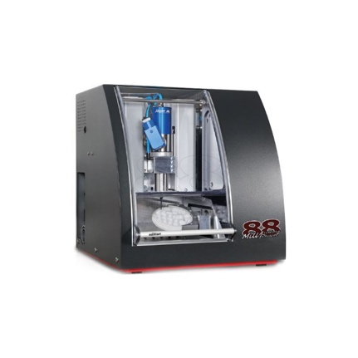 | 4-axis milling with aluminum frame, electrospindle, and versatile capabilities. | Limited tool storage capacity may impact workflow efficiency.
88 dent | E-FOUR | 88 dent, Italy | DentalCAM | 60,000 RPM | 6-tool automatic changer with AIRTOOL. | NA | Glass-ceramics, composites, zirconium oxide, plastics, PMMA, other composites | 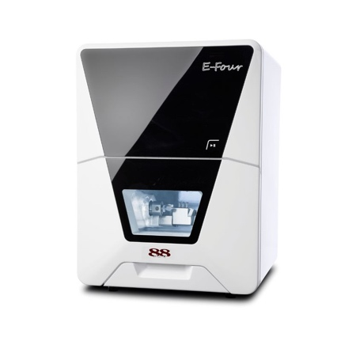 | 4-axis wet/dry milling with PUREWATER and AIRTOOL technologies, compact 28 kg design. | High initial cost
88 dent | Esse 5 | 88 dent, Italy | DentalCAM | 60,000 rpm | 16-tool and 8-disc automatic changers. | NA | CoCr, titanium, glass ceramic | 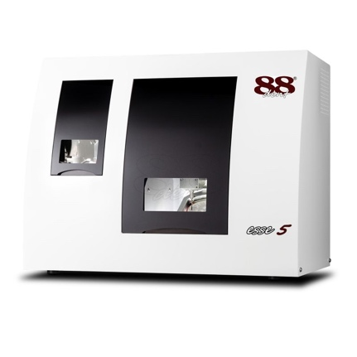 | 5-axis simultaneous milling with precision spindle and 8-disc changer. | High initial cost
88 dent | E- FIVE | 88 dent, Italy | DentalCAM | 60,000 rpm | 16-tool automatic changer with AIRTOOL. | NA | Zirconia, PMMA, composites, CoCr sintered metals, other common materials | 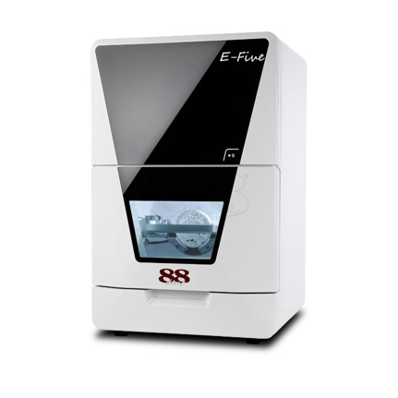 | Compact 5-axis dry milling with AIRTOOL cast aluminum frame and 3 μm accuracy. | Initial costs may be high, specific to practices with digital workflows.
88 dent | P53 DC | 88 dent, Italy | UPCAM | 60,000 rpm | 12-disc and 11-tool automatic changers. | Zirconia: 13 min; Wax: 5.5 min | Zirconia, Wax, PMMA, PEEK, and soft materials | 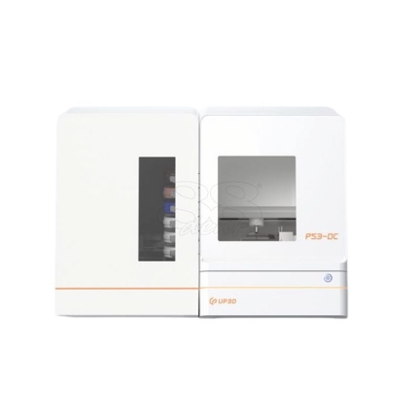 | 5-axis simultaneous milling, 24-hour capability, and air-cooled operation. | Initial setup may require technical expertise and higher power requirements.
88 dent | EMME30 | 88 dent, Italy | NO CAM | 61,800 rpm | 15-tool automatic changer. | NA | All common dental materials | 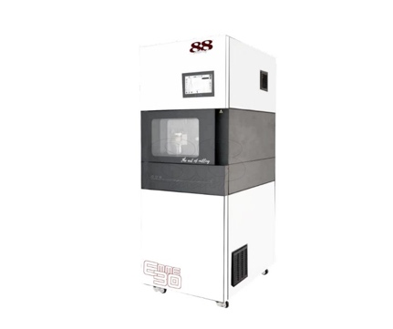 | 5-axis milling with liquid-cooled spindle, fast calibration, and cast iron chassis | High cost, requires regular maintenance.
88 dent | Easy53 | 88 dent, Italy | UPCAM | 40,000-60,000 rpm | Automatic with air pressure >0.5 MPa. | Zirconia: 13 min, Wax: 5.5 min | Zirconia, Wax, PMMA, PEEK, soft materials | 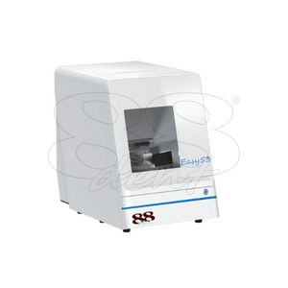 | Full CAD/CAM integration with LED progress bar and remote connectivity. | Potential learning curve for users new to CAD/CAM software.
88 dent | 88Mill Five S | 88 dent, Italy | DentalCAM | 60,000 rpm | 16-tool automated loader. | NA | Various: wax, plastic, plaster, zirconium, composite models, Cr/Co | 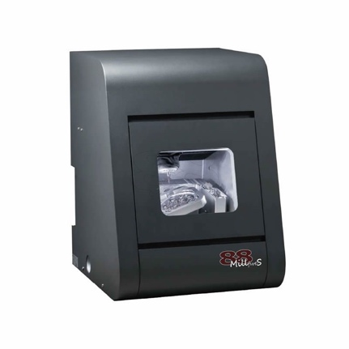 | 5-axis dry milling with aluminum frame, electrospindle, and ±35° rotation. | Requires compressed air supply; dry milling only.
88 dent | Kappa5+Dry | 88 dent, Italy | DentalCAM | up to 60,000 rpm | 16-tool automatic changer. | NA | PMMA, Wax, Zirconium, Composites, CoCr, pre-milled CoCr, Composite blocks | 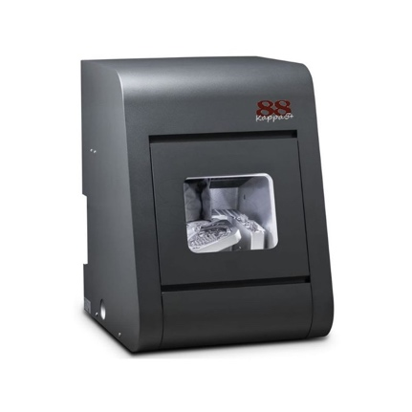 | 5-axis dry milling with DirectDisc, ionizer, and high-frequency spindle. | Requires compressed air and extraction system.
88 dent | 88 Erre5 | 88 dent, italy | hyperdent | 80,000rpm | 16-tool automatic changer. | NA | Pmma, Wax, Zirconium, Composites, Co-Cr, Titanium,premiled Co-Cr/Titanium, CompositeandDisilicateblocks | 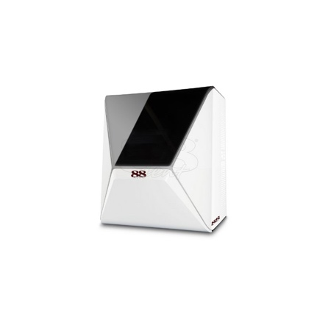 | 5-axis milling with DirectDisc, ionizer, water cooling, and drying function. | Requires compressed air and extraction system.
Aidite | AMD-500 NO CAM | 88 dent, Italy | No CAM | 6,000 - 60,000 rpm | 6-tool automatic changer. | NA | Zirconium, PMMA | 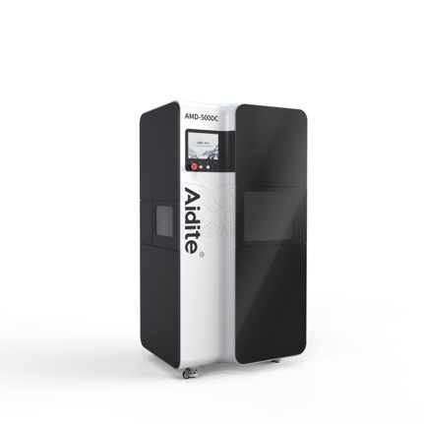 | 5-axis dry milling, benchtop configuration, 2 µm machining precision, 500 W power | Limited to dry milling.
BLZ dental | MO150 | BLZ dental , China | Millbox/hyperdent | Up to 60,000 rpm | 10-tool automatic changer. | NA | Zirconia, Wax, PMMA, PEEK | 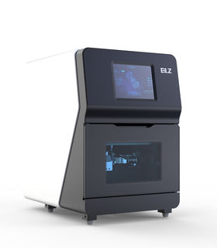 | 5-axis milling with 1800 W spindle, 0.01 mm accuracy, and aluminum alloy construction. | Requires specific setup for optimal performance.
BLZ dental | BX5 | BLZ Dental, China | Millbox | 60,000 RPM | 6-tool automatic changer. | NA | Zirconia, PMMA, Wax, Inner Crown, Inner Crown Bridge, Full Crown, Full Crown Bridge, Crown Tube, Inlay, Porcelain Veneer, Pre-stored Abutment, Abutment, Implant Bar, Implant Malong Bridge, Dental Model, Complete Denture, Steel Support, Surgical guide | 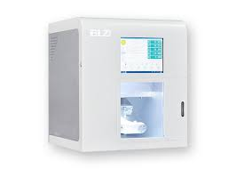 | 5-axis milling with 500 W spindle, 0.005 mm accuracy, and compact design (75 kg) | Limited to 6 burs, requiring frequent tool changes.
SilaMill | SilaMill T5 | Siladent, Germany | DENTALCAM | 60,000 rpm | 16-tool automatic changer. | NA | PEEK, Composite, PMMA, Wax, Zirconium oxide | 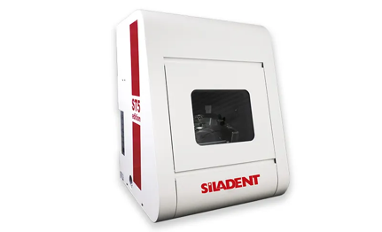 | 5-axis dry milling with hybrid ceramic bearings, ionizer, and tool-free blank holder. | Limited to 3 mm tool shank.
SilaMill | SilaMill N4 | Siladent, Germany | DENTALCAM | Up to 60,000 rpm | 8-tool automatic changer. | NA | Zirconium oxide, Glass-ceramic, Titanium | 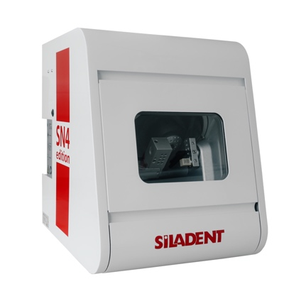 | 4-axis milling with liquid cooling, 300 W spindle, and rotary axis range of +190° to -10°. | Requires manual blank changes.
SilaMill | SilaMill 5.8 | Siladent, Germany | DENTALCAM | Up to 60,000 rpm | Automatic blank and tool changer. | NA | Zirconium oxide, Resin / PEEK, Wax, Glass Ceramics, Titanium | 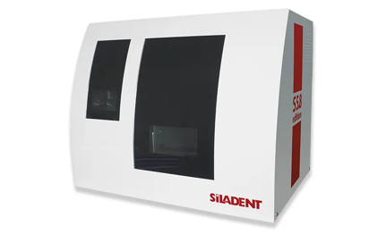 | 5-axis wet/dry machining with ±360° and ±30° rotary axis range, and ionizers for static charge neutralization. | Additional cost and setup for wet processing and grinding options.
SilaMill | SilaMill R5 | Siladent, Germany | DENTALCAM | up to 80.000 rpm | Automatic changer for 10 discs, 60 blocks, or 60 abutments. | NA | Zirconium oxide, plastics / PEEK, Wax, Titanium, Glasceramics | 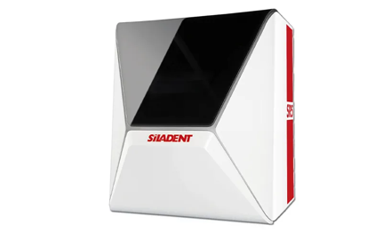 | 5-axis, wet/dry milling, 10-disc changer, water-cooled spindle, and ±35° rotation. | Additional cost and setup for wet grinding options.
Redon best mill | Best Mill® 1M CAM | Redon Technology, Turkey | Open Systems | 60,000 RPM | 24-tool automatic changer with AC-Servo spindle. | NA | - Metal (Ti, CoCr)  - Glass Ceramic  - Zirconia, PMMA, Wax  - Premill/Prefab Abutment | 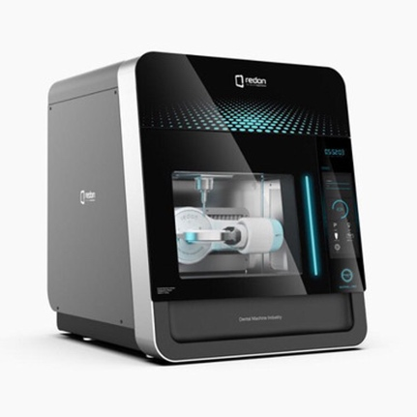 | Dry & wet milling capabilities; Suitable for various materials including metal, glass ceramic, and soft materials; Indicated for premill/prefab abutment fabrication; Includes CAM software. | Expensive setup.
Redon best mill | Best Mill® 1M 1L CAM | Redon Technology, Turkey | Open Systems | 60,000 RPM | 24-tool automatic changer | NA |  | 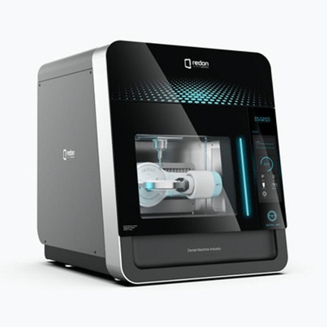
Redon best mill | Best Mill® 2M 1L CAM | Redon Technology, Turkey | Open Systems | 60,000 RPM | 24-tool automatic changer | NA | - Metal (Ti, CoCr)  - Glass Ceramic  - Zirconia, PMMA, Wax  - Premill/Prefab Abutment.
Redon best mill | Best Mill® with Leader | Redon Technology, Turkey | Open System | 60.000 Rpm | 24-tool automatic changer | NA | Zirconium, CoCr, Glass-Ceramic, Wax, Titanium | 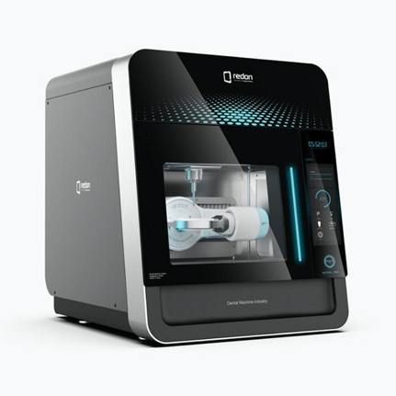 | 5-axis wet and dry milling, digital absolute servo motor, zero-point clamping system, monoblock cast body, high-performance 3.7 kW spindle, ultra-sensitive surfaces, automatic block changer for uninterrupted production, high precision with a wide machining angle, fully automatic operation, aesthetic design. | High initial cost
Redon mill | R-one+ | Redon Technology, Turkey | Open system | 100.000 RPM | 7-tool automatic changer | NA | Glass-Ceramic, Premill, Zirconium, PMMA, Composite, Wax, PEEK | 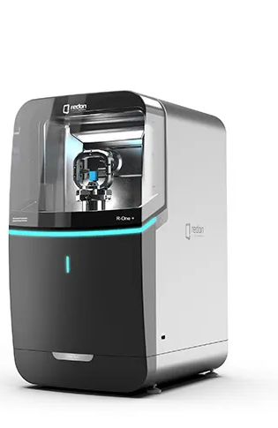 | 4-axis wet/dry milling, compact monoblock body, integrated water tank, eco-friendly, chairside system | Lower spindle power
Redon mill | GTR | Redon Technology, Turkey | Open system | 60,000 rpm | 12-tool automatic changer | NA | Titanium, Zirconium, CoCr, Glass-Ceramic, Wax, PMMA | 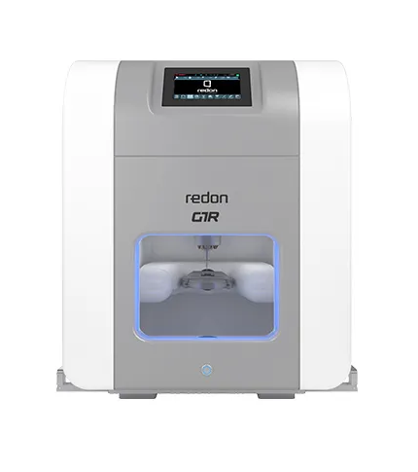 | 5-axis wet/dry milling, digital servo motor, maximum angle -30° to +120°, monoblock cast body, 3.7 kW spindle | High initial cost
Redon mill | GTR | Redon Technology, Turkey | Open system | 60,000 rpm | 12-tool automatic changer | NA | Zirconium, PMMA, Wax, Gypsum, Glass Ceramic, Titanium | 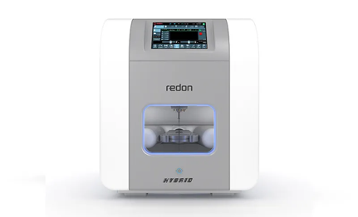 | 5-axis wet/dry milling, digital AC-servo spindle, auto-calibration, compact dimensions: 560x360x650 mm | Air requirement is high (100 L/Min)
Willemin-Macodel  Series 40 | 408B | Willemin-Macodel, Switzerland | ESPRIT CAM | Up to 42,000 rpm | 72-tool automatic changer | NA | Zirconium oxide, Plastics / PEEK, Wax, Titanium, Glass-ceramics | 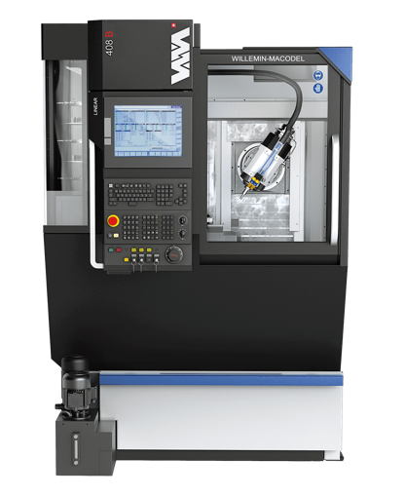 | 5- to 7-axis machining, swiveling spindle, high angular resolution divider, automatic back machining unit | higher cost due to advanced features
Willemin-Macodel  Series 40 | 408MT | Willemin-Macodel, Switzerland | ESPRIT CAM | Up to 42,000 rpm | 48-tool automatic changer | NA | Zirconium oxide, Plastics / PEEK, Wax, Titanium, Glass-ceramics | 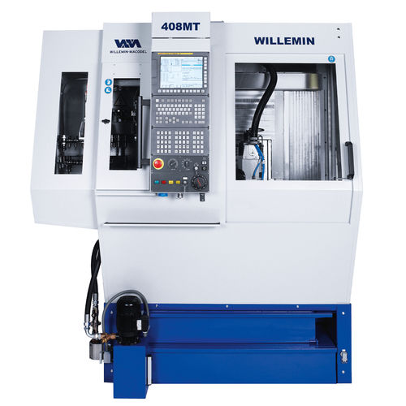 | Multi-process machining, turning mode up to 6,000 RPM, high angular resolution, automatic back machining | High cost
Willemin-Macodel  Series 40 | 408S2 | Willemin-Macodel SA Switzerland | ESPRIT CAM | p to 42,000 rpm | 96-tool automatic changer | NA | Bar stock, slugs, and various pallet standards | 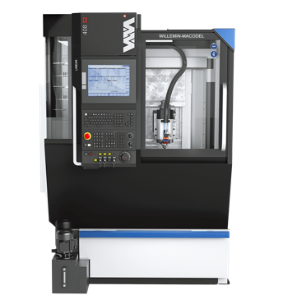 | 5-axis simultaneous machining, turning on the C-axis up to 4,000 RPM, dual divider, compact footprint (2.8 m²) | Potential high initial investment cost
Aidite | AMW400 | 3D Totem, Switzerland | Millbox / hyperdent /worknc | Up to 60,000 rpm | 6-tool automatic changer | 15 to 25 minutes | Vitroceramic, composites, pre-milled | 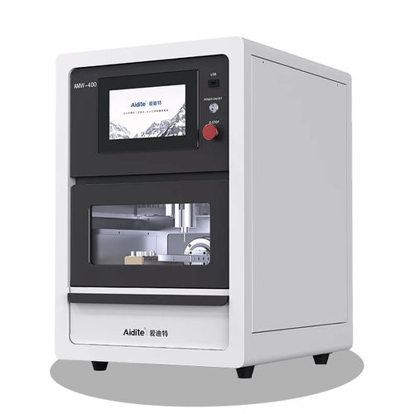 | 4-axis wet milling, 0.008 mm precision, handles up to 6 blocks, 360° A-axis rotation | Limited to 6 tools, Noise level up to 70 dB(A) during operation
Aidite | AMD500 | 3D Totem, Switzerland | Open system | Up to 60,000 rpm | 6-tool automatic changer | 12 minutes | Zirconia, Wax, PMMA, Composite | 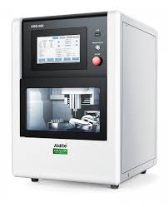 | 5-axis wet/dry milling, touchscreen control, B-axis tilt -30°/+90°, A-axis 360° rotation, 0.008 mm precision | Limited to 6 tools, Noise level up to 70 dB(A) during operation
YENADENT | D10 MAX | YENADENT, Turkey | YenadentCAM | 60.000 RPM | 12-tool automatic changer | NA | Zirconia / PMMA / Wax / Peek / Soft Metals | 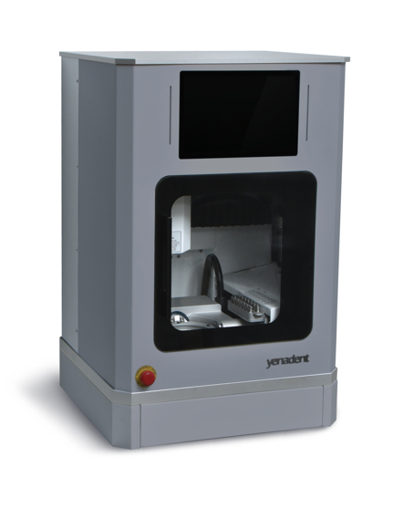 | 5-axis wet/dry milling, A&B tilt angles 90°x360°, spindle power 0.5 kW | Wet system hardware options are additional costs
YENADENT | D15 MAX | YENADENT, Turkey | YenadentCAM | 60,000 rpm | 6-tool automatic changer | ranges from 8 to 15 minutes. | Zirconia, PMMA, Wax, Peek, Soft Metals | 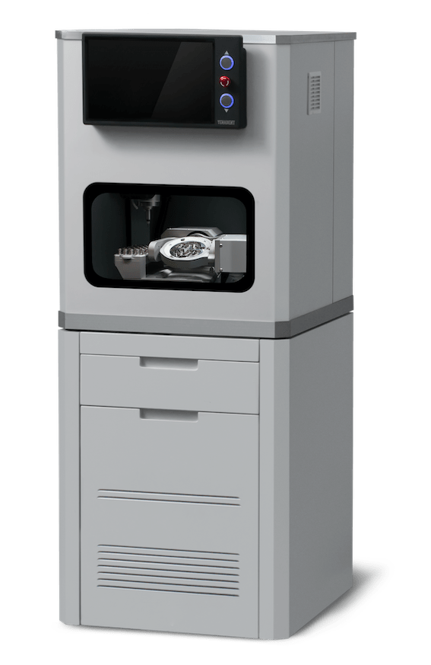 | 5-axis milling, high-speed machining, precision spindle, A&B tilt angles, compact design | Limited to 6 tools, Noise level during operation
YENADENT | D10 | YENADENT, Turkey | YenadentCAM | 60,000 rpm | 12-tool automatic changer | NA | Zirconia, PMMA, Wax, PEEK, Ceramics | 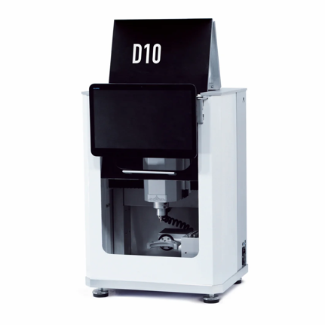 | 5-axis milling, A&B axes tilt angle of 30 degrees, Work area light, Precision guides, and ball screws | limited work area size
Al dente | PROSPLINT E3 | al dente Dentalprodukte GmbH, Germany | TrimCAD | Up to 60,000 rpm | Fully automatic aligner separation | Under 60 seconds | High-transparency thermoforming foil for splints | 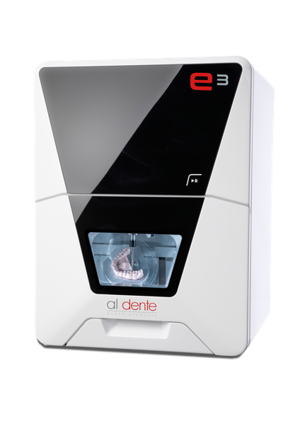 | Optimized for aligner production, automatic aligner separation, and TrimCAD software for optimal trimline determination. | Limited to processing thermo-formed plastic foil.
Tecno-Gaz | C5 | Tecno-Gaz industries , Italy | Millbox | Up to 60,000 rpm | 16-tool automatic changer | NA | All pre-sintered metals, soft materials, silicates, thermoplastic materials, wax, PMMA, PEEK, resins, zirconium dioxide, aluminum oxide | 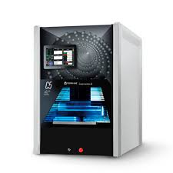 | 5-axis continuous interpolation, Jäger spindle (1 kW), open CAM software, desktop/tablet PC management | The steep learning curve for new operators
Tecno-Gaz | A6 | Tecno-Gaz industries , Italy | Millbox | 60,000 rpm | 11-tool automatic changer | NA | Zirconium oxide, plastics/PEEK, wax, titanium, glass ceramics | 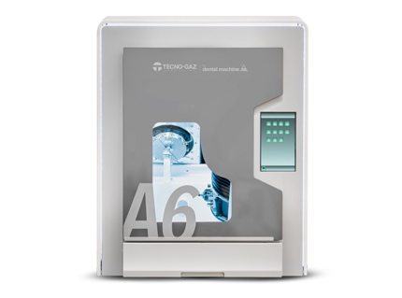 | 5-axis wet/dry milling, compact design, 0.4 kW Jäger spindle. | Unsuitable for heavy-duty industrial applications
Tecno-Gaz | A6 plus | Tecno-Gaz industries , Italy | Millbox | 60,000 rpm | 11-tool automatic changer | NA | Zirconium oxide, plastics/PEEK, wax, titanium, glass ceramics | 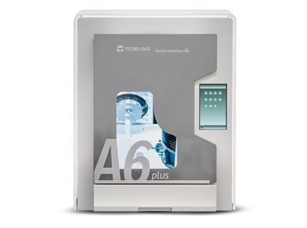 | 5-axis wet/dry milling, compact design, 0.55 kW Jäger spindle. | Higher initial investment than A6 and
Tecno-Gaz | A6 evo | Tecno-Gaz industries , Italy | Millbox | 60,000 rpm | 11-tool automatic changer | NA | Zirconium oxide, plastics/PEEK, wax, titanium, glass ceramics | 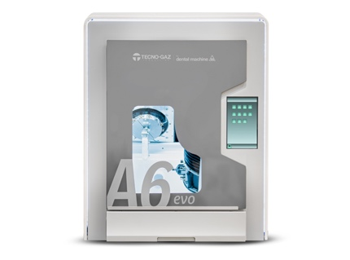 | 5-axis wet/dry milling, compact design, 0.55 kW Jäger spindle. | Higher initial investment than A6 and A6 Plus
Tecno-Gaz | G5 | Tecno-Gaz industries , Italy | Millbox | 50,000 rpm | 20-tool automatic changer | NA | Wax, PMMA, different resins, composite, pre-sintered zirconium dioxide and aluminum oxide, hydroxyapatite, titanium (grades 2 and 5), Cr-Co, etc. | 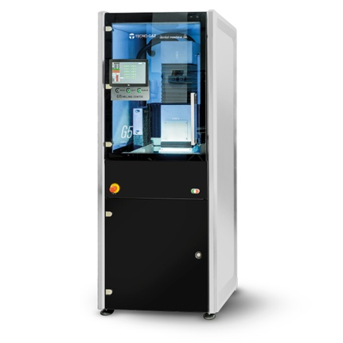 | 5-axis dry/wet milling, linear optical lines for precision, robust construction, open CAM software | High Initial Investment
Renishaw® | Renishaw® Dental Milling Machines | Renishaw, UK | Renishaw CAM software | 60,000 rpm | Manual tool changes | NA | Zirconia, wax | 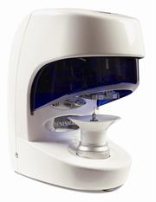 | Compact for labs, billet mounting, precise end stops, USB PC communication, optical encoders for motor feedback | Limited automation with manual tool changes
Dentium | Rainbow™ MILL | Dentium, South Korea | hyperDENT | 60,000 rpm | 7-tool automatic changer | 15 minutes | Zirconia, PMMA, Wax | 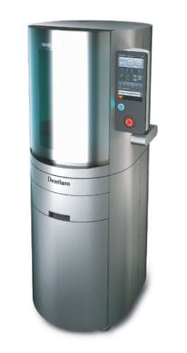 | 5-axis dry milling, integrated dust collector, servo motor drives, self-diagnosis system | Limited to dry processing only
Dentium | Rainbow™ Mill-Zr | Dentium, South Korea | hyperDENT | 60,000 rpm | 7-tool automatic changer | 25 Min | Glass-ceramic, Resin ceramic, PMMA | 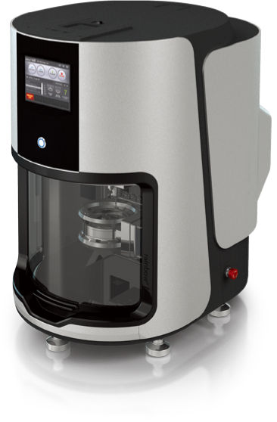 | 5-axis wet milling, high-precision Jäger spindle, stable water cooling system, user-friendly interface | Limited material compatibility
CHIRON Group | MICRO5 | CHIRON Group, Germany |  | 60.000 rpm | 60-tool magazine with auto load/unload | NA | Medical technology, watch housing and plates, watch movements, jewelry, components for precision mechanics and micro-mechanics | 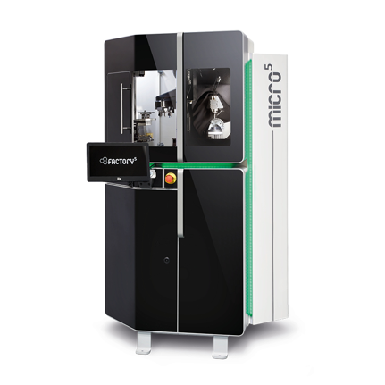 | 5-axis milling, ultra-compact, energy consumption 50x lower, high spindle performance, 5:1 machine-to-workpiece ratio | Large size and weight reduce installation flexibility.
Rollomatic | LASERSMART 501 | Rollomatic, Switzerland | LaserSuite | Not applicable (laser precision machining) | 18-tool automatic changer | NA | PCD, CVD, MCD, natural diamond | 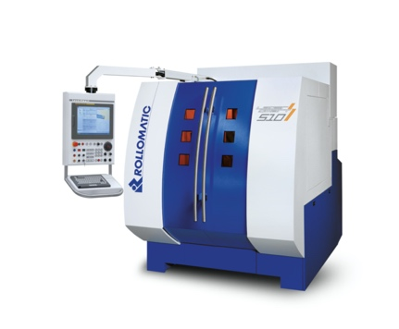 | 5-axis high-precision laser machining, sharp edge creation, negative chamfers, defined cutting edge preparation, surface finish above industry standards, integrated 6-axis robot. | Limited to laser machining applications.
MEGAGEN | Ti-CAM PRO | MEGAGEN, South Korea | R2GATE | 42,500 RPM |  | 25 minutes | Tiitaniumcustomized abutments | 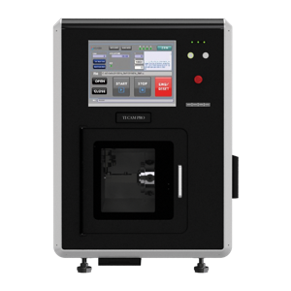 | 4-axis milling, optimized for titanium abutments, compact size (600×600×840 mm), lightweight (145 kg). | Limited to titanium and performed abutments
MEGAGEN | WHITE-CAM PRO | MEGAGEN, South Korea | R2GATE | 42,500 RPM | 7-tool automatic changer | 25 minutes | PMMA, Zirconia, Wax, Ultimate | 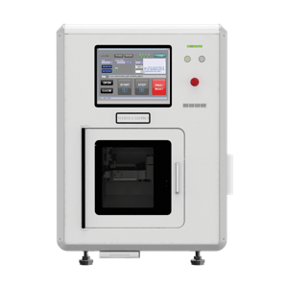 | Precise 5-axis dry milling supports full arch restorations and customized abutments, compact size. | Limited tool change options
MEGAGEN | WHITE-CAM WET | MEGAGEN, South Korea | R2GATE | 80,000 RPM | 8-tool automatic changer | 25 min | PMMA, Wax, Glass-ceramic, Hybrid ceramic | 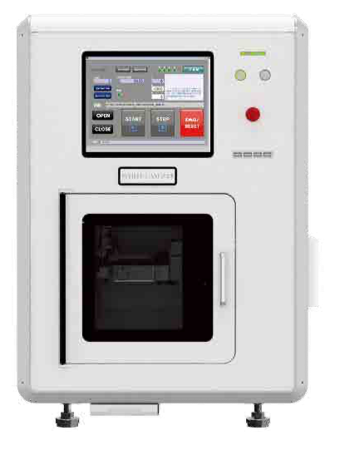 | 4-axis wet milling, compact design, supports all white milling materials. | Limited to wet milling, lower weight may affect stability.
DATRON | D5 ENTRY | DATRON, Germany | DATRON DentalCAM | 50,000 RPM | 15-tool automatic changer | NA | Standard dental blanks, glass ceramics, metals | 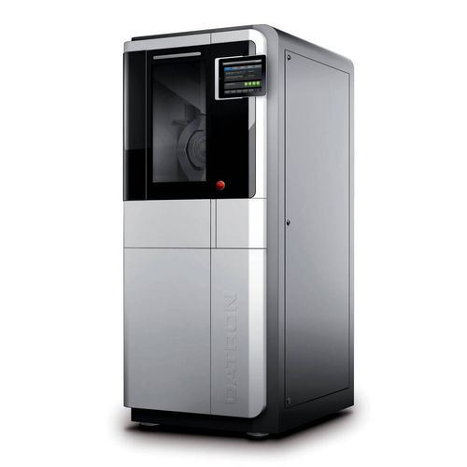 | 5-axis simultaneous milling, compact design, integrated blank changer, spindle cooling, rotary swivel axis, minimum cooling lubrication. | Heavyweight (approx. 900 kg)
Arrow Mill | Arrow Mill COLIBRI | DENTAS, Slovenia |  | 30,000 RPM | 11-tool automatic changer | NA | Zirconium oxide, soft sinter metals, PMMA, composite, wax | 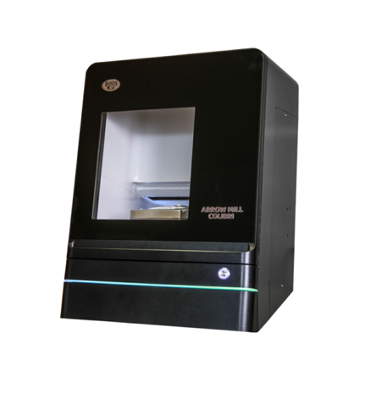 | 5-axis dry machining, compact (443×628×718 mm), user-friendly software, instant dust extraction during zirconia machining. | Power limitation (1.1 kW) affects processing speed.
Arrow Mill | Arrow Mill Sirio | DENTAS , Slovenia |  | 6000 to 60,000 rpm | 8-tool automatic changer | NA | wax, zirconia, titanium, ceramics, dental composites, metal, PMMA, CoCr | 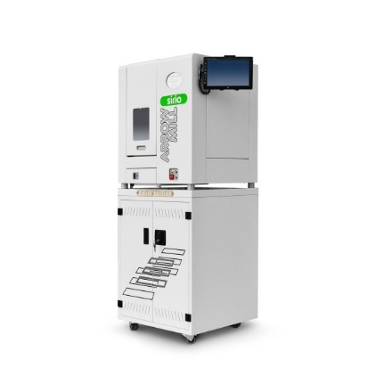 | 5-axis wet/dry milling, aluminum construction for stability, tool clamping system. | Relatively large size and weight affect mobility.
Arrow Mill | Arrow Mill Beluga | DENTAS , Slovenia |  | 6000 to 60,000 rpm | 18-tool automatic changer | NA | wax, zirconia, titanium, ceramics, dental composites, metal, PMMA, CoCr | 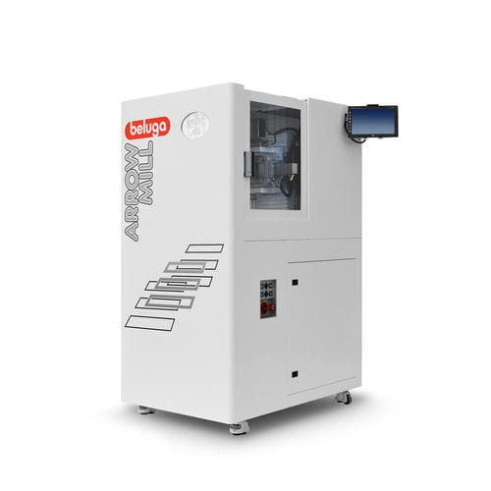 | 5-axis simultaneous machining, high-frequency spindle, cast iron construction for minimal vibration. | Heavyweight (450 kg).
Arrow Mill | Arrow Mill Smart | DENTAS , Slovenia |  | 6000 to 60,000 rpm | 15-tool automatic changer | NA | wax, zirconia, titanium, ceramics, dental composites, metal, PMMA, CoCr | 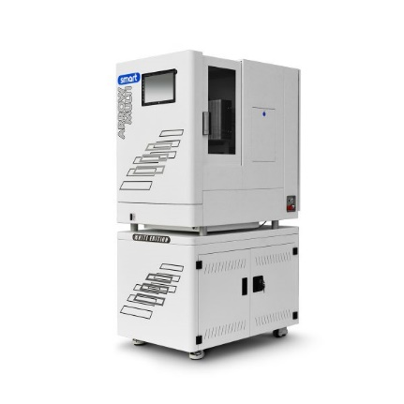 | 5-axis wet/dry milling, cast iron construction, compact design, equipped with wheels. | Heavyweight (220 kg).
Dynamic | DDM-4A | Dynamic, China |  | 1,000-60,000 RPM | Pneumatic tool changer | NA | Feldspar-type ceramics, Lithium-based ceramics, Hybrid materials, PMMA | 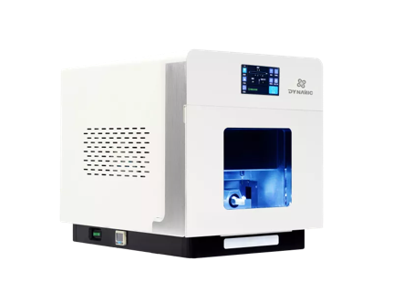 | 4-axis milling, chairside CAD/CAM, supports crowns, veneers, inlays, onlays, and screw-retained implant crowns.
Dynamic | DDM-5A | Dynamic, China |  | 15,000-60,000 rpm | Pneumatic tool changer | NA | Zirconia, PMMA, Wax, Hybrid materials, Feldspar-type ceramicsLithium based ceramics, etc | 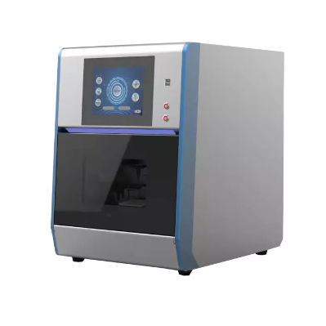 | 5-axis coordinated milling, wet/dry modes, high precision spindle, 3 µm repeatability, large angle cutting. | limited rotation angle (A: 360°, B: 25°)
Dynamic | DDM-5AD | Dynamic, China |  | 60,000 rpm | Pneumatic, tool, and block changes | NA | Zirconia, PMMA, Wax, PEEK, etc. | 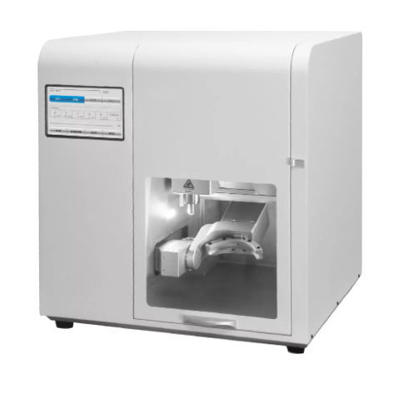 | 5-axis CAD/CAM milling, high stability, and precision supports crowns, bridges, inlays/onlays, implant bridges | High initial cost
DENTAL PLUS | RS5-001 | DENTAL PLUS, South Korea | Hyperdent, mailbox | 70,000 rpm | 16-tool fully automated | NA | Co-Cr, Titanium, Zirconia, Dental Wax, Ceramics, Cobalt-Chromium, PMMA | 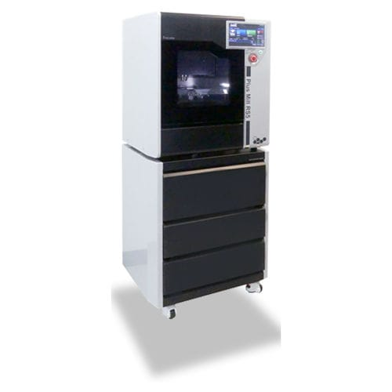 | 5-axis milling, servo motor, dynamic flexibility for various dental restorations | Heavyweight
DENTAL PLUS | X5 II | DENTAL PLUS, South Korea | Hyperdent | 60,000 rpm | 9-tool fully automated | NA | Zirconia, PMMA, PEEK, Wax, Composite, Hybrid ceramics, Sintering metal, etc. | 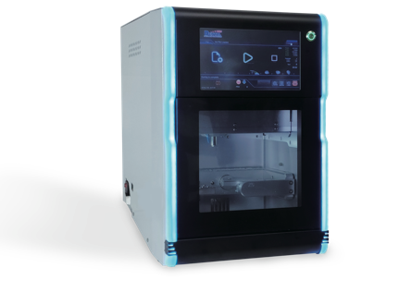 | 5-axis Dry milling, LED lighting, spacious milling room | Limited to dry milling
DENTAL PLUS | BX4 II | DENTAL PLUS, South Korea | Hyperdent, mailbox | 50,000 rpm | 10-tool fully automated | NA | Composite, Hybrid ceramics, Glass-ceramics, Titanium (Pre-milled), etc. | 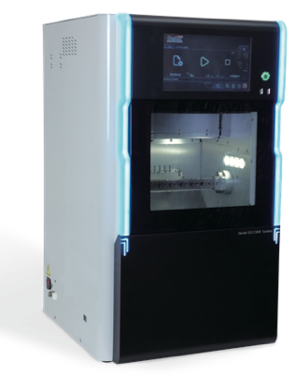 | 4-axis wet milling, optimized for custom abutments, jig for 11 pre-milled abutments | Limited to wet milling
DENTAL PLUS | BXL5 | DENTAL PLUS, South Korea | Hyperdent, mailbox | 50,000 rpm | 10-tool fully automated | NA | Zirconia, PMMA, PEEK, Wax, Composite, Hybrid ceramics, Glass-ceramics, Titanium (Pre-milled), Sintering metal, etc. | 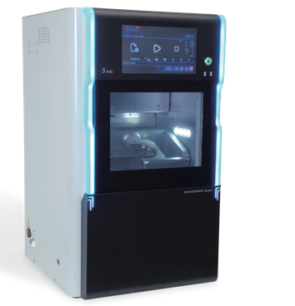 | 5-axis Wet / Dry milling, simultaneous processing of up to 5 glass ceramics, touch screen interface | The learning curve for advanced features
DENTAL PLUS | BX5 | DENTAL PLUS, South Korea | Hyperdent, mailbox | 50,000 rpm | 10-tool fully automated | NA | Zirconia, PMMA, PEEK, Wax, Composite, Hybrid ceramics, Glass-ceramics, Titanium (Pre-milled), Sintering metal, etc. | 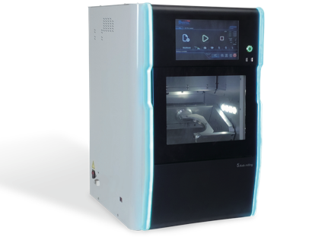 | 5-axis Wet / Dry milling, simultaneous processing of up to 5 glass ceramics, touch screen interface | The learning curve for advanced features
ORIGIN | PROTEUS 5X | B&D Dental Technologies , USA |  | 60,000 rpm | 12-tool fully automated | NA | Zirconia, Titanium, Dental wax, PMMA, CoCr | 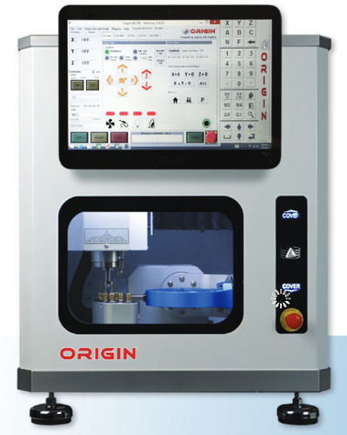 | 5-axis wet/dry milling in a compact, affordable package. Despite its small footprint, it delivers robust performance and cutting-edge technology. | Limited Material Compatibility
OROTIG | WHITEC 5.3 | OROTIG , Italy | HyperDENT CAM | 60,000 RPM | Automatic tool exchange | NA | Dental wax, Zirconia, Titanium, Ceramics, Metal, Cobalt-chromium | 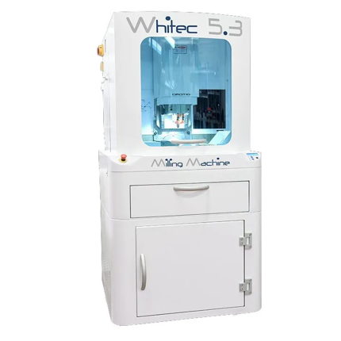 | 5-axis CNC, high-precision milling, backlash-free ball bearing guides, digital stepper motor | Heavyweight (380 kg) complicates relocation.
DOF | SHARP 2-PLUS | DOF Inc., South Korea | hyperdense | Up to 60,000 rpm | 12-tool fully automated | NA | Titanium, Zirconia, Ceramic, Dental composites, PMMA | 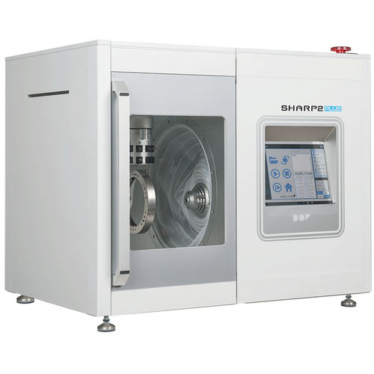 | 5-axis wet/dry milling, compact design, efficient for various materials | High initial cost
YUCERA | YRC-5X | YUCERA , China | Hyperdent | 60,000rmp | 7-tool fully automated | NA | Zirconia, Wax, PMMA, PEEK, and other dental composites | 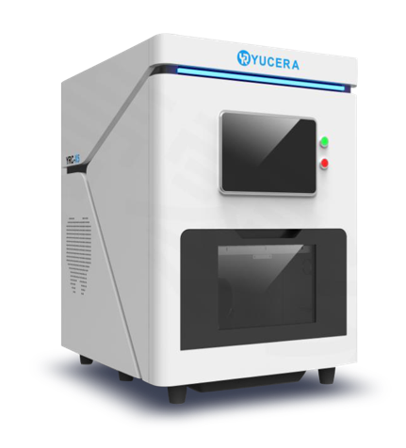 | 5-axis dry milling, high precision (0.01 mm), Wi-Fi control, resume function for interrupted processes | Limited for dry milling
YUCERA | GSL5T | YUCERA , China | Hyperdent | 60,000rpm | 6-tool fully automated | NA | All machinable materials up to 60 mm in diameter, including titanium and dental composites | 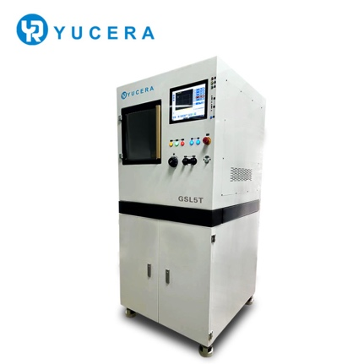 | -Precise 5-axis milling, single clamping, compact design (1 m²), high-performance spindle (1.8 kW) | Heavyweight 320 kg
YUCERA | Hot CADCAM 5 | YUCERA , China | Hyperdent |  | 5-tool fully automated | NA |  | 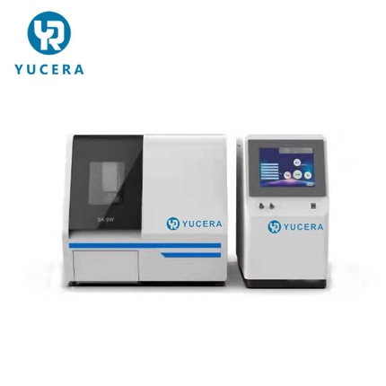 | 5-axis wet milling, high cutting precision (0.02 mm), tool detection sensor, 20% faster horizontal processing
YUCERA | YRC-6X | YUCERA , China | Hyperden | 60,000 rpm | 10-tool fully automated | NA | Glass-ceramics, titanium columns, composite materials | 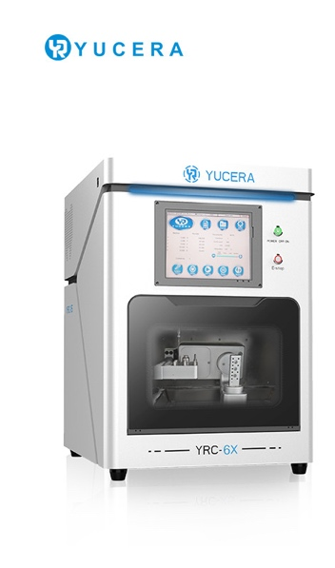 | 5-axis wet milling, Compact design with built-in water tank, supports milling implant holes. | Limited for wet milling
YUCERA | YRC-8X | YUCERA , China | Hyperden | 60,000 rpm | 10-tool fully automated | NA | Zirconia, wax, PMMA, PEEK | 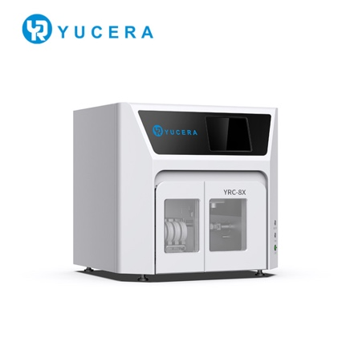 | -5-axis dry milling, 24-hour production, high precision, fully automated material changes | Limited for dry milling
YUCERA | Sk-5a | YUCERA , China | Hyperdent/Worknc | 60,000 rpm | Automatic tool change and calibration | Wax: 2-5 minutes  Zirconia: 6-8 minutes | zirconia blocks, PMMA, WAX, PEEK | 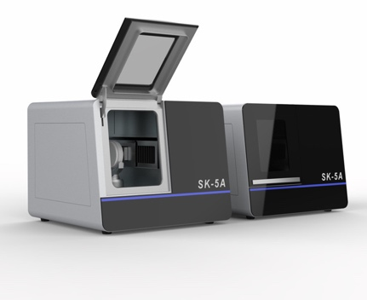 | 4/5-axis dry milling, dust collection, high-speed data processing, high-resolution digital servo control system | Limited to 3 burs, material thickness 10–24 mm.
Pi dental | COBRA 4 | Pi Dental, Hungary | PiCAM | 60,000 rpm | 8-station automatic tool changer | NA | Zirconium, PMMA, Wax, Gypsum | 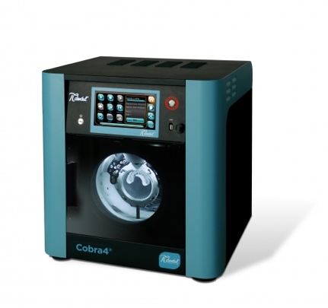 | Compact design, 4-axis dry milling, dust extraction, high accuracy (<0.015 mm), easy cleaning, STL file compatibility | Limited to dry machining only
Pi dental | COBRA6® | Pi Dental, Hungary | PiCAM | 60,000 rpm | 6-station automatic tool changer | NA | Zirconium, PMMA, Wax, Gypsum, Glass Ceramic | 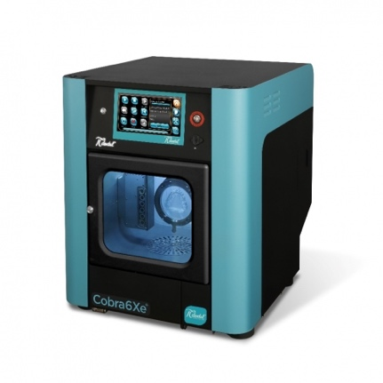 | Compact 5-axis wet/dry milling, built-in computer, absolute encoder system, user-friendly interface | Higher power consumption with additional equipment (600 W + ~1500 W for vacuum cleaner)
imes-icore | DCS PRO 4 | Messenger, Germany |  |  | Autonomous operation | NA | Titanium, Zirconium, PMMA, Wax, Gypsum, Glass Ceramic, all common materials | 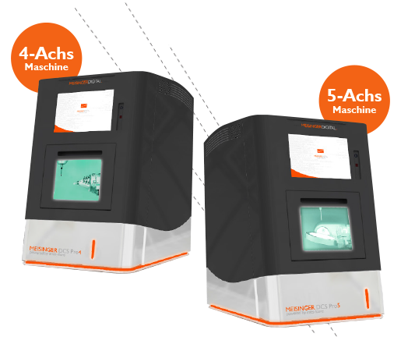 | 4-axis wet/dry milling, integrated PC, auto-calibration, cleaning function, temperature compensation | high initial cost
imes-icore | DCS PRO 5 | Meisenger , Germany |  |  | Autonomous operation | NA | Titanium, Zirconium, PMMA, Wax, Gypsum, Glass Ceramic, all common materials |  | 5-axis wet/dry milling, integrated PC, auto-calibration, cleaning function, temperature compensation | high initial cost

References:

[1] Abdullah A, Muhammed F, Zheng B, Liu Y. An overview of computer aided design/computer aided manufacturing (cad/cam) in restorative dentistry. Journal of Dental Materials and Techniques 2018/03/01;7.
[2] Stutes RD. The history and clinical application of a chairside cad/cam dental restoration system. Shanghai Kou Qiang Yi Xue 2006;15:449-55.
[3] Kakade P, Zambre G, Mhatre S, Srichand R, Joshi M, Gholap P. Evolution of intraoral scanners in dentistry: An overview. Chem Bull 2023;12:4267-76.
[4] Andersson M, Razzoog ME, Oden A, Hegenbarth EA, Lang BR. Procera: A new way to achieve an all-ceramic crown. Quintessence Int 1998;29:285-96.
[5] Afiqah Hamzah N, Razak NAA, Sayuti Ab Karim M, Gholizadeh H. A review of history of cad/cam system application in the production of transtibial prosthetic socket in developing countries (from 1980 to 2019). Proc Inst Mech Eng H 2021;235:1359-74.
[6] Vafaee F, Firouz F, Mohajeri M, Hashemi R, Ghorbani Gholiabad S. In vitro comparison of the accuracy (precision and trueness) of seven dental scanners. J Dent (Shiraz) 2021;22:8-13.
[7] Nedelcu R, Olsson P, Nystrom I, Ryden J, Thor A. Accuracy and precision of 3 intraoral scanners and accuracy of conventional impressions: A novel in vivo analysis method. J Dent 2018;69:110-8.
[8] Emir F, Ayyildiz S. Evaluation of the trueness and precision of eight extraoral laboratory scanners with a complete-arch model: A three-dimensional analysis. J Prosthodont Res 2019;63:434-9.
[9] Nulty AB. A comparison of full arch trueness and precision of nine intra-oral digital scanners and four lab digital scanners. Dent J (Basel) 2021;9.
[10] Ezmek B, Sipahi OC. Evaluation the scanning accuracy of blue-light laboratory scanners in complete edentulous maxilla with multiple implants with titanium scan bodies. Odovtos - International Journal of Dental Sciences 2023:360-71.
[11] Diker B, Tak Ö. Accuracy of six intraoral scanners for scanning complete-arch and 4-unit fixed partial dentures: An in vitro study. J Prosthet Dent 2022;128:187-94.
[12] Diker B, Tak Ö. Accuracy of digital impressions obtained using six intraoral scanners in partially edentulous dentitions and the effect of scanning sequence. Int J Prosthodont 2021;34:101-8.
[13] Gurpinar B, Tak O. Effect of pulp chamber depth on the accuracy of endocrown scans made with different intraoral scanners versus an industrial scanner: An in vitro study. J Prosthet Dent 2022;127:430-7.
[14] Ender A, Zimmermann M, Mehl A. Accuracy of complete- and partial-arch impressions of actual intraoral scanning systems in vitro. Int J Comput Dent 2019;22:11-9.

