Sr No | P  (Prime Number 1) | Q  (Prime Number 2) | D  (Private Key) | N  (Public Key)
1 | 11 | 13 | 103 | 143
2 | 17 | 19 | 173 | 323
3 | 31 | 37 | 463 | 1147
4 | 47 | 53 | 1595 | 2491
5 | 67 | 71 | 1777 | 4757
6 | 83 | 89 | 4811 | 7387
7 | 103 | 107 | 4325 | 11021
8 | 127 | 131 | 14891 | 16637
9 | 149 | 151 | 6343 | 22499
10 | 167 | 173 | 19035 | 28891
11 | 191 | 193 | 10423 | 36863
12 | 211 | 223 | 21191 | 47053
13 | 233 | 239 | 36811 | 55687
14 | 277 | 281 | 14051 | 77837
15 | 307 | 311 | 27103 | 95477
16 | 331 | 337 | 34117 | 111547
17 | 353 | 359 | 84011 | 126727
18 | 379 | 383 | 115517 | 145157
19 | 401 | 409 | 69943 | 164009
20 | 431 | 433 | 159223 | 186623
Table S1: Shows Prime number combinations used and their respective Keys

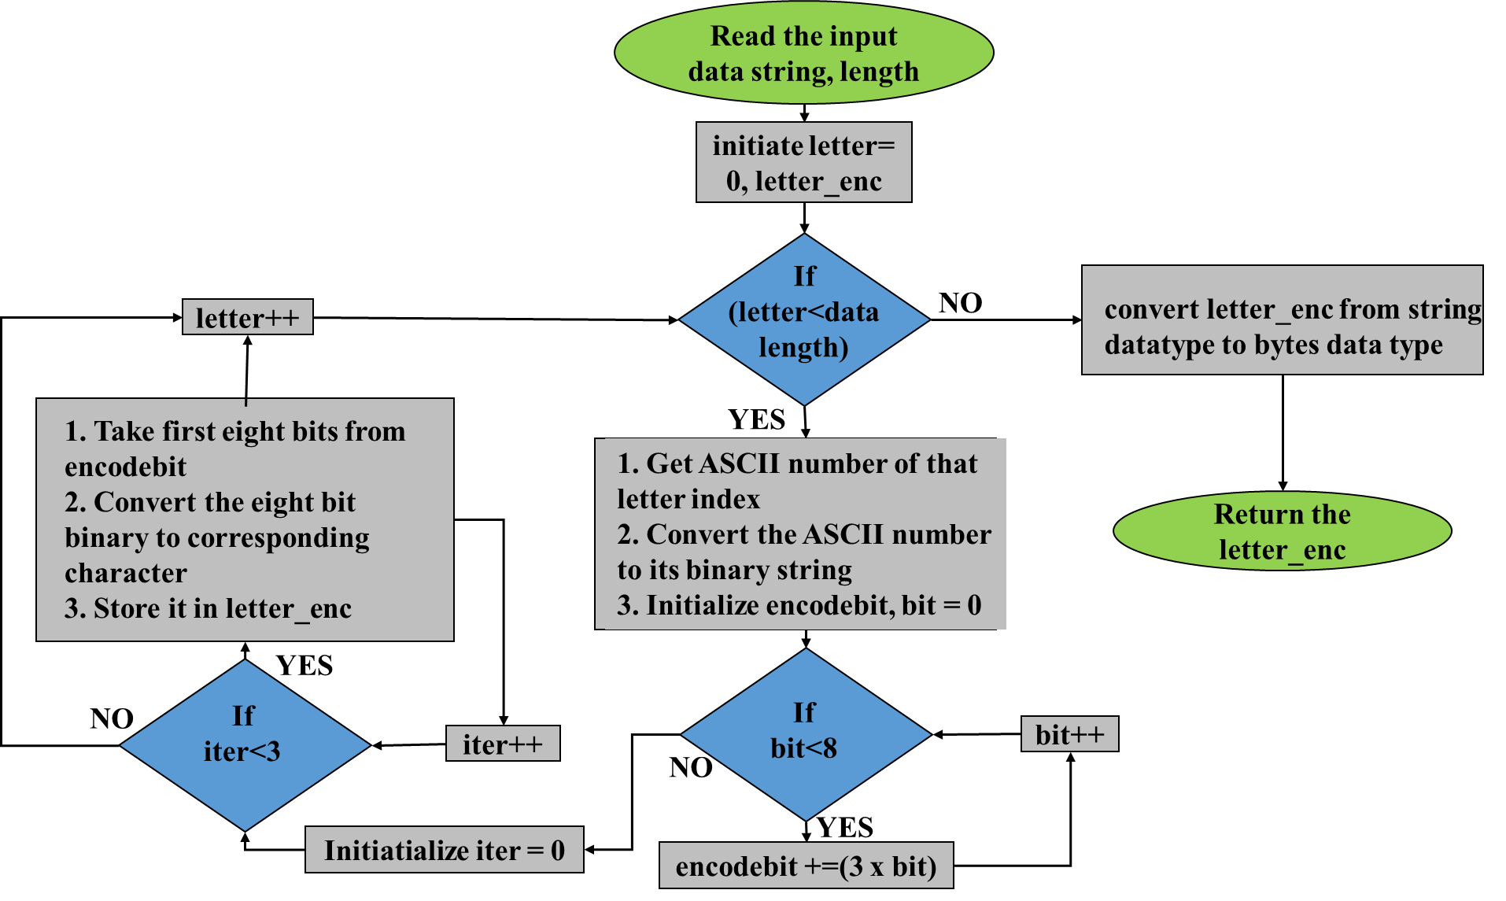
Figure S1: Shows the encoding process of Repeat 3 FEC
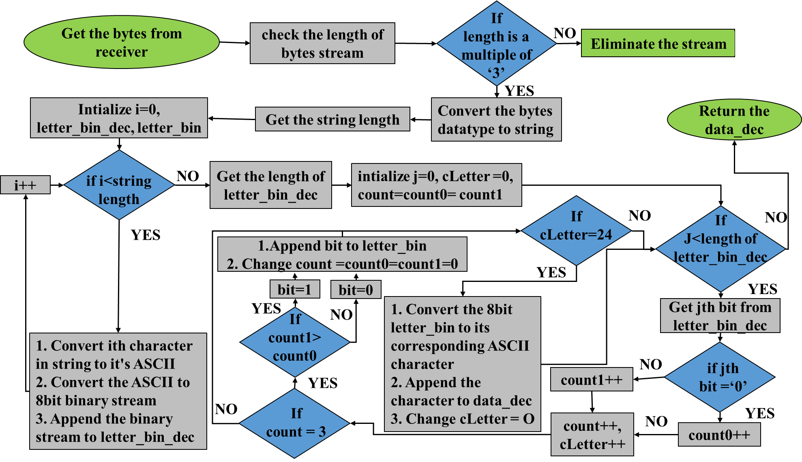
Figure S2: Shows the decoding process of Repeat 3 FEC

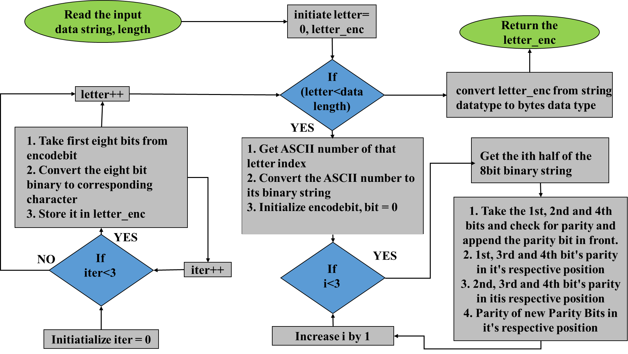
Figure S3: Shows the encoding process of Hamming FEC
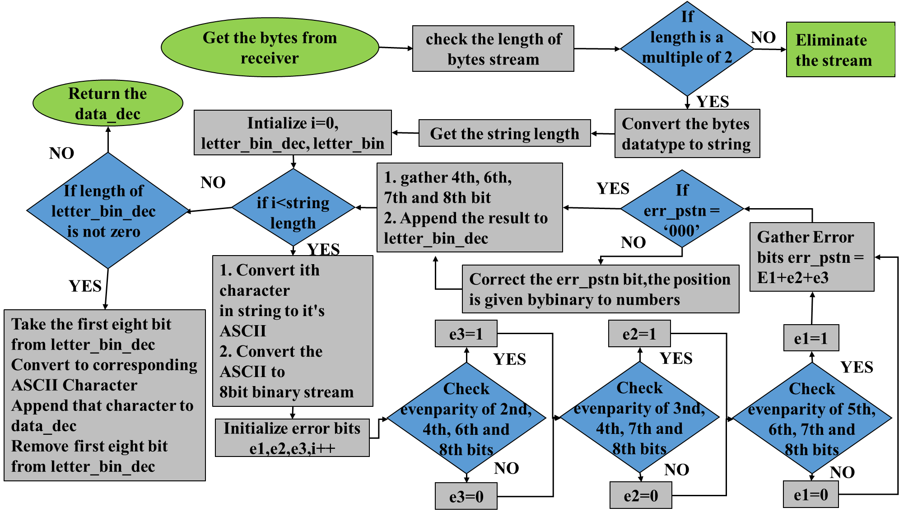
Figure S4: Shows the decoding process of Hamming FEC

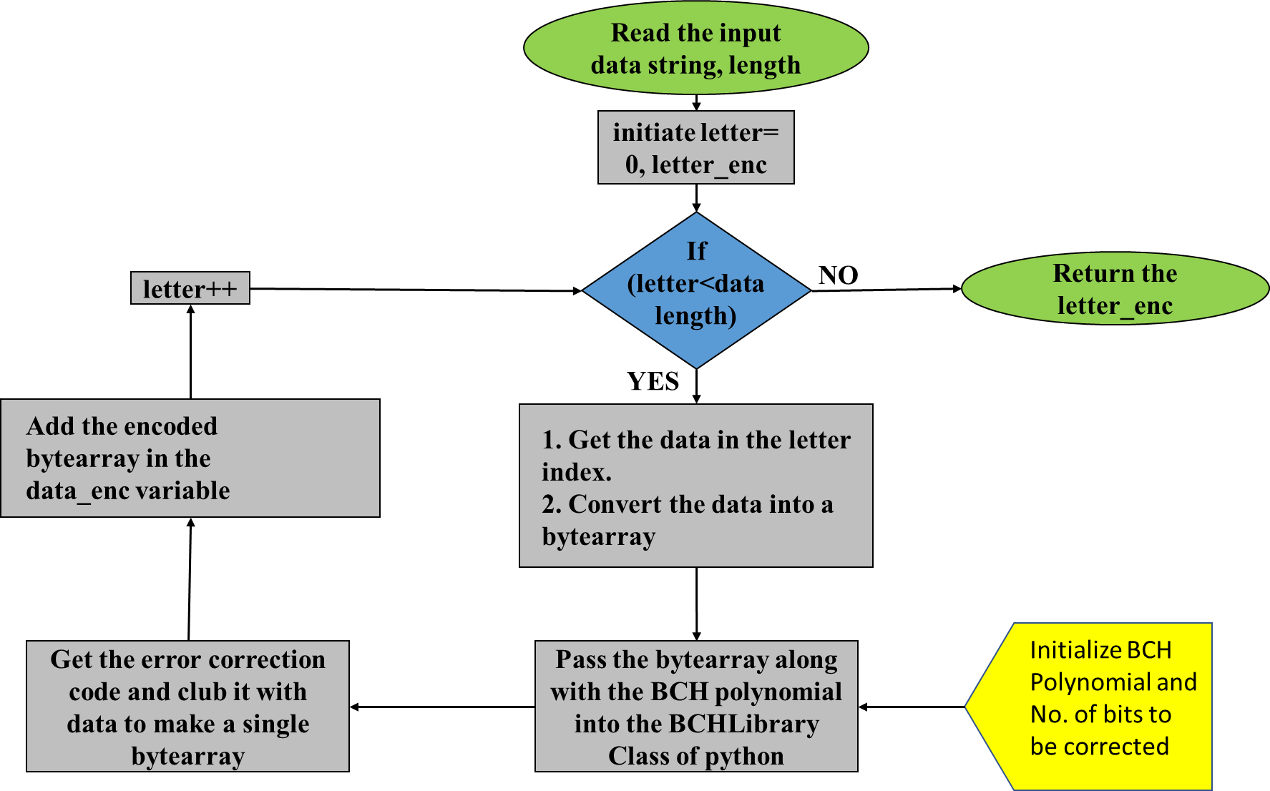
Figure S5: Shows the encoding process of BCH FEC
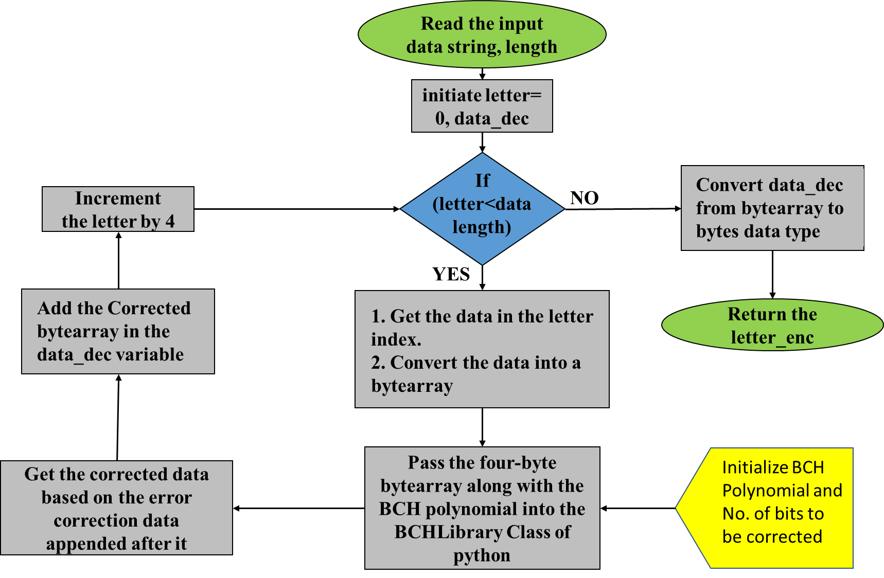
Figure S6: Shows the decoding process of BCH FEC

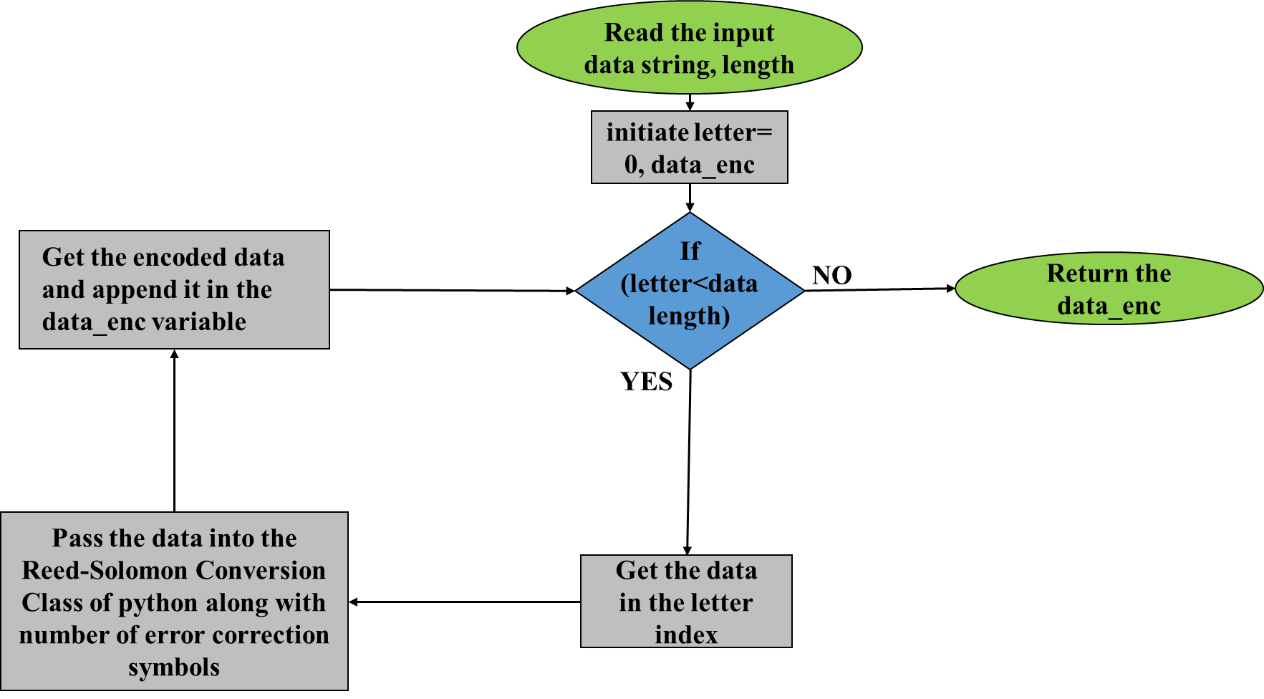
Figure S7: Shows the encoding process of Reed-Solomon FEC

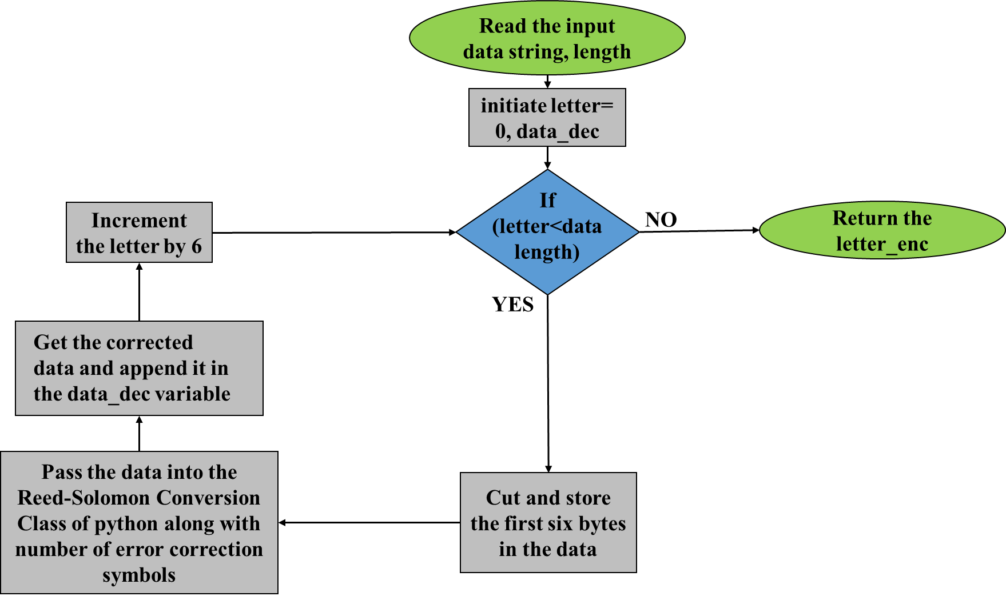
Figure S8: Shows the decoding process of Reed-Solomon FEC

